
H
ere we have it, the first, best ‘hard-boiled’ detective novel.
Raymond Chandler published it in 1939. He wasn’t really a novelist – he had, at 52, recently quit being an oil company vice-president out in California (too bored to endure it, and too drunk). And before that, during World War I, he had been a Canadian soldier, and an airman in the RAF; and before that a reporter in England; and before that school-boy at Dulwich College (established 1619),
So he wasn’t an American, either; yet The Big Sleep didn’t just re-invent the American crime novel, it changed the way everyone, even Americans. picture America; and it changed the way even American try to speak the American language.
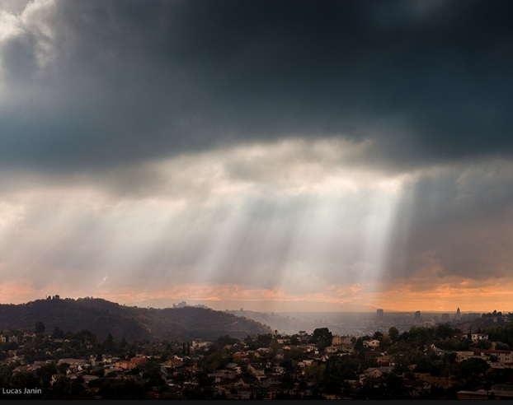
More than that: it created a whole new spiritual mood: tropical-urban-Gothic. America is at its most American way out West, in Los Angeles, a strip of sandy paradise pinched between the black San Gabriel mountains and the turquoise Pacific. The people are polished plastic and lovely and the sun never stops shining through the fifty-foot palm trees, except when it rains (here’s the aftermath of a rainstorm over the L.A. foothills). So is everyone happy? No, they’re lost out there – inarticulate gangster-poets, damned souls, criminal plutocrats, philosopher-pornstars and tragic molls all craving an opportunity to howl.
Anyway, that’s what Southern California looked like to a bookish Edwardian English public school-boy like Chandler, And this is what he had to say ….

RJCM

Chapter One

I
t was about eleven o’clock in the morning, mid October, with the sun not shining and a look of hard wet rain in the clearness of the foothills. I was wearing my powder-blue suit, with dark blue shirt, tie and display handkerchief, black brogues, black wool socks with dark blue clocks on them. I was neat, clean, shaved and sober, and I didn’t care who knew it. I was everything the well-dressed private detective ought to be. I was calling on four million dollars.
The main hallway of the Sternwood place was two stories high. Over the entrance doors, which would have let in a troop of Indian elephants, there was a broad stained-glass panel showing a knight in dark armor rescuing a lady who was tied to a tree and didn’t have any clothes on but some very long and convenient hair. The knight had pushed the vizor of his helmet back to be sociable, and he was fiddling with the knots on the ropes that tied the lady to the tree and not getting anywhere. I stood there and thought that if I lived in the house, I would sooner or later have to climb up there and help him. He didn’t seem to be really trying.

There were French doors at the back of the hall, beyond them a wide sweep of emerald grass to a white garage, in front of which a slim dark young chauffeur in shiny black leggings was dusting a maroon Packard convertible. Beyond the garage were some decorative trees trimmed as carefully as poodle dogs. Beyond them a large green house with a domed roof. Then more trees and beyond everything the solid, uneven, comfortable line of the foothills.
On the east side of the hall a free staircase, tile-paved, rose to a gallery with a wrought-iron railing and another piece of stained-glass romance. Large hard chairs with rounded red plush seats were backed into the vacant spaces of the wall round about. They didn’t look as if anybody had ever sat in them. In the middle of the west wall there was a big empty fireplace with a brass screen in four hinged panels, and over the fireplace a marble mantel with cupids at the corners. Above the mantel there was a large oil portrait, and above the portrait two bullet-torn or moth-eaten cavalry pennants crossed in a glass frame. The portrait was a stiffly posed job of an officer in full regimentals of about the time of the Mexican war. The officer had a neat black Imperial, black mustachios, hot hard coalblack eyes, and the general look of a man it would pay to get along with. I thought this might be General Sternwood’s grandfather. It could hardly be the General himself, even though I had heard he was pretty far gone in years to have a couple of daughters still in the dangerous twenties.
I was still staring at the hot black eyes when a door opened far back
under the stairs. It wasn’t the butler coming back. It was a girl.
She was twenty or so, small and delicately put together, but she looked durable. She wore pale blue slacks and they looked well on her. She walked as if she were floating. Her hair was a fine tawny wave cut much shorter than the current fashion of pageboy tresses curled in at the bottom. Her eyes were slategray, and had almost no expression when they looked at me. She came over near me and smiled with her mouth and she had little sharp predatory teeth, as white as fresh orange pits and as shiny as porcelain. They glistened between her thin too taut lips. Her face lacked color and didn’t look too healthy.
“Tall, aren’t you?” she said.
“I didn’t mean to be.”
Her eyes rounded. She was puzzled. She was thinking. I could see, even on that short acquaintance, that thinking was always going to be a bother to her.
“Handsome too,” she said. “And I bet you know it.” I grunted.
“What’s your name?”
“Reilly,” I said. “Doghouse Reilly.”
“That’s a funny name.” She bit her lip and turned her head a little and looked at me along her eyes. Then she lowered her lashes until they almost cuddled her cheeks and slowly raised them again, like a theater curtain. I was to get to know that trick. That was supposed to make me roll over on my back with all four paws in the air.
“Are you a prizefighter?” she asked, when I didn’t.
“Not exactly. I’m a sleuth.”
“A-a-“ She tossed her head angrily, and the rich color of it glistened in the rather dim light of the big hall. “You’re making fun of me.”
“Uh-uh.”
“What?”
“Get on with you,” I said. “You heard me.”
“You didn’t say anything. You’re just a big tease.” She put a thumb up and bit it. It was a curiously shaped thumb, thin and narrow like an extra finger, with no curve in the first joint. She bit it and sucked it slowly, turning it around in her mouth like a baby with a comforter.
“You’re awfully tall,” she said. Then she giggled with secret merriment. Then she turned her body slowly and lithely, without lifting her feet. Her hands dropped limp at her sides. She tilted herself towards me on her toes. She fell straight back into my arms. I had to catch her or let her crack her head on the tessellated floor. I caught her under her arms and she went rubber-legged on me instantly. I had to hold her close to hold her up. When her head was against my chest she screwed it around and giggled at me.
“You’re cute,” she giggled. “I’m cute too.”
I didn’t say anything. So the butler chose that convenient moment to come back through the French doors and see me holding her.
It didn’t seem to bother him. He was a tall, thin, silver man, sixty or close to it or a little past it. He had blue eyes as remote as eyes could be. His skin was smooth and bright and he moved like a man with very sound muscles. He walked slowly across the floor towards us and the girl jerked away from me. She flashed across the room to the foot of the stairs and went up them like a deer. She was gone before I could draw a long breath and let it out.
The butler said tonelessly: “The General will see you now, Mr. Marlowe.”
I pushed my lower jaw up off my chest and nodded at him. “Who was that?”
“Miss Carmen Sternwood, sir.”
“You ought to wean her. She looks old enough.”
He looked at me with grave politeness and repeated what he had said.

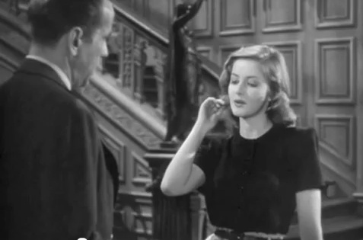
Here’s Martha Vickers as Carmen, doing her thing in the 1946 film of The Big Sleep. You can watch the scene at
http://youtu.be/jTBj3hXgOZE

Now read Chapter One through carefully for the second time.

1. What do you make of the Sternwood mansion? Into what circle of hell has young Philip (“neat, clean, shaved and sober” for once) strayed?

2. Chandler’s prose is full of sudden surprising phrases, poetic and rather sinister. “If I lived in the house, I would sooner or later have to climb up there and help him” – what’s the point of this remark? What do you think of that stained-glass window?

3. Another sinister phrase: what do have to say about Carmen’s “predatory teeth, as white as fresh orange pits”?

4. Select three more striking phrases from Chapter One and be ready to talk about them.

