British International School of Ljubljana: History, year 10/11

END OF YEAR CLASS EXAMINATION
Friday, 1 June 2012

Your name……………………..

WRITE YOUR NAME HERE AND ON THE BACK PAGE.
ATTEND CAREFULLY TO THE POINTS AVAILABLE FOR EACH QUESTION!
TIME YOURSELF CAREFULLY. YOU NEED TO BE COVERING
WRITE ON THE QUEstION PAPER IN CLEAR, LARGE, PLEASANT LETTERING.
good luck.

Section I: short questions on Germany 1918-1945 [25 marks]

Answer all questions in this section.

1. What was the Beer Hall putsch?
2. What was the KPD?
3. What was the NSDAP?
4. What has been the sovereign of Germany before 1918?
5. What was hyperinflation?
6. Why was the Dawes Plan so good for Germany?
7. When was the Wall Street Crash?
8. How did Hindenburg become a national hero?
9. What was the Kapp putsch?
10. Who was Gustav Streseman?
11. What year was Hitler made Chancellor?
12. What was the Reichstag Fire?
13. Who was the first President of Germany?
14. What was the Locarno Pact?
15. What is the name we give to the regime that ruled Germany from 1919 to 1933?
16. Who were the Spartacists?
17. What was the Ruhr?
18. Who occupied the Ruhr in 1923?
19. With which country was an alliance formed by Nazi Germany in August 1939?
20. Who were the Stormtroopers?
21. What did the Nazis mean by the word Aryan?
22. Name four groups the Nazis persecuted.
23. What was the Anschluß?
24. What was the Sudetenland?
25. What was the Polish Corridor?
Section II: longer questions on Germany 1918-1945 [30 points]
Choose one of these topics. Write the letter of the topic in this wee box
and then write a short essay explaining the topic, and explaining why it is important.

A. Appeasement
B. The occupation of the Rhineland
C. Anschluss
D. Munich Crisis
E. Polish Crisis of 1939
F. The Soviet Pact of August 1939

Section III: map questions on Germany 10 points

Under the terms of the Treaty of Versailles, Germany lost her colonies, and also the following territories:

Alsace-Lorraine
West Prussia, Silesia and Posen
North Schleswig

Mark these territories carefully on the map, which shows the boundaries of 1914.

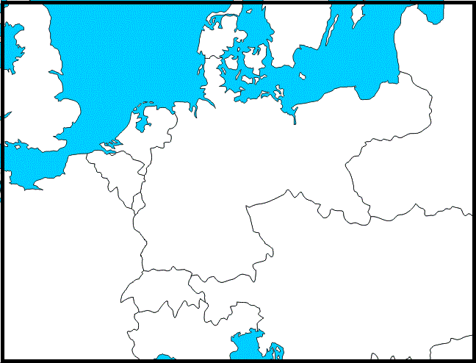

Section IV. Source-based question [30 marks]

Study the sources, and then answer the questions which follow.

Source A
1 We demand the union of all Germans into a greater Germany.
4 Only fellow Germans can have the right of citizenship. A fellow German can only be so if born
to German parents. This excludes Jews.
14 We demand that large industries share their profits with the workers.
15 We demand generous improvements in the old age pension system.
25 To achieve this programme the party demands the setting up of a strong national government
with complete authority for parliament over the whole country.
Extracts from the Twenty-Five Point Programme
of the National Socialist German Workers’ Party (NSDAP), 1920.

Source B
Hitler never stood as a candidate for the Reichstag as he was not a German citizen until 1932. By 1928 Hitler was little known outside southern Germany and even there was seen as part of the lunatic fringe of Bavarian politics. In the 1928 elections the Nazis won only twelve of the 491 Reichstag seats. It would have been all too easy for the Nazi Party to disintegrate. Faced with indifference and half-amused contempt from voters, these were the years of waiting for Hitler. He had made progress in rebuilding the Party from its 1924-5 low and was its unchallenged leader. The one quality of his leadership was the fact that he never let go, never lost faith in himself and, having dealt with earlier rivals, kept the loyalty of the men around him.
From Hitler, A Study in Tyranny,
by a British professor of history, 1962.

1. What can you tell from this Source A about the aims of the NSDAP?
Support your answer with reference to the source. [10 marks]

2.How far does Source B show that Hitler was an effective leader in the 1920s? Explain your answer.
[10 marks]

3. Is one of these sources more useful than the other as evidence about the Nazis in the 1920s?
Explain your answer.
[10 marks]

Section V. The Treaties of 1919-1923 [15 marks]

1. Draw lines connecting the treaties and countries:

Neuilly Germany

Sevrès Bulgaria

Trianon Austria

St Germain Hungary

Versailles Turkey

2. Identify each of these figures, and explain why he is important. I have done the first one for you, to show what

Woodrow Wilson: President of the United States. He had already proposed a scheme of post-war settlement in his Fourteen Points. He came to Paris to negotiate the peace treaties. He urged leniency with Germany, and the foundation of a League of Nations.

Admiral Miklós Horthy

Georges Clemenceau

David Lloyd George

Charles I and IV, Emperor of Austria and King of Hungary

Vittorio Orlando

3. Briefly explain each of these dates in Hungarian history:

896

1000

1526

1867

1920

YOUR NAME (AGAIN)

………………………………………….

MARKING
Section I /25 (Germany)

Section II /20 (essay)

Section III /10 (map)

Section IV /30 (source)

Section V /15 (Treaties)

TOTAL:

