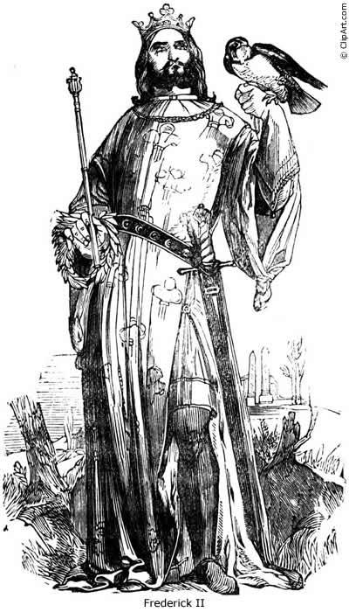
Your name

........................................

FREDERICK II,
HOLY ROMAN EMPEROR,
KING OF SICILY
& JERUSALEM,
the wonder
of the world

- Here is a portrait of Frederick. Draw him as you imagine him.
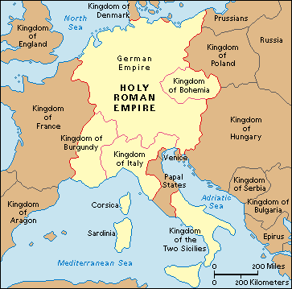

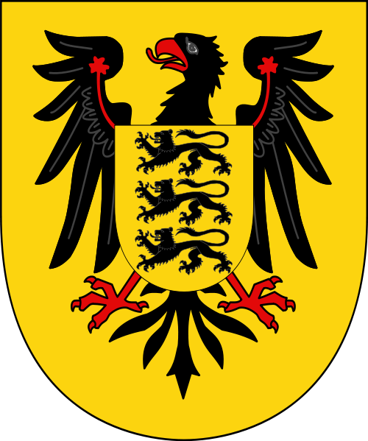
2. Here is Europe in 1250, when Frederick died. Colour the map intelligently.

- Here is Frederick´s coat of arms. Colour it accurately (find out on line what colours the House of Hohenstauffen bore).

http://en.wikipedia.org/wiki/File:Hohenstaufen_emporer_arms.svg

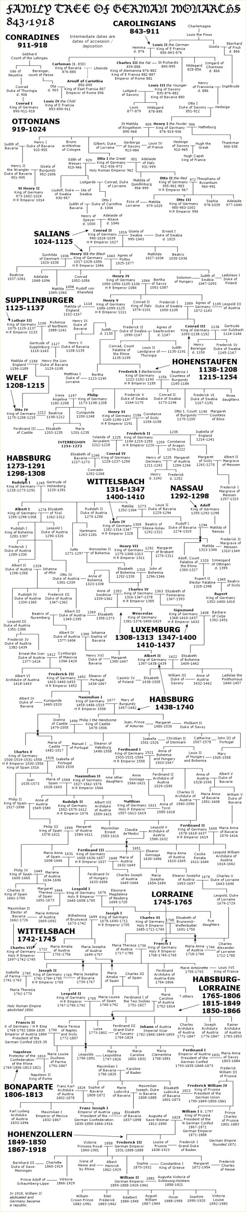
- Study the family tree of the Kings of Germany. Then name Frederick II´s

- father
- mother
- wife
- children

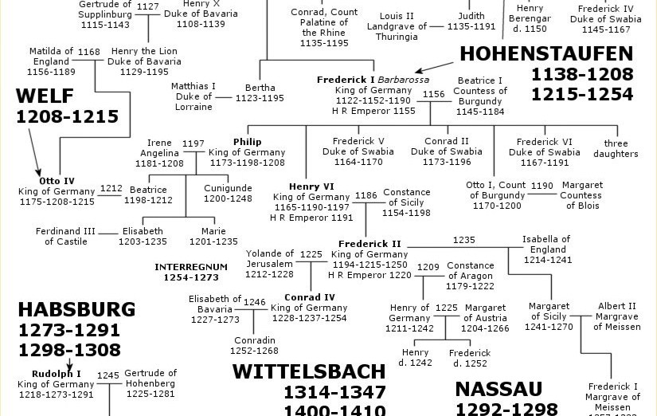

FREDERICK THE SCIENTIST
Frederick loved exotic animals in general: his menagerie, with which he impressed the cold cities of Northern Italy and Europe, included hounds, giraffes, cheetahs, lynxes, leopards, exotic birds and an elephant.
He was also alleged to have carried out a number of experiments on people. These experiments were recorded by the monk Salimbene di Adam (who despised Frederick) in his Chronicles. Amongst the experiments included shutting a prisoner up in a cask to see if the soul could be observed escaping though a hole in the cask when the prisoner died; feeding two prisoners, sending one out to hunt and the other to bed and then have them disemboweled to see which had digested their meal better; imprisoning children without any contact to see if they would develop a natural language.
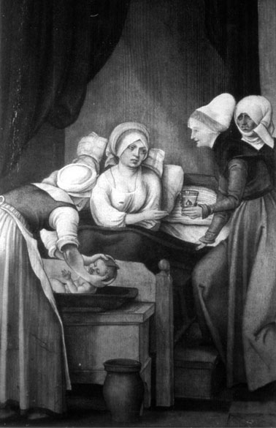
In the Language deprivation experiment young infants were raised without human interaction in an attempt to determine if there was a natural language that they might demonstrate once their voices matured. It is claimed he was seeking to discover what language would have been imparted unto Adam and Eve by God. In his Chronicles Salimbene wrote that Frederick bade foster-mothers and nurses to suckle and bathe and wash the children, but in no ways to prattle or speak with them; for he would have learnt whether they would speak the Hebrew language (which had been the first), or Greek, or Latin, or Arabic, or perchance the tongue of their parents of whom they had been born. But he laboured in vain, for the children could not live without clappings of the hands, and gestures, and gladness of countenance, and blandishments.

- What did Frederick want to discover about children?

FREDERICK THE FALCONER
Frederick II is the author of the first treatise on the subject of falconry, De Arte Venandi cum Avibus (The Art of Hunting with Birds). In the words of the historian C.H. Haskins:

It is a scientific book, approaching the subject from Aristotle but based closely on observation and experiment throughout, Divisivus et Inquisitivus, in the words of the preface, it is at the same time a scholastic book, minute and almost mechanical in its divisions and subdivisions. It is also a rigidly practical book, written by a falconer for falconers and condensing a long experience into systematic form for the use of others.

Frederick’s pride in his mastery of the art is illustrated by the story that, when he was ordered to become a subject of the Great Khan (Batu) and receive an office at the Khan’s court, he remarked that he would make a good falconer, for he understood birds very well. He maintained up to fifty falconers at a time in his court, and in his letters he requested Arctic gyrfalcons from Lübeck and even from Greenland.

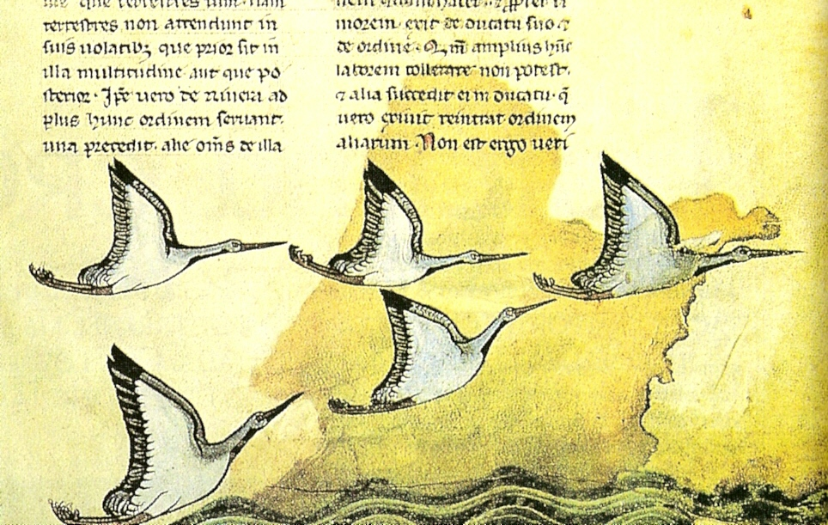

- What is falconry?

FREDERICK THE EMPEROR

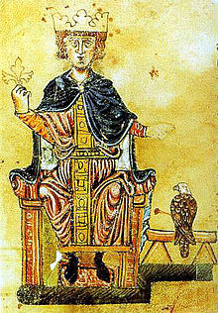
Emperor Frederick II spent little time in Germany as his main concerns lay in Southern Italy. He founded the University of Naples in 1224 to train future state officials and reigned over Germany primarily through the allocation of royal prerogatives, leaving the sovereign authority and imperial estates to the ecclesiastical and secular princes. He made significant concessions to the German nobles, such as those put forth in an imperial statute of 1232, which made princes virtually independent rulers within their territories. These measures favoured the further fragmentation of the Empire.
By the 1226 Golden Bull of Rimini, Frederick had assigned the military order of the Teutonic Knights to complete the conquest and conversion of the Prussian lands. A reconciliation with the Welfs took place in 1235, whereby Otto the Child, grandson of the late Saxon duke Henry the Lion, was named Duke of Brunswick and Lüneburg. The power struggle with the popes continued and resulted in Fredrick's excommunication in 1227. In 1239, Pope Gregory IX excommunicated Fredrick again, and in 1245 he was condemned as a heretic by a church council. Although Frederick was one of the most energetic, imaginative, and capable rulers of the time, he was not concerned with drawing the disparate forces in Germany together. His legacy was thus that local rulers had more authority after his reign than before it. The clergy also had become more powerful.
By the time of Frederick's death in 1250, little centralized power remained in Germany. The Great Interregnum, a period in which there were several elected rival kings non of whom was able to achieve any position of authority, followed the death of Frederick's son King Conrad IV of Germany in 1254. The German princes vied for individual advantage and managed to strip many powers away from the diminished monarchy. Rather than establish sovereign states however, many nobles tended to look after their families. Their many male heirs created more and smaller estates, and from a largely free class of officials previously formed, many of these assumed or acquired hereditary rights to administrative and legal offices. These trends compounded political fragmentation within Germany. The period was ended with the election of Rudolph of Habsburg in 1273.
- Was Frederick a successful monarch?

FREDERICK THE CRUSADER
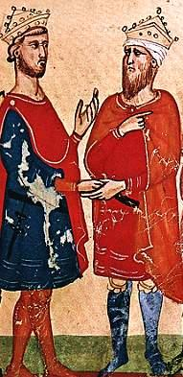
The fifth Crusade in 1220 attacked Egypt with the intention to advance toward Jerusalem. On this one, Francis of Assisi went as kind of a chaplain, but with a side agenda to win the Sultan for Christianity and make peace through dialogue. The Crusade failed; the armies never got out of Egypt, but Francis won the Sultan’s lasting friendship.
Defiantly, Frederick II decided to embark on the Fifth Crusade in 1228. To the surprise of the pope and other leaders, he fought the crusade with political means: he negotiated a peaceful handover of Jerusalem with Sultan al-Kamil. Arab historians documented the extent of the intercultural encounter. One anecdote relates that the sultan ordered the muezzins of Jerusalem to cancel the call for prayer during the Christian ruler’s stay in the city. According to the historian, Frederick II complained the next morning that the muezzins had not called for prayer. The qadi Shams al-Din replied: “‘It is I who prevented them form doing so, out of respect for Your Majesty.’ ‘You should not have acted thus,’ the emperor said, ‘for if I spent this night in Jerusalem, it was above all to hear th e muezzin’s call in the night.

8. What did Fredericka chieve in the Holy Land?

