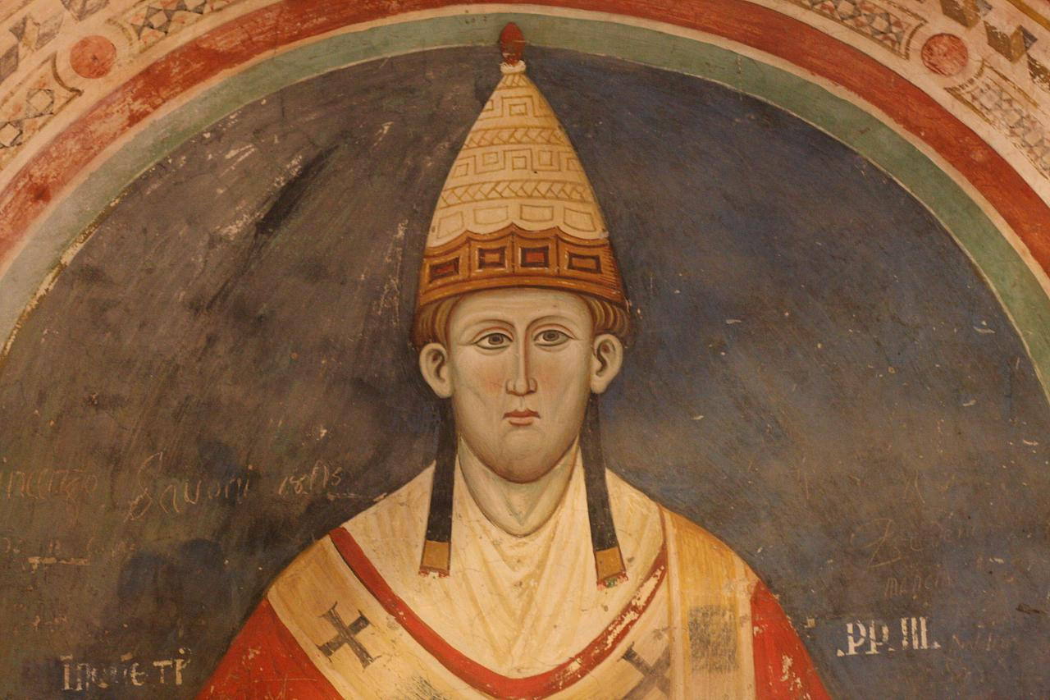Your name ........................................

POPE INNOCENT III

- Here is a portrait of Innocent. Draw him as you imagine him.
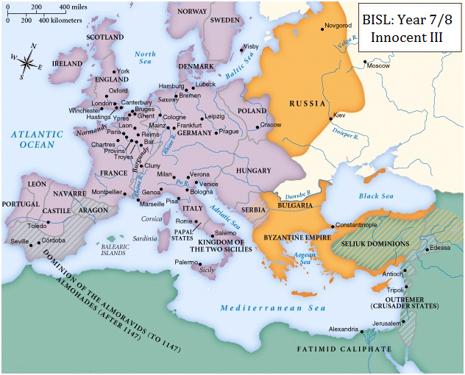

2. Here is a religious map of Europe in Innocent's time.
Adapt it intelligently to show
Roman Catholicism
Greek Orthodoxy
Islam

Using the class webpage and any other resources, answer the following questions:

3. Who was the greatest Catholic thinker of the thirteenth century?

4. Who was the greatest Catholic spiritual leader of the thirteenth century?

5. What happened when Innocent met Francis? Why is this important?

6. Who was Lothair of Segni?

7. When was he born? (What century is that?)

8. Where was Lothair educated?

9. What happened to him in 1190? What does this mean?

10. What year did he become pope?

11. How did he become pope? (How does anyone become a pope?)

12. List three of Pope Innocent III's accomplishments:

13. Did Innocent get on well with the Holy Roman Empire?

14. What happened at the Fourth Lateran Council?

15. What happened on the Fourth Crusade?

16. Where and when did Innocent III die?

