Your name ........................................

St Louis IX,
KING OF FRANCE
1226-1270

- Here is a contemporary bust of Louis. Draw him as you imagine him.
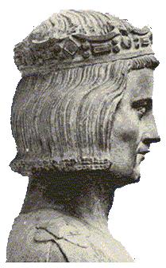
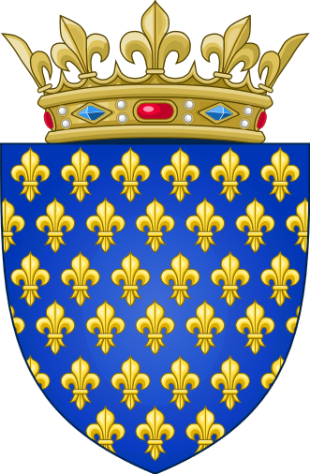
- Here is St Louis´ coat of arms. Colour it accurately (find out on line what colours the Kings of France bore).

- Study the family tree. The name Louis IX´s

- father
- mother
- wife
- successor as King of France

- List Louis´ children:

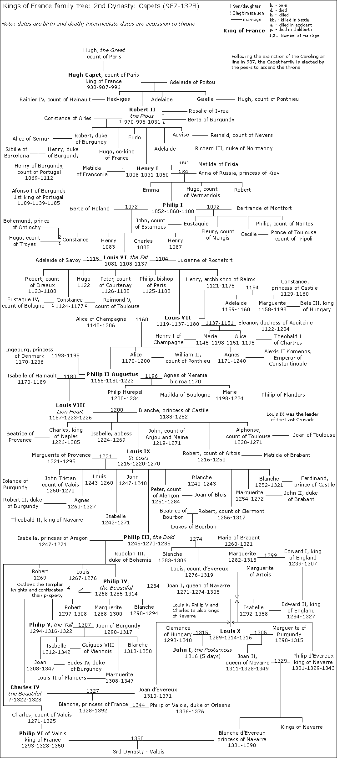
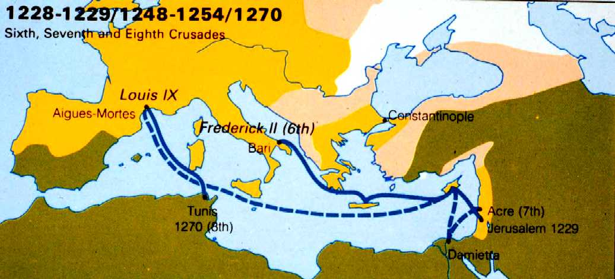
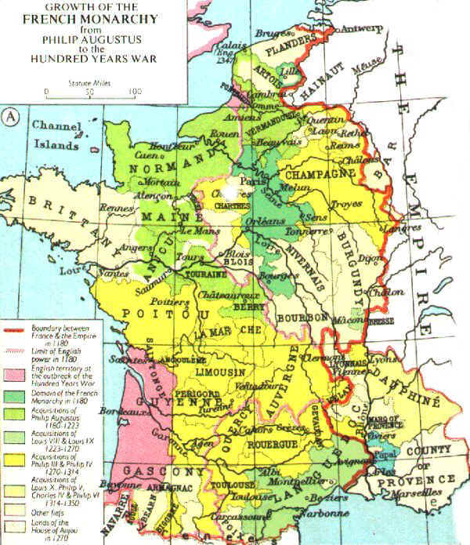
5. Here are maps of the Kingdom of France, and of the routes of the VIth, VIIth and VIIIth Crusades.
On the French map, mark:

Paris, King Louis´ capital
Reims, where he was crowned
the County of Provence,
where his wife came from
the Kingdom of Navarre
the Duchy of Normandy

6. What was the Seventh Crusade? What happened at the Battle of Fariskur in 1250? What happened to St Louis afterward?

7. What was the Eighth Crusade? Where did it go?

8. How and where did Louis die? Why was he regarded as a saint?

THE KING DIES
Our great contemporary source about St Louis is Jean de Joinville, whose Life of St Louis was finished in 1309.
Here's what Joinville has to say about King Louis' decision to depart on the Eighth Crusade:

T
o my mind they committed a deadly sin who encouraged his going; for France had reached a condition when all the kingdom was at peace within itself and with its neighbours; and never again has it been so since he left it; but the state of the kingdom has steadily gone from bad to worse. A very great sin it was in those who encouraged him to go, seeing how weak he was in health at the time; for he could endure neither to drive nor ride. His weakness was so great that he let me carry him in my arms from the Count of Auxerre's house, where I took leave of him, as far as the Greyfriars. And yet, weak as he was, if he had stayed in France, he might still have lived a good while and done a great deal of good.
I shall not say anything about his journey to Tunis, nor give any account of it, because I was not there thank God! And I do not wish to say or put anything in my book of which I am not quite sure. So we will speak only of our holy King, and say, that after he landed at Tunis, before the castle of Carthage, he fell sick of a catarrh of the stomach, by reason of which he took to his bed, and felt that the time was come for him to pass from this world to the next. Thereupon he called for my Lord Philip his son, and bade him to observe, as though it were his testament, all the instructions that he left him ....
When the good King had given his instructions to my Lord Philip, his infirmity began to increase greatly upon him, and he asked for the sacraments of Holy Church. And he received them with a sound mind and right understanding, as was plain; for, whilst they were anointing him and repeating the seven psalms, he repeated the verses in response ..... “Lord God, grant that we may so despise the ruggedness of this world that we may fear no adversity.” ....
After that, the holy King made them lay him on bed strewn with ashes, and laid his hands upon his breast, and looking up to heaven, yielded up his spirit to our Creator, in the very same hour when the Son of God died upon the Cross.
A precious matter and worthy of tears is the death of this holy Prince, who so righteously and faithfully watched over his kingdom; who did so many fair works of charity, and founded so many fine institutions. And just as a writer when he has ended his book illuminates it with gold and azure, so did this King illuminate his kingdom with the fair abbeys that he built, and with the almshouses, and convents of Preachers ....

