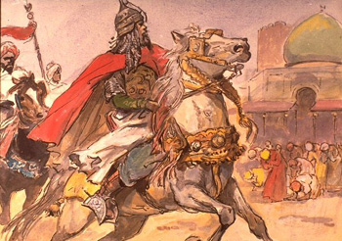
Your name

........................................

SALADIN,
Sultan of Egypt and Syria

Here is a portrait of Saladin.
Find other portraits on the internet and produce a better image.

Please construct a timetline of Saladin's life, lisitng the six most important events between his birth and death.

1138 born in Tikrit

1193 died in Damascus

Here is a map of the Near East.
Mark in:
the boundaries of Saladin's empire
Tikrit, Jerusalem, Constantinople, Cairo, Mecca, Hattin, Damascus
the three great rivers
the Red Sea, Mediterranean, Black Sea, Caspian Sea, Persian Gulf and Indian Ocean

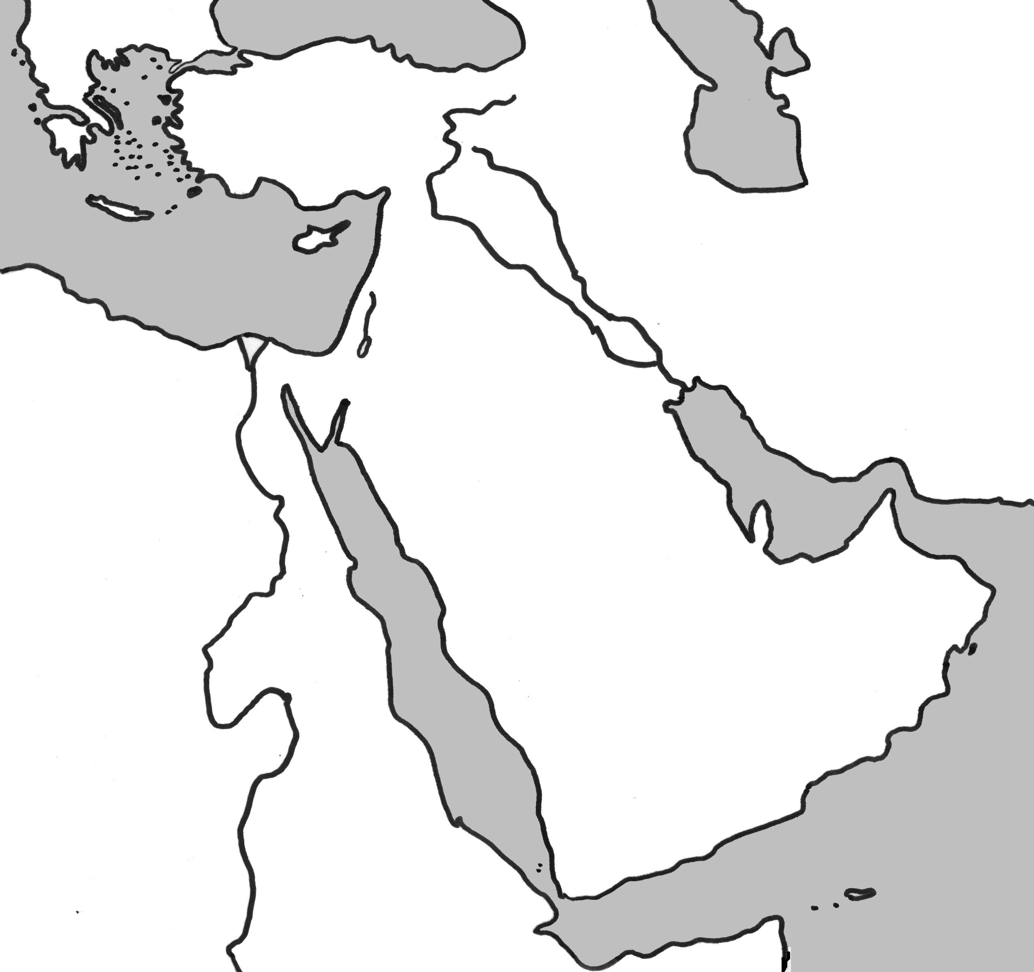

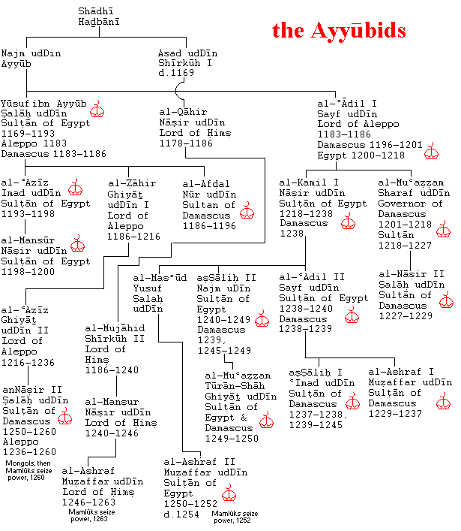

Find Saladin on this genealogical table.
Why was his family called the Ayyubids?
How many Sultans belonged to this family?
When did they cease to reign in Damascus?

Here is Saladin in the best hour of his life. It's late afternoon on 4th July 1187. He's having a lovely, lovely time. Why? What is happening?
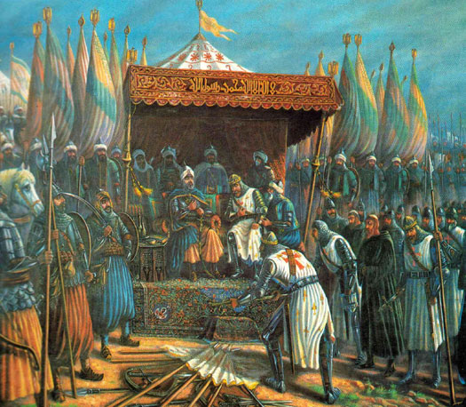

Why is this event so important?
(List three reasons.)

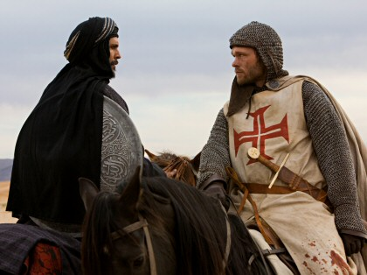
Here is Saladin with his enemy, rival and admirer, Richard the Lionheart
.

Why did Richard admire Saladin?

Why is Saladin relevant to twenty-first century history? Write a short essay (about 200 words).

