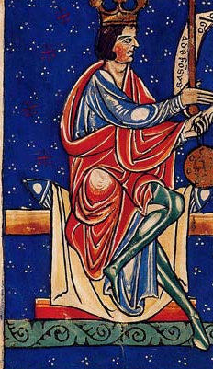
Your name

........................................

ALFONSO VI,
El Bravo, King of León, Castile & Galicia

Here are portraits of Alfonso.
Draw him as you imagine him.

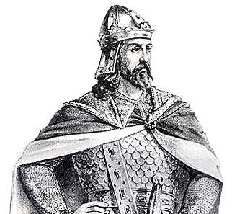
Please construct a timetline of Alfonso's life, lisitng the six most important events between his birth and death.

1040 born, second of three sons of Ferdinand I, King of León.,
and Sancha, heiress of León

1109 dies.

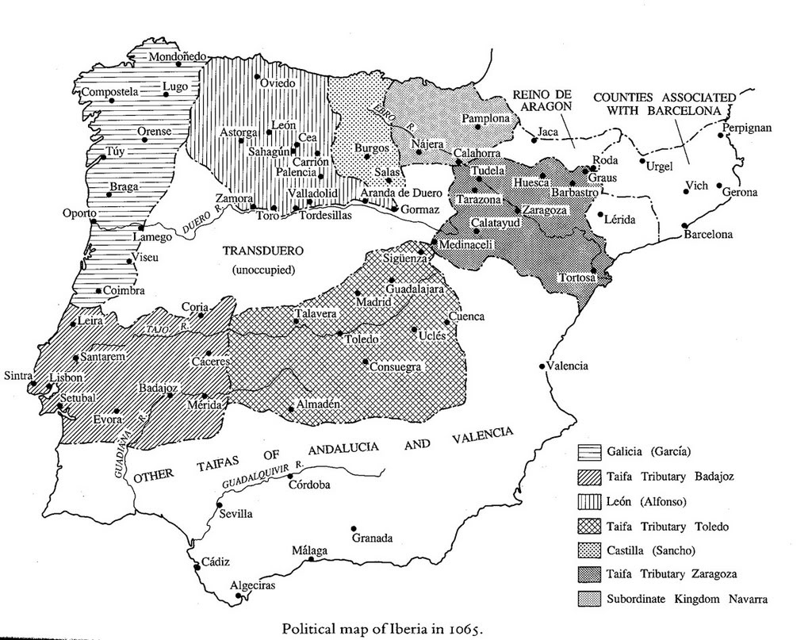

Here is a complicated map of Alfonso's kingdom.
Study it carefully.
Master what it means.
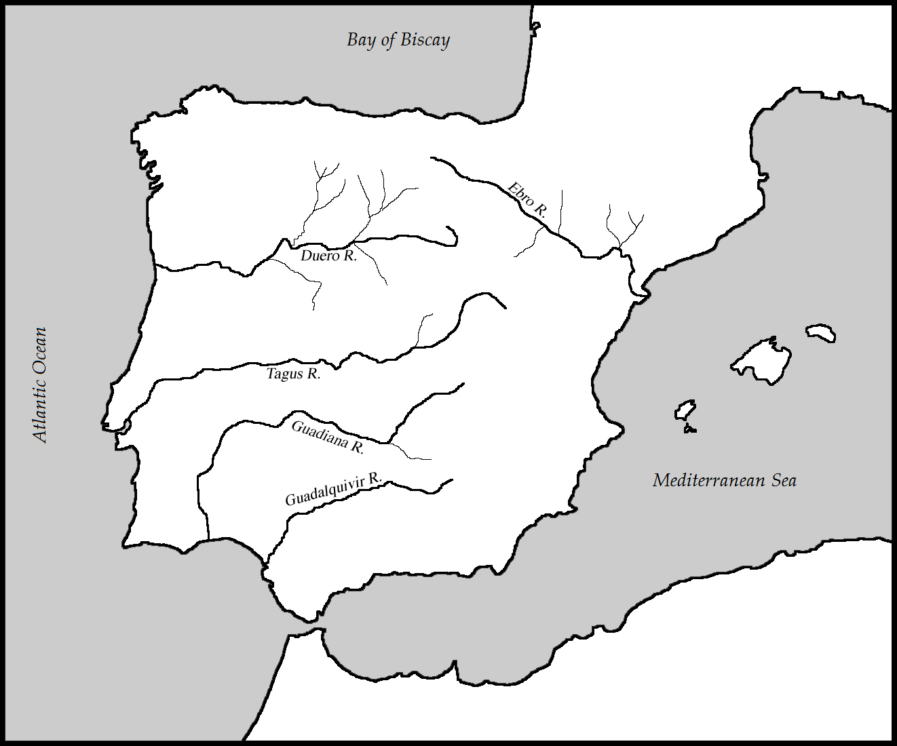

On this map please indicate (accurately and clevelry) the maximum extent of Muslim rule in Spain – what they called Al-Andalus – at the end of the eighth century.

Please draw on this map (carefully, beautifully, intelligently) the realm of Alfonso.
Indicate the main cities, and any battles you think important.

Show the modern political boundaries in the Iberian peninsula, indicating the countries and main cities.
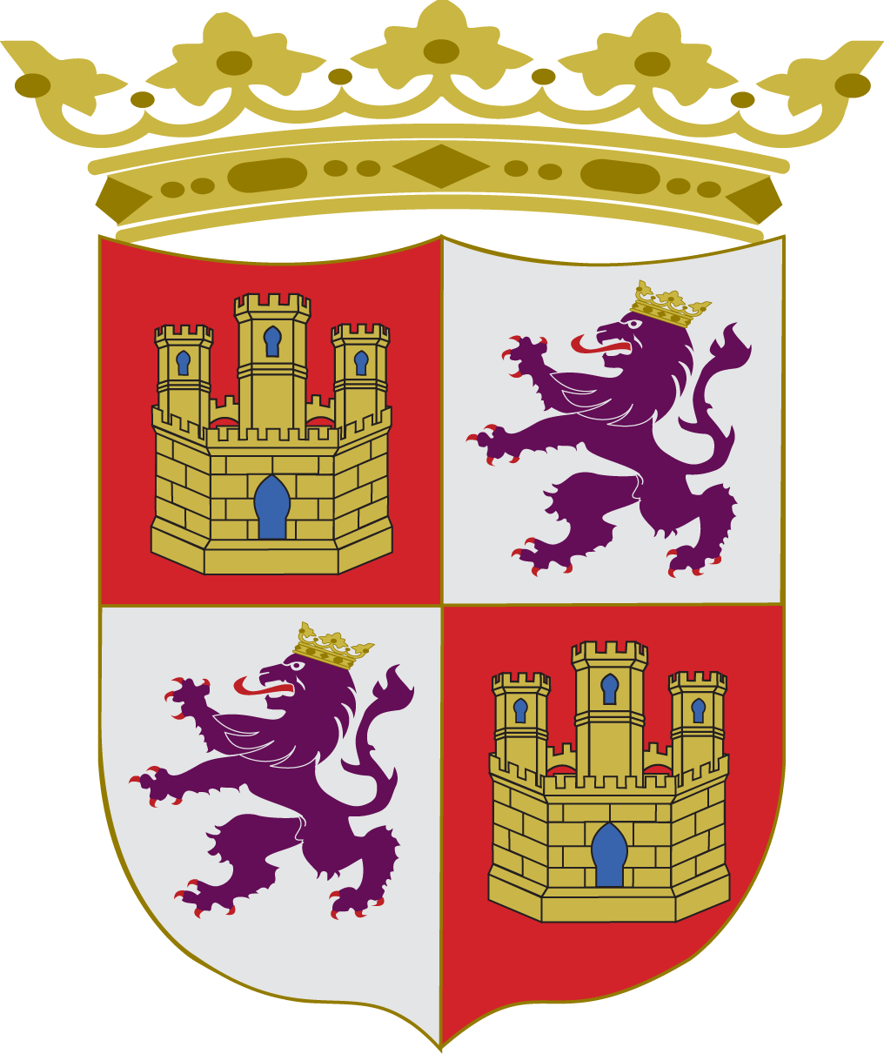

Here is Alfonso's coat of arms. Discover from the internet which bit represents Leon and which Castile (this is not hard), and get the colours right.

Study the family tree (genealogical table) over the page.
List Alfonso's:
parents

siblings

wife

children

grandchildren
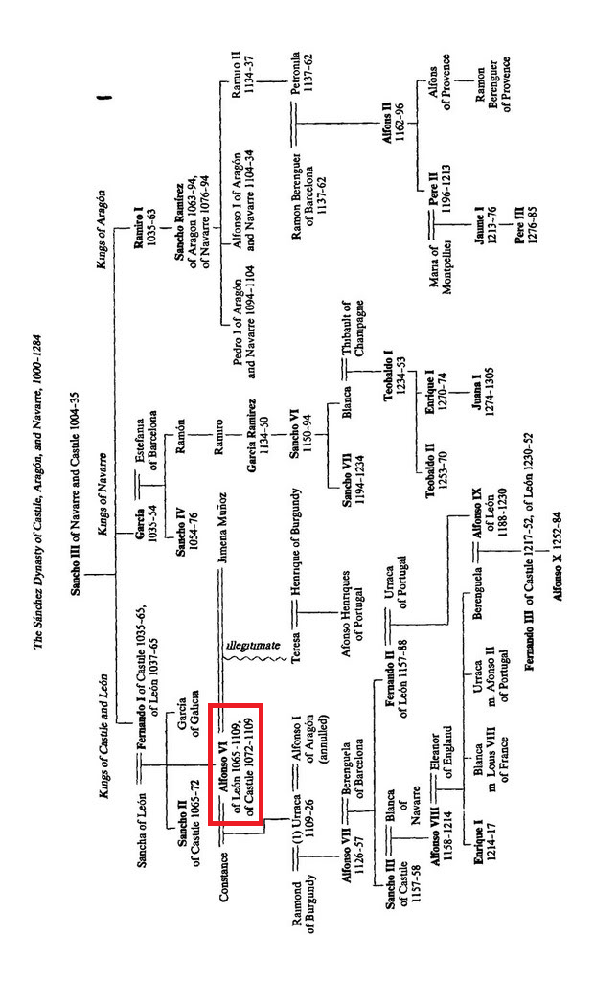
Listen to Spanish music of the eleventh century here:
http://www.youtube.com/watch?v=oIhyIpLgkGg

Watch this brief film about Alfonso VI (in Spanish, but you can handle that):
http://www.youtube.com/watch?v=bcVnfh_EW3w&feature=relmfu
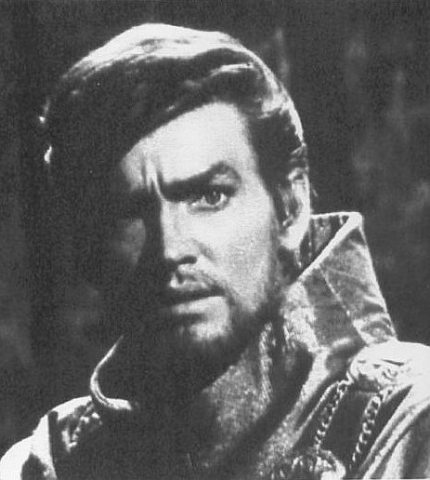
Watch Alfonso as an evil young prince, played by John Fraser, in the Hollywood epic El Cid (1961), here http://www.youtube.com/watch?v=hL5XitDwXDo&feature=relmfu (start at 8:00) and here http://www.youtube.com/watch?v=C77kxJvWf8k&feature=relmfu

Watch the assassiantion of his elder brother, Sancho:
http://www.youtube.com/watch?v=L5J1XUGdpAM (start at 2:00)

Now imagine you are Alfonso VI on his deathbed. Write a short account of your thoughts: what you are proud of in your life; what you are ashamed of; what you think made you a good or a bad mediaeval monarch.

