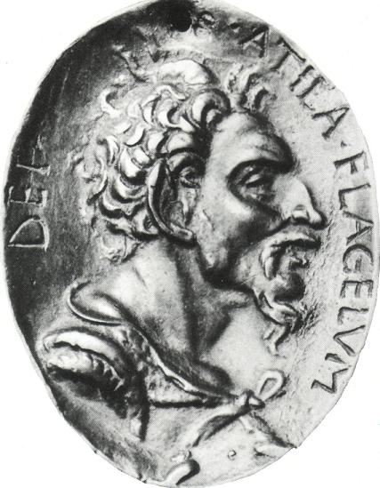
Your name ........................................

ATTILA,
EMPEROR OF THE HUNS

Here is Gerard Butler as Attila in the 2001 miniseries.
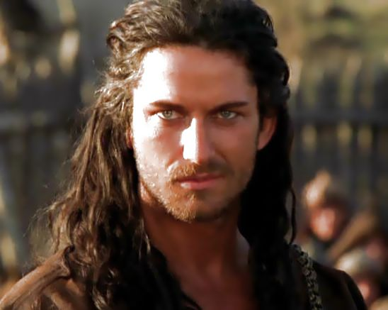
Here is a medal, and here is a contemporary description:
Short of stature, with a broad chest and a large head; his eyes were small, his beard thin and sprinkled with grey; and he had a flat nose and tanned skin, showing evidence of his origin

Quite a difference!
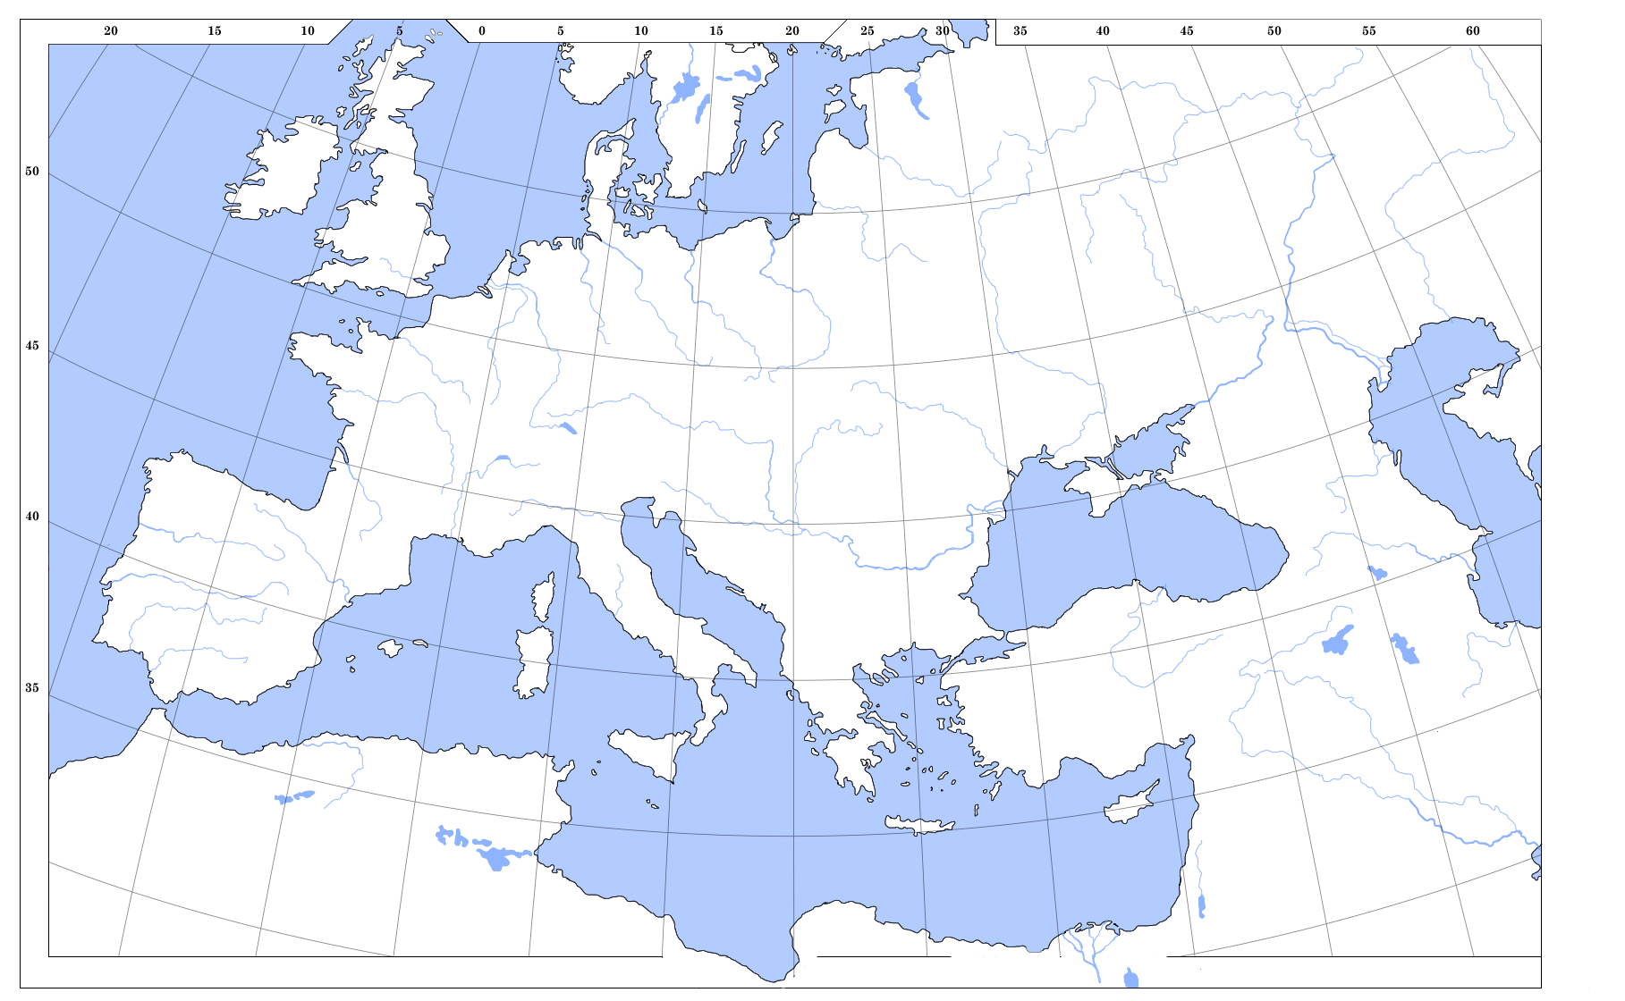
- Make an intelligent map, illustrating Attila’s origins, travels and empire.

2. Using all the resources on the website, produce a timeline of Attila’s life, finishing with his death in 453.

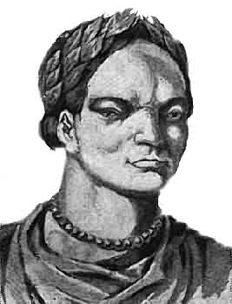

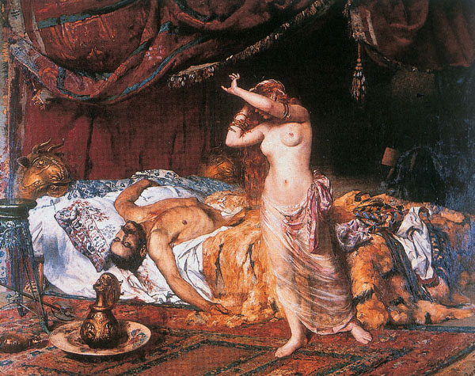
3. There are different theories about how he died. What do you think killed him? Justify your answer.

Explain the following words. What is their significance in the story of Attila?
4. nomad
5. Eurasia
6. Hun
7. Battle of Châlons,
8. Leo the Great
9. Danube

10. Write an essay of about three paragraphs, totalling 300 words, beginning either:
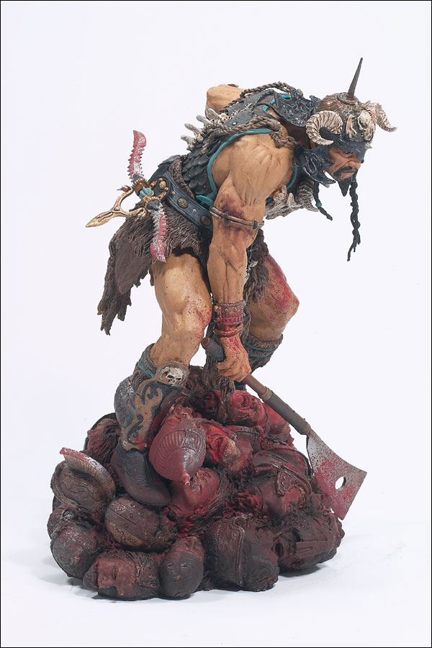
The 2001 film of Attila is a terrible piece of work
because .....

or

The 2001 film of Attila is a great piece of work
because .....

