British International School of Ljubljana: History year 9
Wednesday, 23rd May 2012, periods III and IV

REVIEW TEST ON MEDIÆVAL MONARCHS

Your name ......................................

Alfred the Great
1. What century did Alfred die in?

2. Of what was he king?

3. Who were his enemies?

Tell me two more important things about Alfred.
4.

5.

Pope Innocent III
6. What is a pope?
7. Why did the papacy matter so much in the Middle Ages?

8. In what two centuries did Inoccent live?
Tell me two more interesting things about Innocent:
9.

10.
Genghis Khan
11. What was Genghis Khan’s real name?

12. In which century did he live?

13. Who were the Mongols? Where were they from?

14. What does the word nomad mean?

15. What is a horde?

Abd-Ar-Rahman III
16. In what century did he live?

17. Who were the Moors?

Tell me three interesting things about Abd-Ar-Rahman:
18.

19.

20.

St. Louis IX
21. What was Louis king of?

22. What is a crusade?

Tell me three important things about Louis or about the Crusades:

23.

24.

25.

The Empress Barbara
26. Barbara was born in which Slovene town?

27. Whom did she marry?

28. In which century did she live?

Tell me two more important facts about Barbara:

29.

30.

The Emperor Frederick II
31. Why was Frederick called stupor mundi, the wonder of the world?

32. What was the Holy Roman Empire?

33. Explain one of his scientific experiments.

34. In what century did he live?

35. Tell me one more important fact about Frederick:

Attila
36. What nation did Attila rule?

37. What century did Attila live in?

38. How did he die?
Tell me two more interesting things about him:
39.

40.

Alexis I Comnenus, Emperor of Byzantium
41. What was Byzantium?
42. Tell me one more thing about him.

King Alfonso VI of León and Castile
Tell me three interesting things about King Alfonso
43.

44.

45.
Saladin, Sultan of Egypt and Syria
46. What religion was Saladin?

47. Who was Saladin’s great crusading enemy?

Tell me one more interesting thing about Saladin:
48.

General
50-59. List three characters necessary to be a successful mediæval monarch. For each quality, point to a monarch who showed that quality.

60-66. On the first map, please mark

Spain

Constantinople

Wessex

Rome

Egypt

France

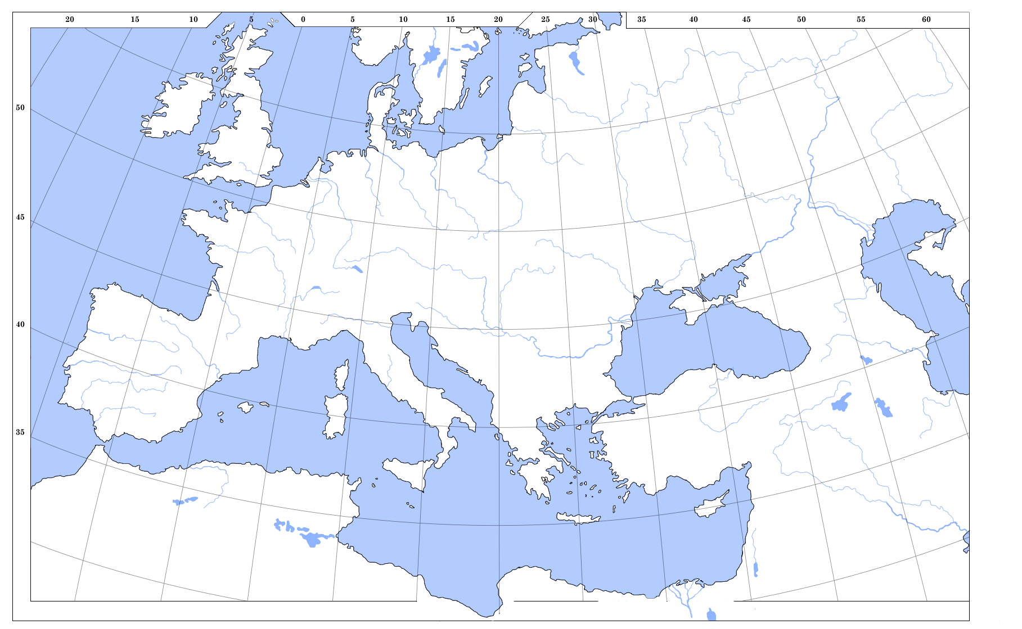
Your name:

............................................

Raw total: /66

%

