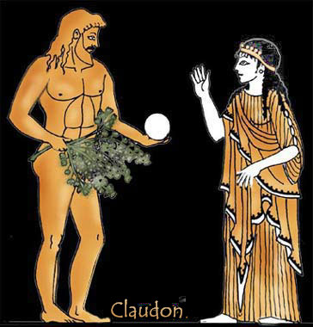
Making notes on
The Reader

richard@richardmajor.com
BISB 20i14

CHRONOLOGY OF THE READER
1922 Hanna Schmitz born
1943 Michael Berg born
early 1945 death-march; burning
autumn 1957 Michael gets hepatitis; meets Hanna
late February 1958 Michael brings Hanna flowers
spring and summer 1958 Michael and Hanna’s affair
May 1965 trial
summer 1968 student unrest (III, i); marriage
1973 divorce
1973 Michael starts sending cassettes
1983 Hanna’s suicide
1993 Michael writes his account

PART I

Chapter i
what year, what season, does this chapter take place? autumn ’57, late Feb ‘58
what happens? onset of hepatitis; vomits; rescued by Hanna; sick all winter; returns

Chapter ii
what year, what season, does this chapter take place?
what happens?

Chapter iii
what year, what season, does this chapter take place?
what happens?

Chapter iv
what year, what season, does this chapter take place?
what happens?

Chapter v
what year, what season, does this chapter take place?
what happens?

Chapter vi
what year, what season, does this chapter take place?
what happens?

Chapter vii
what year, what season, does this chapter take place?
what happens?

Chapter viii
what year, what season, does this chapter take place?
what happens?

Chapter ix
what year, what season, does this chapter take place?
what happens?

Chapter x
what year, what season, does this chapter take place?
what happens?

Chapter xi
what year, what season, does this chapter take place?
what happens?

Chapter xii
what year, what season, does this chapter take place?
what happens?

Chapter xiii
what year, what season, does this chapter take place?
what happens?

Chapter xiv
what year, what season, does this chapter take place?
what happens?

Chapter xv
what year, what season, does this chapter take place?
what happens?

Chapter xvi
what year, what season, does this chapter take place?
what happens?

Chapter xvii
what year, what season, does this chapter take place?

PART II

Chapter i
what year, what season, does this chapter take place? late summer 58 to 1965
what happens? Michael finishes school and goes to university; abortive affair with Sophie; his arrogance, coldness and sentimentality

Chapter ii
what year, what season, does this chapter take place?
what happens?

Chapter iii
what year, what season, does this chapter take place?
what happens?

Chapter iv
what year, what season, does this chapter take place?
what happens?

Chapter v
what year, what season, does this chapter take place?
what happens?

Chapter vi
what year, what season, does this chapter take place?
what happens?

Chapter vii
what year, what season, does this chapter take place?
what happens?

Chapter viii
what year, what season, does this chapter take place?
what happens?

Chapter ix
what year, what season, does this chapter take place?
what happens?

Chapter x
what year, what season, does this chapter take place?
what happens?

Chapter xi
what year, what season, does this chapter take place?
what happens?

Chapter xii
what year, what season, does this chapter take place?
what happens?

Chapter xiii
what year, what season, does this chapter take place?
what happens?

Chapter xiv
what year, what season, does this chapter take place?
what happens?

Chapter xv
what year, what season, does this chapter take place?
what happens?

Chapter xvi
what year, what season, does this chapter take place?
what happens?

Chapter xvii
what year, what season, does this chapter take place?

PART III

Chapter i
what year, what season, does this chapter take place?
what happens?

Chapter ii
what year, what season, does this chapter take place?
what happens?

Chapter iii
what year, what season, does this chapter take place?
what happens?

Chapter iv
what year, what season, does this chapter take place?
what happens?

Chapter v
what year, what season, does this chapter take place?
what happens?

Chapter vi
what year, what season, does this chapter take place?
what happens?

Chapter vii
what year, what season, does this chapter take place?
what happens?

Chapter viii
what year, what season, does this chapter take place?
what happens?

Chapter ix
what year, what season, does this chapter take place?
what happens?

Chapter x
what year, what season, does this chapter take place?
what happens?

Chapter xi
what year, what season, does this chapter take place?
what happens?

Chapter xii
what year, what season, does this chapter take place?
what happens?

