COMIC POEMS
FROM
WORLD WAR ONE

Richard Major

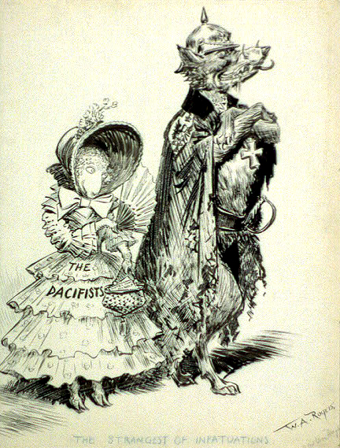

Introduction
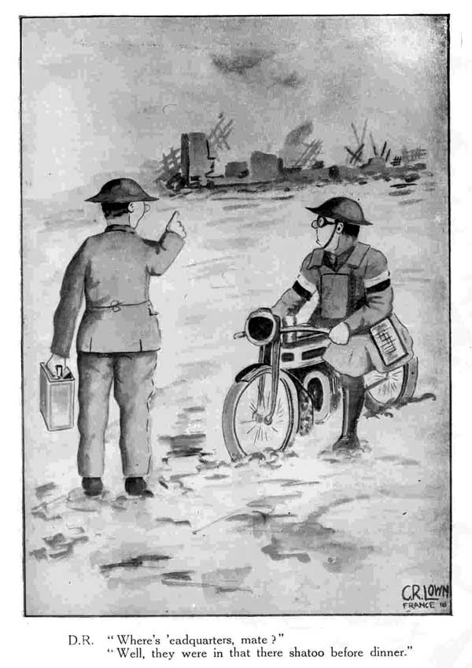
Usually we think of World War One poetry as poems of misery – poems to make people realise how horrible war is.

But there was a lighter side to verse during the Great War, and in this anthology I have gathered a dozen comic verses of that time.

They prove how resilient the human spirit is, and how resilient comedy and poetry are, even in the face of extreme horror.

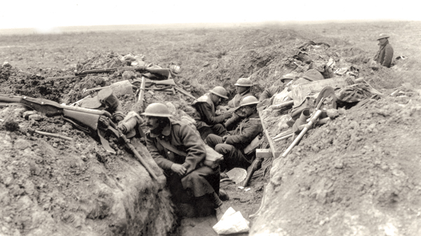

THE SOLDIER'S LETTER

I've lost my rifle and bayonet,
I've lost my pull-through too,
I've lost the socks that you sent me
That lasted the whole winter through,
I've lost the razor that shaved me,
I've lost my four-by-two,
I've lost my hold-all and now I've got damn all
Since I've lost you.

SING ME TO SLEEP

Sing me to sleep where bullets fall,
Let me forget the war and all;
Damp is my dug-out, cold my feet,
Nothing but bully and biscuits to eat.
Over the sandbags helmets you'll find
Corpses in front and corpses behind.

Chorus.

Far, far from Ypres I long to be,
Where German snipers can't get at me,
Think of me crouching where the worms creep,
Waiting for the sergeant to sing me to sleep.

Sing me to sleep in some old shed,
The rats all running around my head,
Stretched out upon my waterproof,
Dodging the raindrops through the roof,
Dreaming of home and nights in the West,
Somebody's overseas boots on my chest.

