POETS OF THE FIRST WORLD WAR
English BISB 2013
10A D3 F VII 8xi13
richard.major@bisb.hu

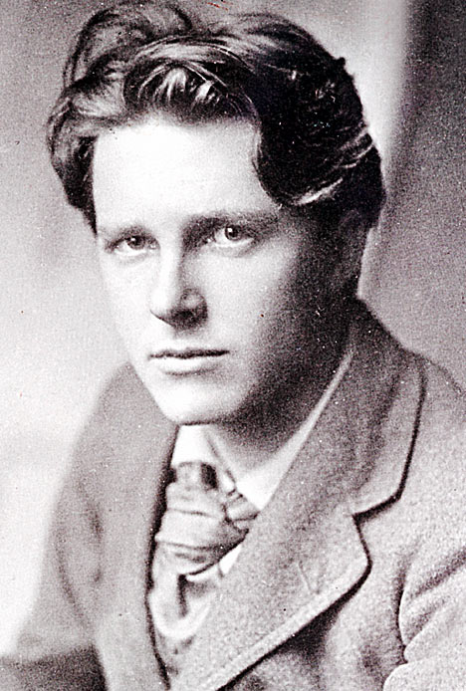
The Soldier Rupert Brooke

If I should die, think only this of me:
That there’s some corner of a foreign field
That is for ever England. There shall be
In that rich earth a richer dust concealed;
A dust whom England bore, shaped, made aware,
Gave, once, her flowers to love, her ways to roam,
A body of England’s, breathing English air,
Washed by the rivers, blest by suns of home.
And think, this heart, all evil shed away,
A pulse in the eternal mind, no less
Gives somewhere back the thoughts by England given;
Her sights and sounds; dreams happy as her day;
And laughter, learnt of friends; and gentleness,
In hearts at peace, under an English heaven.
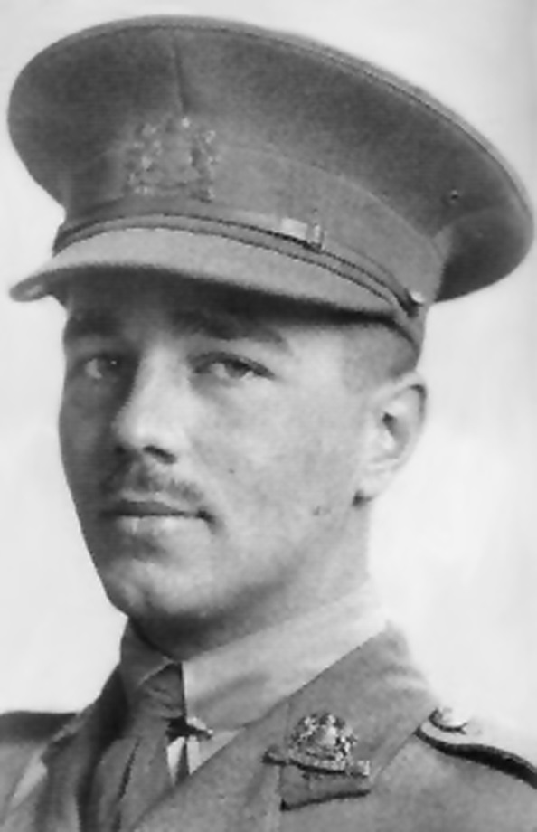

Anthem For Doomed Youth Wilfred Owen
What passing-bells for these who die as cattle?
Only the monstrous anger of the guns.
Only the stuttering rifles’ rapid rattle
Can patter out their hasty orisons.
No mockeries now for them; no prayers nor bells;
Nor any voice of mourning save the choirs,
The shrill, demented choirs of wailing shells;
And bugles calling for them from sad shires.
What candles may be held to speed them all?
Not in the hands of boys, but in their eyes
Shall shine the holy glimmers of good-byes.
The pallor of girls’ brows shall be their pall;
Their flowers the tenderness of patient minds,
And each slow dusk a drawing-down of blinds.

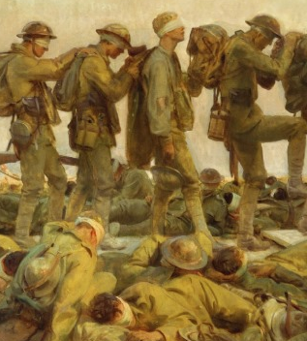
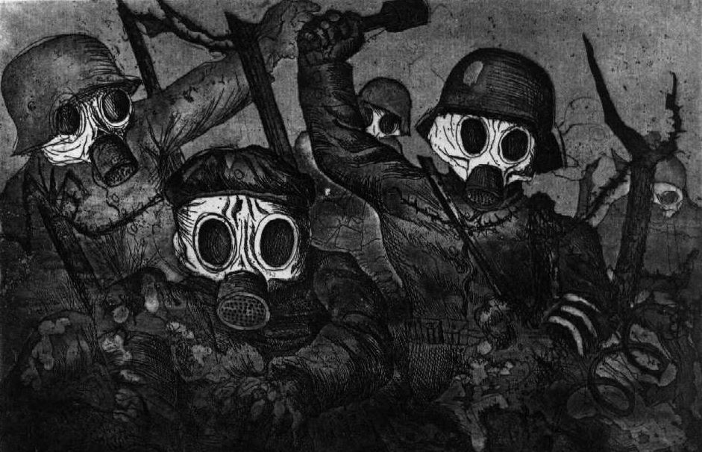
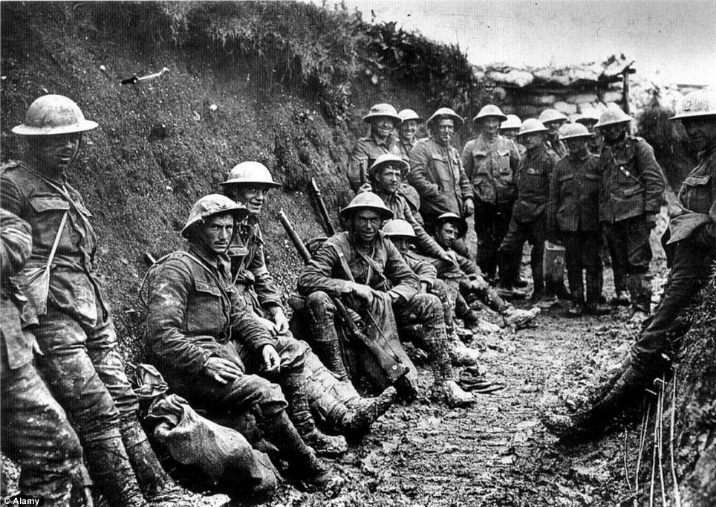
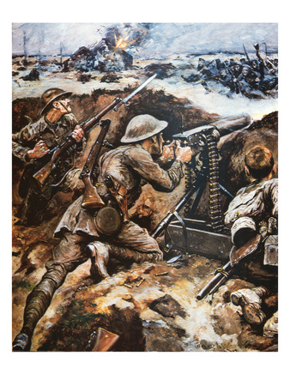

Glossary:
- patter: to make the sound of a series of quick, light taps; to speak or mumble rapidly or glibly; recite (prayers, etc.) mechanically or thoughtlessly
- orisons - a prayer.
- mockeries - a derisive, imitative action or speech: a mocking pretense or imitation; travesty; something absurdly or offensively inadequate or unfitting
- shrill: high-pitched and piercing
- bugles: a brass instrument like a small trumpet, typically without valves or keys and used for military signals.
- shires: a county, especially in England.
- pallor: an unhealthy pale appearance
- pall: a cloth spread over a coffin, hearse, or tomb.
- drawing down of binds: in some countries the blinds are ran in the house where somebody has died
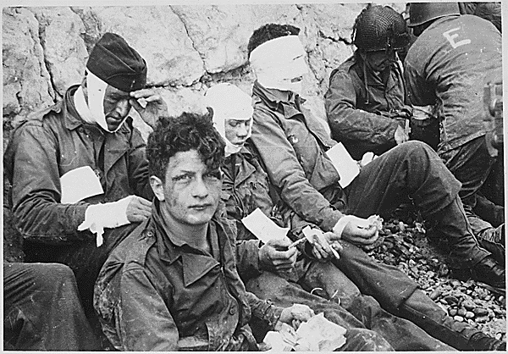

Some footage:
Regeneration ( 1997, Gillies MacKinnon),
film adaptation of the novel by Pat Barker. In this scene Owen meets his idol, Sassoon
http://www.youtube.com/watch?v=FuzRR3jVgS0

Here is the same meeting, with Sam West as Wilfred Owen, from the BBC’s
Strange Meeting (1995) http://www.youtube.com/watch?v=aEUAD9-308Q

Gas attacks http://www.youtube.com/watch?v=22w1UVGv71M

World War One in Color: Slaughter in the Trenches 19’47’’
http://www.youtube.com/watch?v=XWOrzp5KcCw
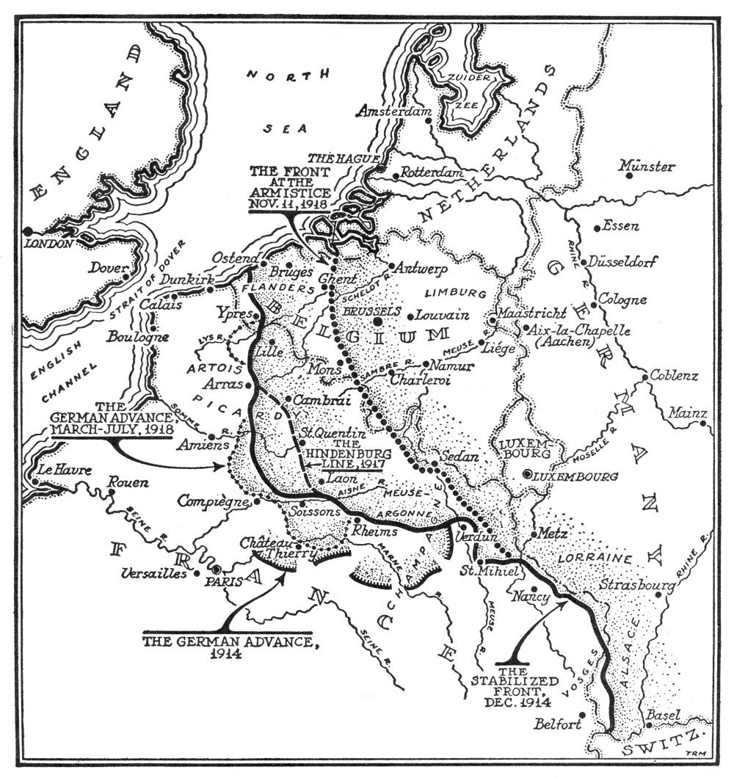

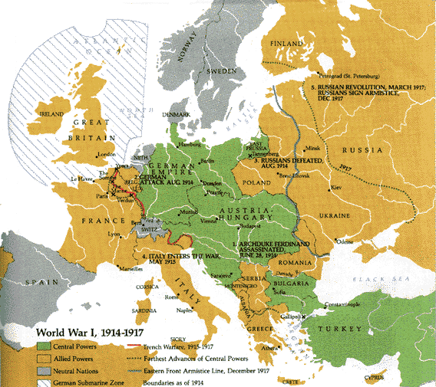
The
Western Front

Europe divided

ASSIGNMENT

Compare and contrast the poems The Soldier and Anthem for Doomed Youth.

Start like this:

What these two poems have in common is that they were both written by soldiers who died in the First World War, their main theme is death and they are both sonnets. However, the poets’ intentions could not be more different. Rupert Brook’s The Soldier is a love poem to England which he personifies as the mother of all soldiers, soldiers who should be proud to die for the mother country. Owen presents an entirely contrary view. The soldiers who die, die ‘like cattle,’ and are even denied a dignified funeral.

Now continue the essay writing paragraphs on the following topics:
Title
Voice
Tone
Word choice
Structure / Form
Imagery
Sound effects

Throughout the commentary you should think carefully about the way the poems have been written to convey meaning and ideas and you should use quotations.

Remember –

POINT

EXAMPLE
ANALYSE

Good luck

JL

