AMERICAN HISTORY SINCE 1945:
a series of lectures offered at Corvinus University, Budapest,
Monday evenings, February-April 2014,
by Richard Major

Class webpage: http://www.richardmajor.com/teaching/Corvinus/USsince1945.html
Dr Richard Major: richard@richardmajor.com

CLASS NOTES I (3 February): America before 1945

1. The phenomenon of the Americas
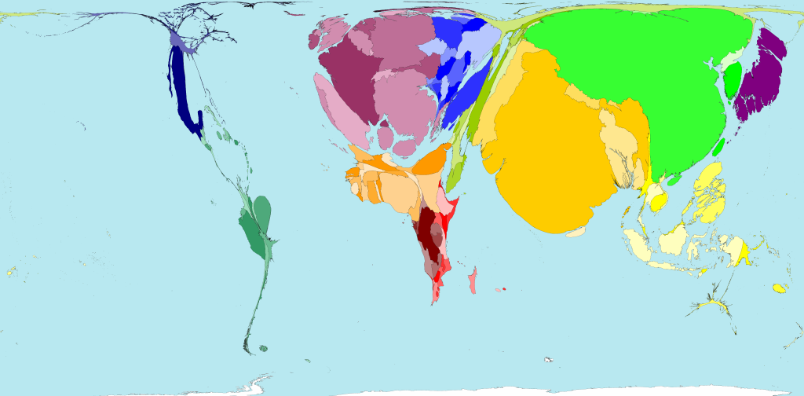
1492: the Old World discovers (accidentally) the New

1500: here is a map of global wealth (size of each territory shows its proportion of worldwide Gross Domestic Product measured in US$, equalised for purchasing power parity). As usual over the millennia, wealth and power lie almost equally with Western Europe, India and China. The New World is peripheral.

1763: the end of the colonial wars. France largely evicted from North America; the New World is now
divided between British and the Spanish –
whose heirs still compete for control!

2. The United States of America
1775-1833: wars of independence. Most of the British and Spanish colonies turn into independent republics. Most are very unstable; the United States, recognised as independent in 1783, is almost uniquely fortunate.
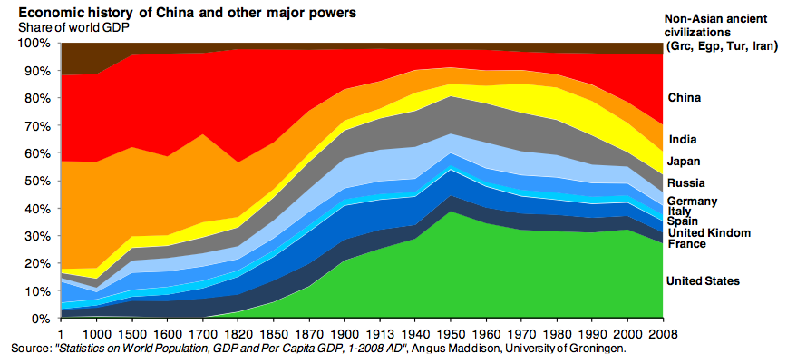
1800: The United States ends its alliance with France and embraces isolationism: no more ‘entangling alliances’, neutrality in European wars (after 1815), mercantilism, expansion to the Pacific (the Midwest purchased 1803, northern Mexico taken 1848).

1861-1865: Sectional division leads to the horrific Civil War; but afterwards

1865-1924: comes an era of prosperity, from the Gilded Age (1869-1898) to the Roaring ’Twenties. Physical splendour, industrialisation, almost perpetual economic growth, heavy immigration, westward settlement. ‘God looks after drunks, children, and the United States of America’ – which is, with its easy neighbours north and south, and its oceans east and west, virtually an island.

1898: Spanish-American War: the U.S. seizes the colonial empire of Spain (the weakest on offer) to become a Power.

1917-1919: America is reluctantly drawn into the First World War. She enjoys her easy victory (0.1 million dead, cf. 1.2 for the British Empire, 3.8 Russia, 2.5 Germany), and the war-time boom, but not the prospect of permanent ‘entanglement’ in the League of Nations. She therefore rejects the the Treaty of Versailles and retreats into isolation.

1929: The stupendous prosperity of the ’Twenties ends with the Wall Street Crash and the Great Depression. America recovers even more slowly than Europe, despite or because of economic experiments by her government.

1933-1941: International security breaks down. World War I losers (Germany, Russia, Hungary, Croatia) or discontented winners (Japan, Italy) overturn the Versailles settlement through aggressive annexations and wars.

1937: a new World War begins, first in Asia, then in Europe. Americans are desperate to avoid it. President Roosevelt (1933-45; ‘FDR’) sends economic and military aid to the Allies but, until ’40, seeks to evade war. History reaches a climax.
3. American governance

The Thirteen Colonies which revolted in 1775 formed first a loose confederation, then (in 1789) a Federal Government which tended, especially after the Civil War, to assume the authority of a traditional national state.

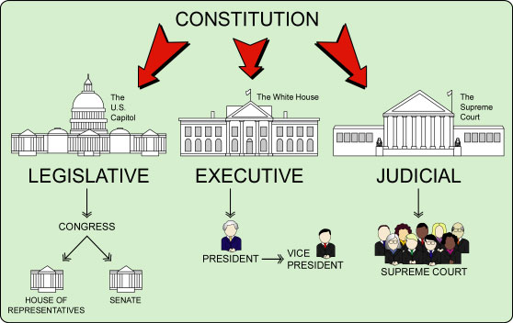
The powers and structure of the Federal Government are defined by the (ambiguous and heavily amended) Constitution of 1789.

The Constitution is essentially a republican version of the C18 British state. The Founding Fathers were anxious about the tendency of the Crown to monopolise power, so the Constitution insists on an sharp ‘separation of powers’ between the Crown (now the Executive Branch, headed by a President) and Parliament (now Congress), with an independent judiciary. In practice, the C20 Presidency has become monarchical, especially during wars, including the long Cold War.

The American party system is easily misunderstood. It is not ideological. There has been one great national party, the Jeffersonians, later known as the Democrats, who achieved power in 1800 and have held it for much of the last 214 years. The Democrats, who symbol is a donkey, are an alliance of city ‘machines’ with various other groups – often immigrants, sometimes the West, or the South, or ‘liberals’ (which in America means ‘social democrats’), or Catholics – and have promoted at various points the French Revolution, territorial expansion, slavery, free trade, and welfarism. The Democrats have been opposed by various parties – first the Federalists, then the Whigs, and since 1860 the Republicans, symbolised by an elephant, who began as a regional anti-slavery party, and have often (before the 1890s, after the 1970s) been in favour of small, efficient government. But both donkey and elephant ‘parties’ are ungainly shifting coalitions – now as in 1941!

4. The end of isolationism and World War II
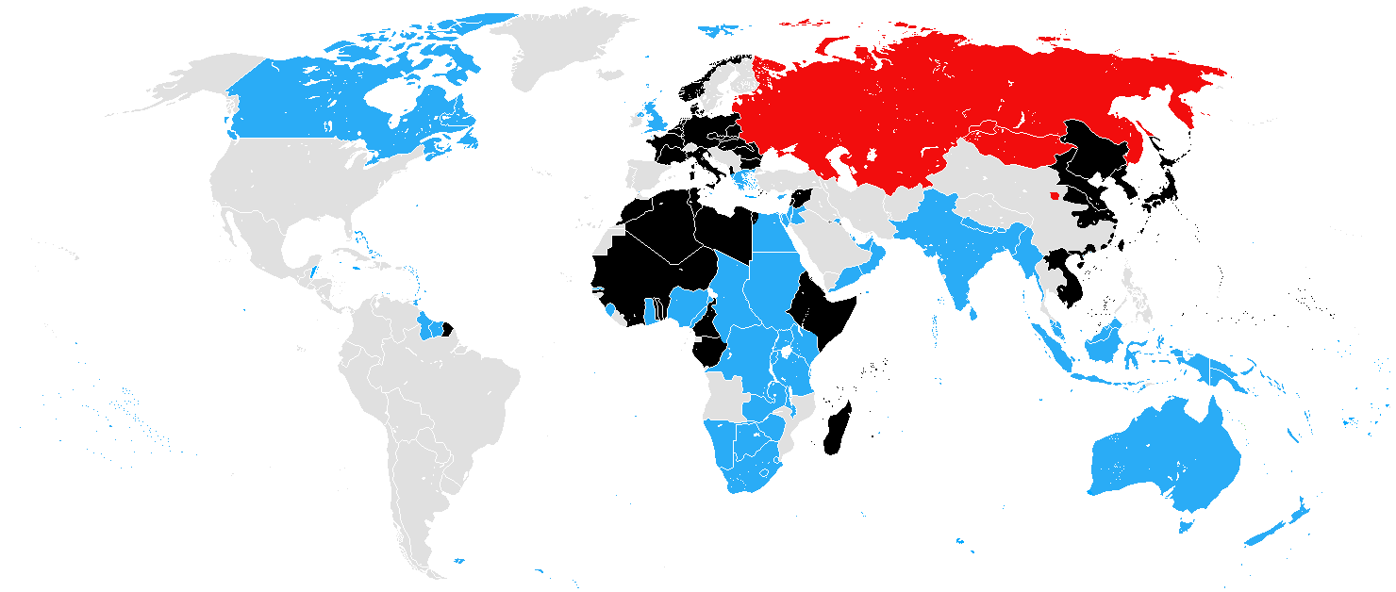
1941: here is the situation on New Year’s Day. The Axis is marked in black: Japan holds most of East Asia; Germany, Italy and their partners (Hungary, Rumania, Bulgaria, Vichy France) hold Europe in alliance with the Soviet Union (red). The surviving Allies (blue) are the British Empire, Greece, and certain French and Dutch colonies. The New World is neutral.
This year is the hinge of modern history. The Axis attacks Stalin in June. In autumn a naval war between America and Germany begins in the Atlantic; then on 7 December the Japanese attack the British, Dutch and U.S. colonies in the Pacific.
Thus by Christmas America finds herself at war with the Axis, in alliance with the British Empire and Communist Russia.

1941-45: Allied victory in both Europe and Asia. America has another comparatively cheap win (losing 0.4 million, or a third of a percent of her 1939 population; cf. 17% Poland, 14% Soviet Union, 11% Germany, 3% whole world). She enjoys a wartime boom; alone of the great Powers she is unbombed; her armies occupy Western Europe and Japan; she ends the war enormously prosperous. Roosevelt has a rather naïve enthusiasm for Stalin, and for decolonisation in the post-war world. But he dies in April 1945, just before Hitler, and history takes a different turn.

5. The American political hegemony and the start of the Cold War

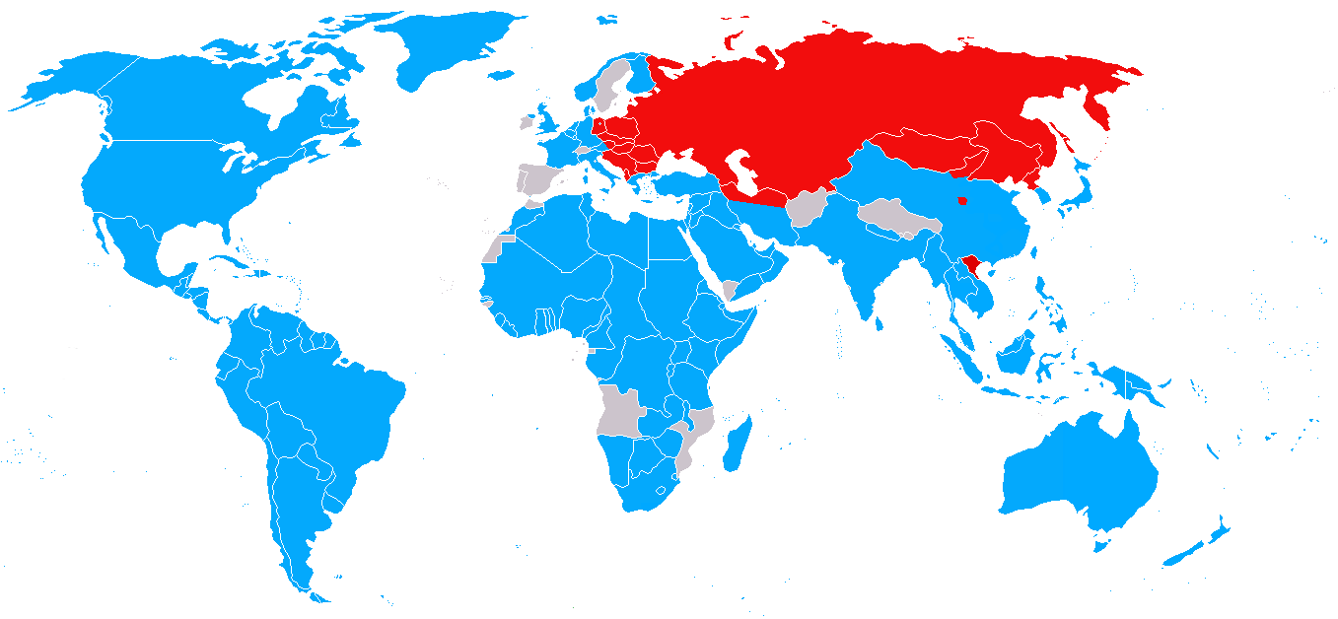
1945: Here is the situation in September, after Japan had surrendered and been occupied. America and the Allies, in blue, hold most of the world, in alliance with Stalin’s empire.

1946: George Kennan’s ‘Long Telegram’; Churchill’s ‘Iron Curtain’ speech; Byrnes, the Secretary of State, announces that American troops will stay in Europe indefinitely and that Germany will not after all be ‘pastoralised’.

1947: The Truman Doctrine: acrtive containment of Communism (President Truman promises “to support free people who are resisting attempted subjugation by armed minorities or by outside pressures”). The Cold War. Militarisation of the American economy.

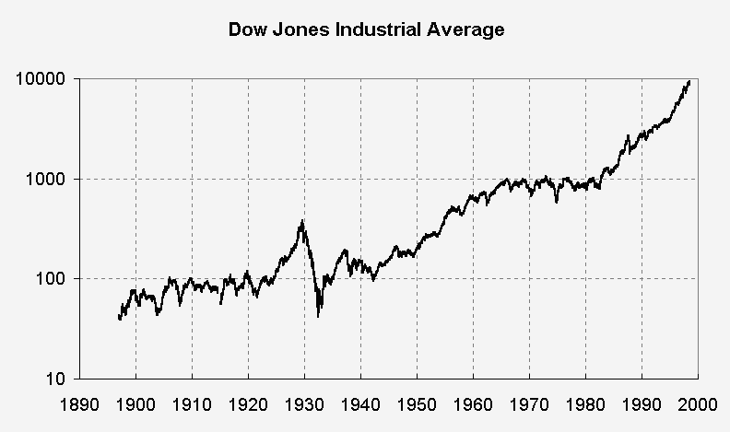
6. The American economic hegemony

1945: For a few heady months, America accounts for most of the world’s GDP! Everywhere else is in ruins.

1948: the Marshall Plan: American-style prosperity is exported to Europe.

1947-1966: European colonial empires dissolved. America and the Soviets vie for domination of the newly independent states.

1960: here is how GDP was distributed in 1960. But note the stagnation in the Dow Jones from 1967 onward!

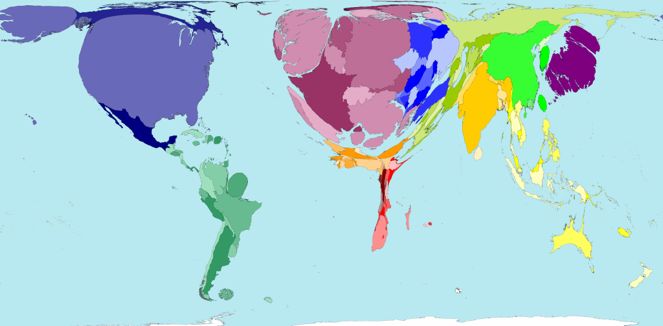 RJCM 01ii14

