AMERICAN HISTORY SINCE 1945:
a series of lectures offered at Corvinus University, Budapest,
Monday evenings, February-April 2014,
by Richard Major

Class webpage: http://www.richardmajor.com/teaching/Corvinus/USsince1945.html
Dr Richard Major: richard@richardmajor.com
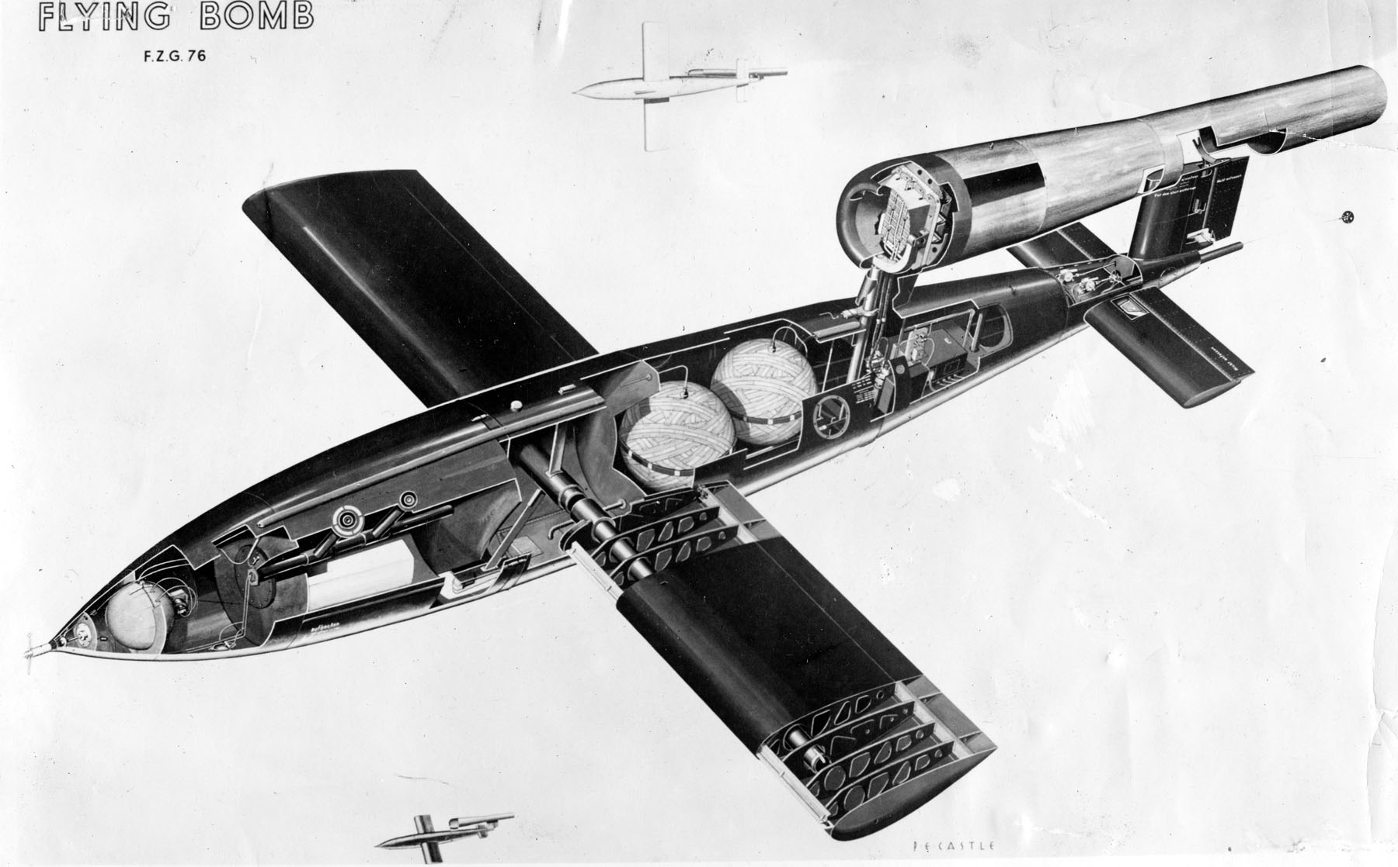
CLASS NOTES V (3 March):
America vs. the Soviets: the Cold War and the space race

1. Science changes the nature of war, and thus changes human nature
Two inventions popped up in the 1940s: missiles and nuclear bombs
¶ How to destroy your enemy, when the balance after 1941 tipped toward air defence (radar) over bombers?
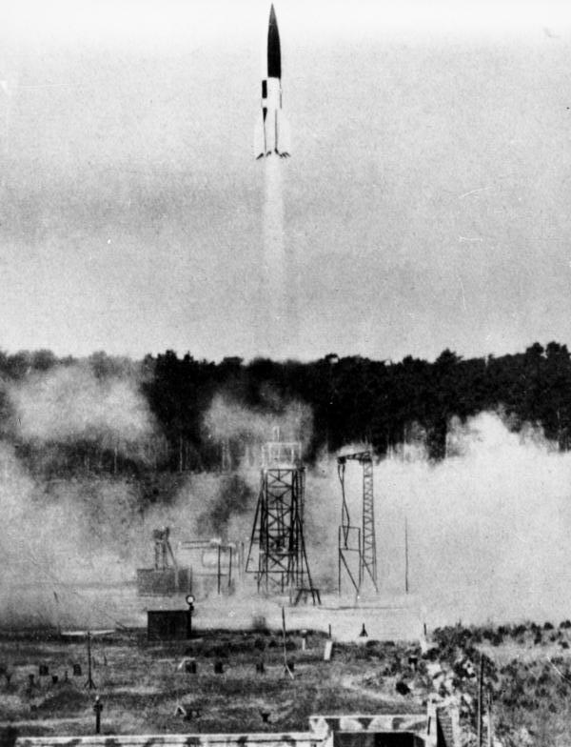
¶ The Germans led the way, developing the cheap and effective V1 or flying bomb (ight): this delivered a ton of high explosive and damaged 20,000 houses in London every day in July 1944. The came the large, expensive, spectacular and V2, the world’s first long-distance ballistic missile, which could reach space (it went 128 miles up) and deliver 12,000lbs of explosive (creating a crater 20m wide, 8m deep, throwing up 3,000 tons of material).
¶ But the V2 was hopelessly inaccurate, not worth what it cost. What was needed was a more destructive payload, and this duly came along, almost in time to win the war for the Germans.
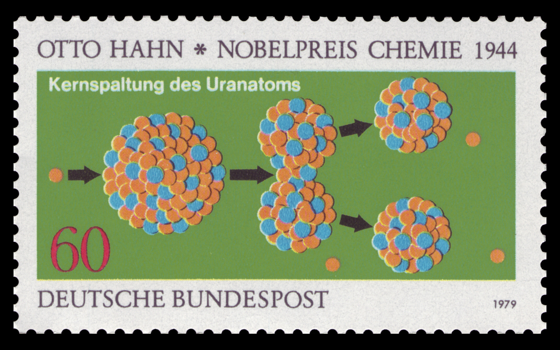
¶ In 1932 an atom was split, releasing 2 million electron volts. In 1939 a chain reaction was achieved – one split atom produced many more. The race was on, led by Hahn in Germany. But it was won by Jewish refugees. They made the A-bomb for the Americans (1945) lest Hitler get it; then they (Fermi of Italy, Edward Teller and Leó Szilárd of Hungary) made the H-bomb for the Americans (1952), lest Stalin get one first
¶ But it was the same community of scientists who betrayed the A-bomb (1949) and then the thermonuclear or H-bomb (1953) to the Soviets!
¶ From 1957, ICBMs (intercontinental ballistic missiles): America’s huge predominance in planes and warheads was cancelled out.
2. The nature of nuclear confrontation
¶ The Americans and the Soviets stockpiled nuclear weapons: the Americans built over 70,000 warheads.
¶ Smaller powers got the Bomb: UK (1952), France (’60), China (’64), India (’74), Israel (’79?), Pakistan (’98), North Korea (2006)
¶ For most of our period, nuclear war was impractical, because a country that suffered a massive nuclear attack (the first strike) could, although ruined, still destroy its attacker (in a second strike). Thus there was Mutually Assured Destruction (MAD).
¶ Nuclear instability sets in only when it seems possible to destroy a foe so utterly there can be no second strike. Nuclear war could thus be won; and might therefore happen. Submarine-based missiles caused this problem and eventually solved it.
¶ Thus nuclear war has hardly ever made military sense; and has not happened
¶ Nonetheless, the possibility of inadvertent war is appalling. Here’s FEMA’s map of what a Russian attack would do to the U.S.
¶ In the background of postwar American prosperity and self-congratulation was naked terror. Hiroshima (2'01'' to 3'03'') had changed the nature of human existence. Nuclear weapons meant that national destruction, and perhaps the annihilation of the human race, were constant possibilities. Watch this chilling and beautiful installation by Isao Hashimoto, tracking nuclear explosions since 1945; a video of the first Soviet H-bomb in 1953; and of the Tsar Bomba. I find Tsar Bomba a particularly beautiful thing to contemplate: see these maps.

3. The alternative to thermonuclear war: the Cold War, or war by proxy
In the background of America’s tremendous prosperity she waged a long subdued war with the Soviets:
¶ The resumed Chinese Civil War (January 1946-October 1949) ended with Mao’s victory: a quarter of the human race passed into the Communist camp. The Nationalist Chinese establish themselves on Taiwan
¶ October 1949: the West wins the Greek Civil War
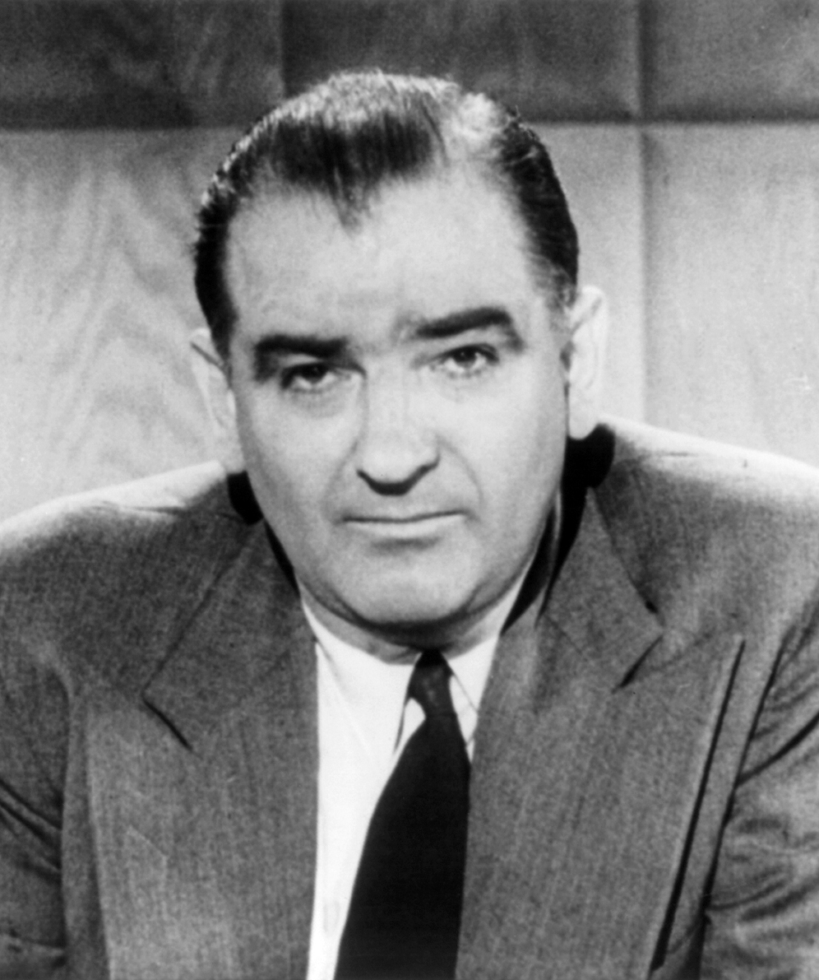
¶ June 1950: North Koreans invades the South. The ‘U.N.’ – America and her allies – drives them back almost to the Chinese frontier; Mao intervenes. Korean War ends in July 1953 in a draw.
¶ March 1953: Stalin dies horribly; a power struggle ends with Khrushchev in control and ‘de-Stalinization’, and eventually the split with China. The kitchen debate (July 1959; 0’52”).
¶ 1950-1956 the Second Red Scare in America (the first was in 1919). Congressional investigation, sometimes rational, often hysterical and unjust, for hidden Communist agents. Associated with Senator Joseph McCarthy, until he was condemned by the Senate (December 1954) for “conduct that tends to bring the Senate into dishonour and disrepute”. Hollywood was a particular target (to 10’02”).
¶ 1955: Americans take over from French in Indochina
¶ August 1961: Berlin Wall suddenly built. Half Europe becomes a prison camp.
¶ October 1962: Cuban Missile Crisis: a serious brush with world war
¶ 1966-1968: the Vietnam War escalates until Johnson is rejected by the war-weary electorate
¶ From the mid-Sixties, the Soviets begin sucking up newly ‘independent’ Third World ‘states’
¶ April 1975: Indochina falls. America seems to have lost the Cold War globally.

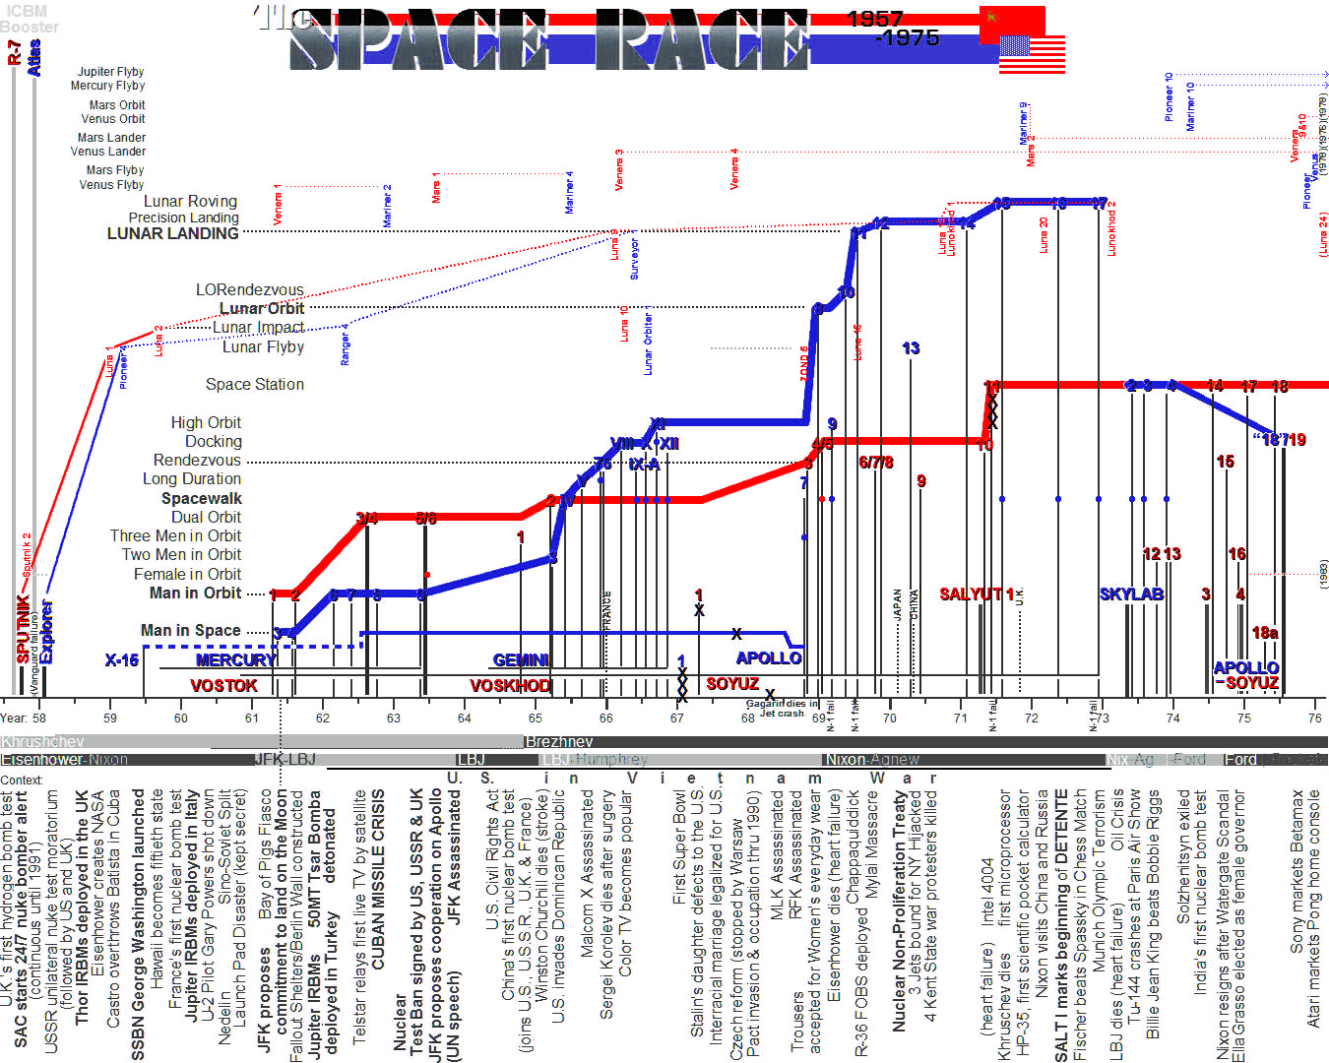
4. The other thing with rockets
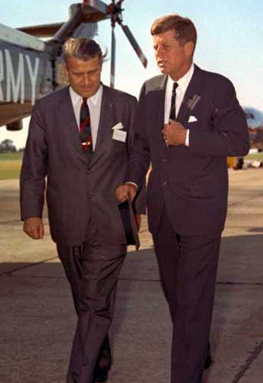
Here’s President Kennedy, who made the Moon an American Cold War ambition, with Wernher, Freiherr von Braun, Prussian aristocrat, scientist, member of the Nazi Party and the S.S., outer space enthusiast and inventor of the V2 (“The rocket worked perfectly except for landing on the wrong planet”). Von Braun taken back to America after the war as loot, and ran NASA.
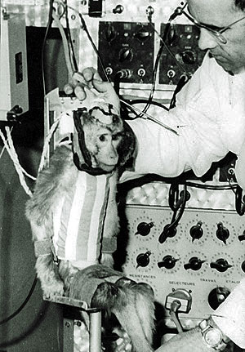
And here’s one of Von Braun’s little helpers, in succession to the slave labour used for the Nazi V2: Albert II, a rhesus monkey who was the first primate in space in 1949, flying on a V2 and dying after a parachute failure.

5. Cinema of the Cold War
Last week we look at how Hollywood pictured the golden age of capitalism.
But film also reflected the other side of post-war American history: global rivalry with Communism and the atomic peril. Here are some of those films.

