AMERICAN HISTORY SINCE 1945:
a series of lectures offered at Corvinus University, Budapest,
Monday evenings, February-April 2014,
by Richard Major

Class webpage: http://www.richardmajor.com/teaching/Corvinus/USsince1945.html
Dr Richard Major: richard@richardmajor.com

CLASS NOTES X/i (7 April):
A clash of civilisations? 2001-2014

I. THE THEME OF OLD WORLD HISTORY
Americans think of 1492 as virtually the beginning of history, when it was in fact the climax.
On 2 January Granada, the last Muslim kingdom in Western Europe, fell. The Reconquista of Iberia was consummated after 780 years of warfare. Christopher Columbus watched the last Emir, Muhammed XIII, emerge from the city to kiss the hands of King Ferdinand and Queen Isabella in surrender. The result was Spain – not an ancient kingdom but a nationalist state, based on an official ideology and historiography, intolerant of minorities.
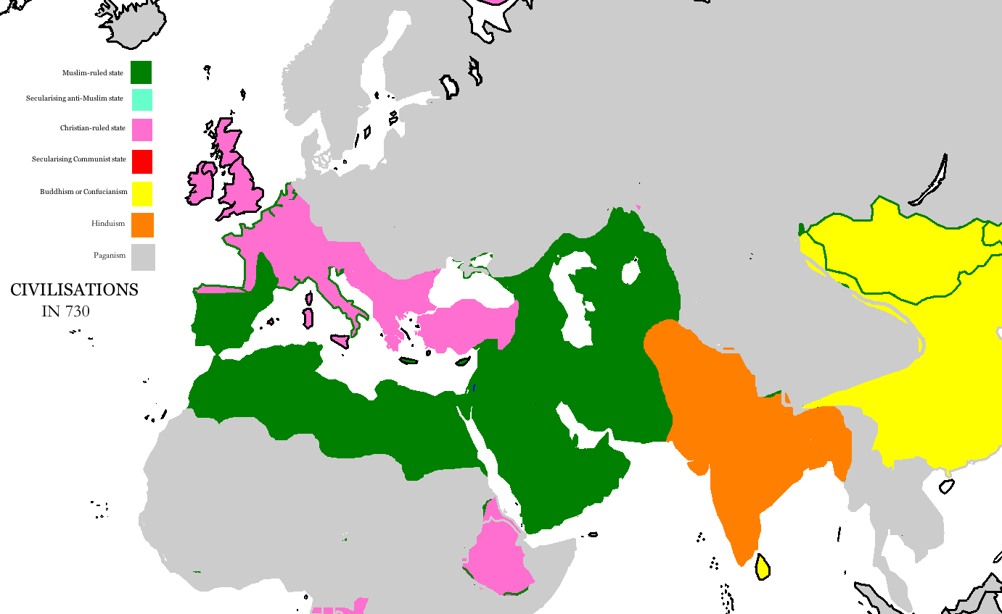
On 3 August Columbus sailed for Japan, which he had persuaded Isabella lay only a few days west of Portugal – an eccentric opinion. He made landfall on 12 October. For the rest of his life he maintained he’d got to the East Indies. In fact, Japan is as far off as everyone thought; he had, instead, bumped into the New World.
Thus European America came into existence a few months after Western Europe freed itself of Asia. The greatest theme of European civilisation for over a millennium – the long war between Christian and Islamic civilisation – was to make no direct impression on the history of the Americas.
The long war had begun in the early seventh century, when newly-invented Islam poured out of Arabia to besiege Christendom from the south and the east. Islam was checked at the Battle of Tours (732), which saved France. My first map shows the situation: the West is recovering; the Reconquista is beginning.
II. THE ECLIPSE OF ISLAM
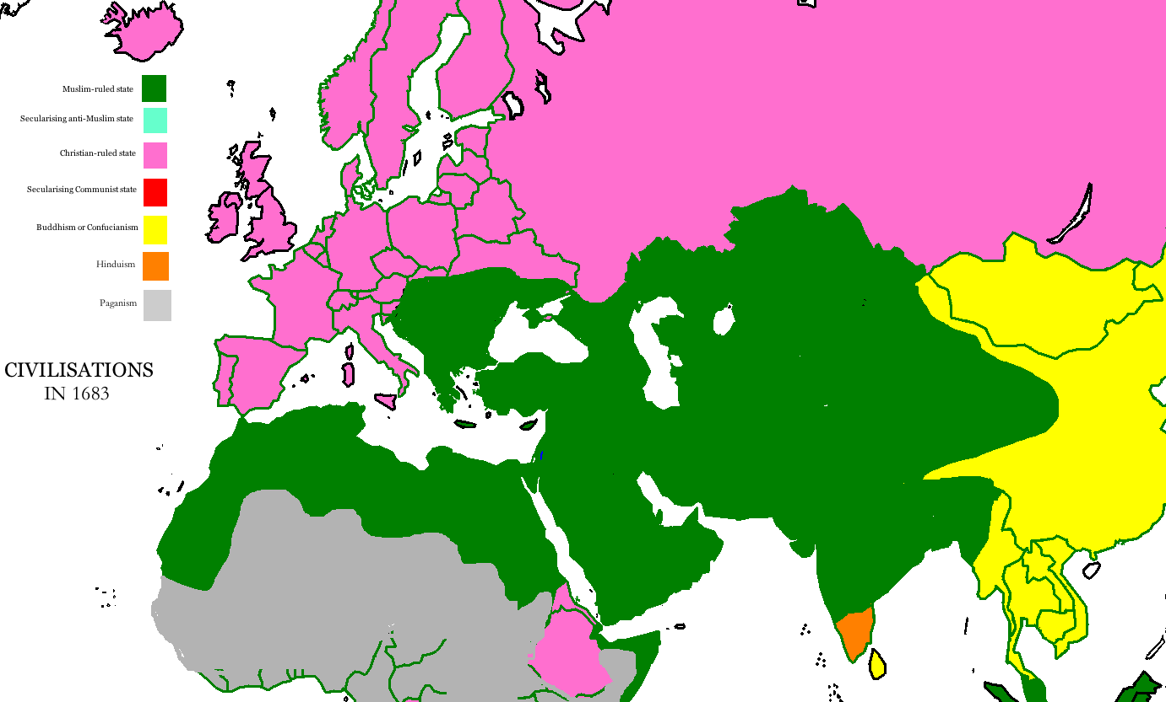
The Crusades of the eleventh to thirteenth centuries were counter-attacks in the east; they failed, and although, pushing south, Christianity reconquered Iberia by the end of the fifteenth, Islam, having wiped out Byzantium, launched a fresh assault in Central Europe.
In 1683 the Turks nearly took Vienna and nearly broke into Germany. My second map shows that moment, with the Ottoman and Mogul empires (and Morocco and the Asian khanates) dominating most of the civilised world.
The Turks failed at the gates of Vienna, and three centuries of political decline began for the Islamic powers.
The Ottoman Sultanate was destroyed in the First World War – see the poster below. The caliphate, or religious leadership of all Islam, had been vested in the Ottoman Sultan, and it was suppressed soon afterward. The French and British and Italians were now colonial masters of most of the Muslim world, and even where they were resisted, the rulers of Turkey, Persia and Afghanistan were enemies of the ‘backward’ Islamic faith.
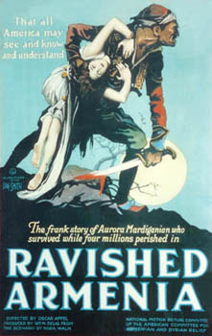
My third map shows the apparent irrelevance of Islam at the start of our period.
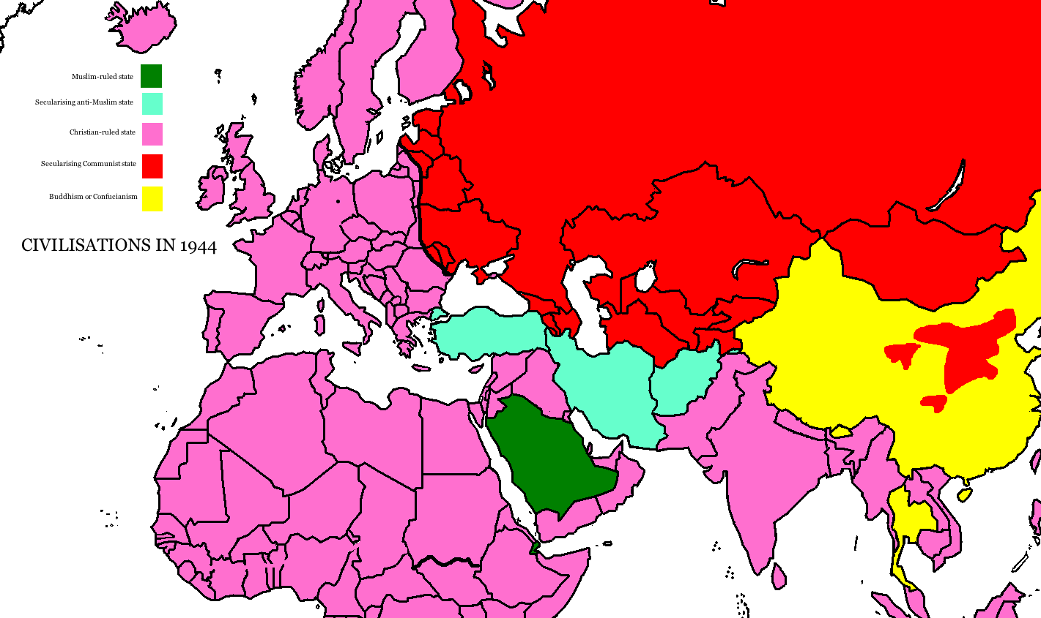
The revival of Islam, beginning in the 1970s, was partly a function of decolonisation: as the European powers withdrew, small Islamic came into existence, first kingdoms, then republics, then, on the whole, military dictatorships.
But it was also part of the general revival of faith, Christian and Hindu as well as Muslim, that was a theme of world history from the ’Seventies onward.

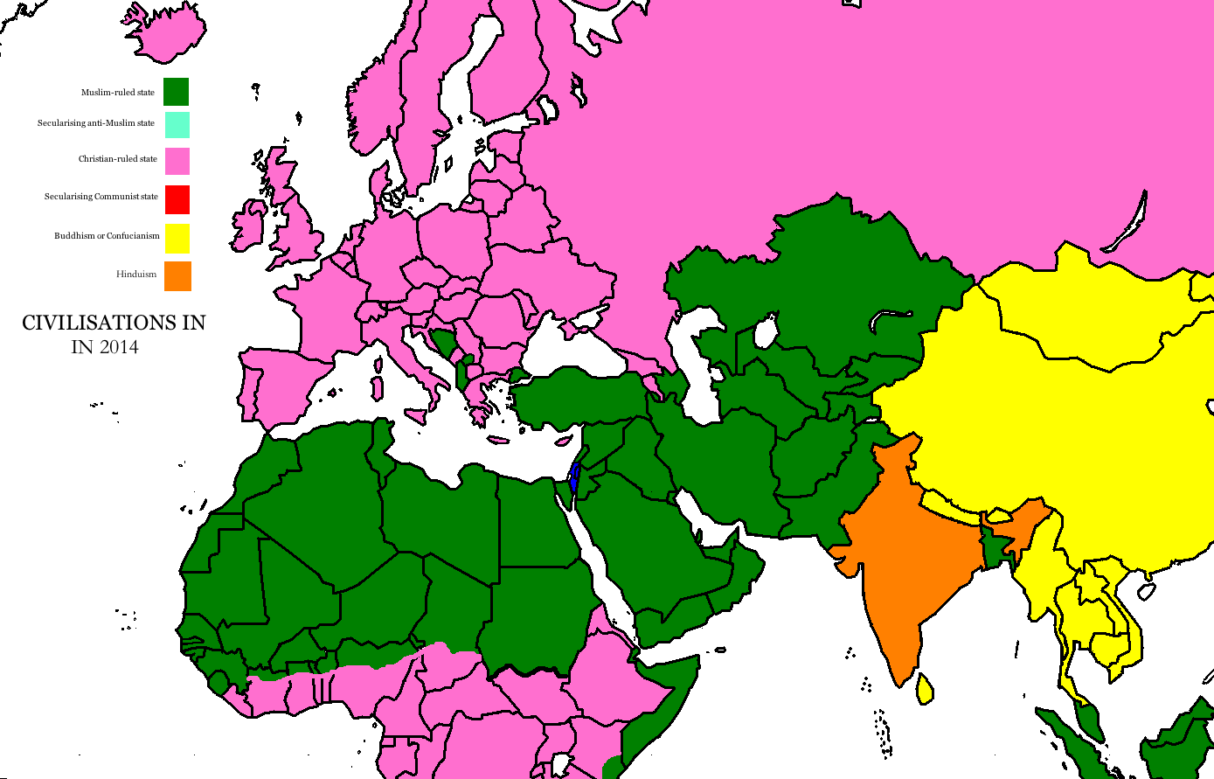
III. THE ISLAMIC REVIVAL
My fourth map shows the present situation.
Now, as in the eighth century, Islamic states block in Europe to the east and south.
There are three big differences in the global situation, though.
One is that European exploration, going round the Islamic Maghreb, has almost finished Christianising Africa. It is now not Christendom but Islam that feels besieged. The Christian impetus, going north, is colliding with Islamic conversion, pushing south. The last pagan territory is being wiped out. There is a violent religious front between Islam and Christianity: the wars going on now in Mali, Chad, the Central African Republic and the two Sudans are all essentially religious wars.
The second big difference is that, although Europe is in no military danger, it is in profound demographic danger. Europeans are very slowly dying out because the birthrate is so low; cheap Muslim labour has to be imported, from ex-French North Africa, ex-British South Asia, and the Near East. These immigrants do not convert, and are not always socially assimilated.
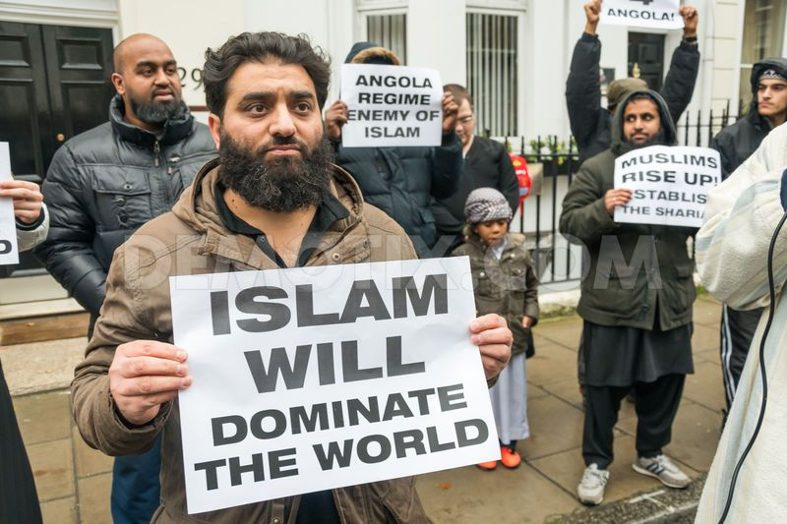
The third complication is Zionism, the movement to migrate to Palestine and revive the Jewish state that vanished in A.D. 70. The British at first encouraged (1917), then try to halt, Jewish migration to Palestine, which they ruled until 1948. When the British left, a Jewish-Arab war led to the creation of Israel, in the heart of Islam. After 1967 Israel occupied the Old City of Jerusalem, sacred to Islam and Christianity. It was nuclear-armed from about 1970. It was viable only because of the enthusiastic financial, political and military support of the United States.
Since 1948 there has been almost constant violence in the region: big wars in 1967 (Israeli conquest of the Occupied Territories) and 1973 (a brush with World War III); invasions of Lebanon in 1982 and 2006; Intifada risings in the Occupied Territories 1987-1993 and 2000-2005; Gaza Wars in 2008–2009 and 2012. The United States has not always supported Zionism’s wars, but actual condemnation of Israel remains taboo in American politics.

IV. THE AGE OF RENEWED RELIGIOUS WAR
The late twentieth century saw religiously-charged wars within Islam, and all round the edge of the Muslim world.
Internally, Islam is divided into two factions, the Shi’ites (who rule in Iran and Iraq, and dominated Syria until the civil war), and Sunnis (dominant almost everywhere else). Extreme Sunnis – such as the Wahhabi sect, which rules in Saudi Arabia – and el-Qaeda, do not recognise the Shi’a as Muslims, and sometimes think it right to kill them. Anti-Wahhabis seized the Kaaba in Mecca in 1979, and had to be overcome by French commandoes. There was a Shi’ite rising in Mecca in 1987 that killed 400. And so it goes on. The Iraq-Iran War was represented as a Sunni struggle against resurgent Shi’a.
In the east, the British Raj was partitioned in 1947 on religious lines. Hindu India and Muslim Pakistan went to war at once, and have fought in 1965, 1971 and 1999. Both have nuclear bombs. America has traditionally ‘tilted’ toward supporting Pakistan, partly because India was aligned with the Soviet Union (against China).
In Europe, the dissolution of Yugoslavia in the 1990s led to wars between the Bosniaks and Albanians – Europeans converted to Islam in Ottoman days – and the Christian Serbs and Croats. NATO, including the U.S., intervened in 1995 and 1999 on the Islamic side.
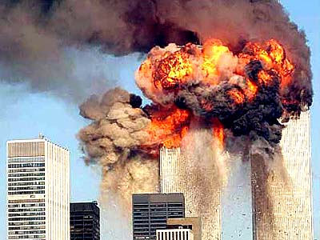
Afghanistan, on the edge of what was then the Soviet empire, was invaded in 1979 and finally, with a great deal of American hardware, drove the Russians out in 1988. It then fell into the hands of jihadists, Muslim fundamentalists (often Arabs from far away) who wanted to create Islamicist states throughout the world. A particularly radical organisation known as the Taliban ruled most of Afghanistan, and gave shelter to an international Islamicist terrorist group known as el-Qaeda, run by Osama bin Laden, the Western-educated son of a Saudi billionaire.
That was the situation on 11 September 2001.

V. THE GOLDEN AGE OF TERRORISM
is extreme violence used randomly against the public as a political tool of intimidation. Because terrorism defies all law and all rules of war, it has tended to be the preserve of extremist groups, or of ‘rogue’ regimes.
There was a wave of Anarchist terrorism around 1900, but the golden age only began in July 1946, when the Zionist terrorist organisation Irgun (later called Likud; it came to power in 1977 and has dominated Israeli politics ever since) blew up the King David Hotel in Jerusalem, killing 91.
The practice increased throughout the 1970s, when hijacking was at its peak. Sometimes the perpetrators were secular nationalists (Sikh, Tamil, Fenian, Palestinian, Basque). But because the most effective means is suicide bombing, with the murderer triggering the bomb at zero range, it is commonest with religious groups, most of all Islamicists, who are promised eternal rewards.
El-Qaeda, blaming the “tyranny of the American-Israeli alliance against our people in Palestine and Lebanon” for the suffering of Islam, and the carnage of 1982 especially, hijacked four planes. On one plane the passengers resisted; it crashed in a field. Another was flown into the Pentagon in Washington, headquarters of the Department of Defense; the other two hit the Twin Towers, the tallest buildings in New York. Almost 3000 people were killed, and the United States found itself unwillingly folded into the large and protracted history I have tried to sketch in these notes. RJCM 31iii14

