AMERICAN HISTORY SINCE 1945:
a series of lectures offered at Corvinus University, Budapest,
Monday evenings, February-April 2014,
by Richard Major

Class webpage: http://www.richardmajor.com/teaching/Corvinus/USsince1945.html
Dr Richard Major: richard@richardmajor.com

CLASS NOTES X/ii (7 April):
A clash of civilisations? 2001-2014

OVERVIEW
• The Americas were discovered a few months after Western Europe crushed its last Muslim state;
• since 1492, Europe has generally been on the offensive against Islam
• but this long war did not much affect the New World
• until in September 2001 America found itself folded back into the great Islamic theme of world history
(Muslim versus Christian civilisation; Sunni versus Shi’a; secular versus religious; and Arab versus Zionist)

MEANWHILE, IN DOMESTIC POLITICS:
2005 August Hurricane Katrina strikes the Gulf Coast region: 1,833 killed, $108 billion damage (in 2005 dollars); Bush condemned
2006 November Democrats regain Congress; Bush increasingly unpopular
2007 summer housing bubble bursts (‘subprime mortgages’), leading to the Global Financial Crisis
2008 September failure of Lehmann Brothers; “capitalism totters”; the Great Recession
2008 November Senator Barack Obama, who had voted against the Iraq War, wins 53% of the popular vote:
the biggest Democratic share in half a century.
2010 March ‘Obamacare’: health care reform. America spends $8,608 per capita, 17.2% of its GDP, on healthcare,
more than any other nation (2011; Hungary spends 7.9%, Britain 9.4%).
Obamacare ended the strictly private nature of this extraordinary expense.
2010 November Republicans regain House; cause government shutdown of October 2013
2011 March NATO – the U.S. grudgingly – intervenes in Libyan Civil War (under terms of Security Council Resolution 1973)
2013 June Supreme Court strikes down (5-4) the Defense of Marriage Act

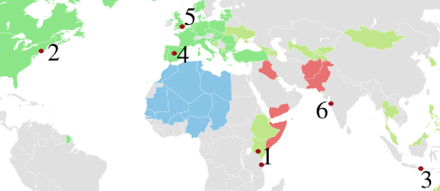
VI. THE WAR ON TERROR
Al-Qaeda was founded in 1989 in Pakistan, an outgrowth of the war against the Soviets in Afghanistan. Its aim is to war against infidels (non-Muslims and Shi’a) and found a Wahhabi caliphate. It is well-funded, loosely-connected, and astute (62% of members are university educated). Al-Qaeda and its allies have managed a remarkable run of mass murder:
1998 August An affiliate, the Egyptian Islamic Jihad, bombs the U.S. embassies in Nairobi and Dar es Salaam; 224 killed
2000 October Al-Qaeda hits U.S.S. Cole: 17 dead
2001 September 11 The “9/11” attacks kill 2,996 in D.C., New York and Pennsylvania
2002 October 12 Al-Qaeda kills 202 with a bomb at a tourist spot in Bali
2004 March 11 Al-Qaeda kills 191 with four bombs on commuter trains in Madrid
2005 July 7 Al-Qaeda kills 56 in four suicide bombs on trains and buses in London
2008 November Lashkar-e-Taiba kills 164 in a three day rampage through Bombay

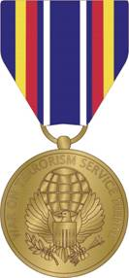
These attacks lead to what Bush proclaimed (20 September 2001) as the Bush Doctrine of preventative war, and a Global War on Terror (or GWOT; the Obama administration prefers to say “Overseas Contingency Operation”; some people say World War IV, counting the Cold War as World War III). The U.S. military still awards the Global War on Terrorism Service Medal (GWOTSM), left. The green and blue areas are active allies in GWOT; the red areas, Afghanistan, Pakistan, Iraq, Yemen and Somalia, indicate wars.

At home, this meant, among other things:
2001 September 14 Congress passes (420-1 in House, 98-0 in Senate) The Authorization for Use of Military Force Against Terrorists (AUMF) authorising the President to “use all necessary and appropriate force against those nations, organizations, or persons he determines planned, authorized, committed, or aided” 9/11 “to prevent any future acts of international terrorism against the United States”.
2001 October The USA PATRIOT Act (Uniting and Strengthening America by Providing Appropriate Tools Required to Intercept and Obstruct Terrorism), authorising indefinite detentions of immigrants, widened searches, FBI taps and without a court order, &c. The courts have struck some of this down as unconstitutional.
November 2002 The Department of Homeland Security formed, placing the U.S. government in permanent anti-terrorist mode.
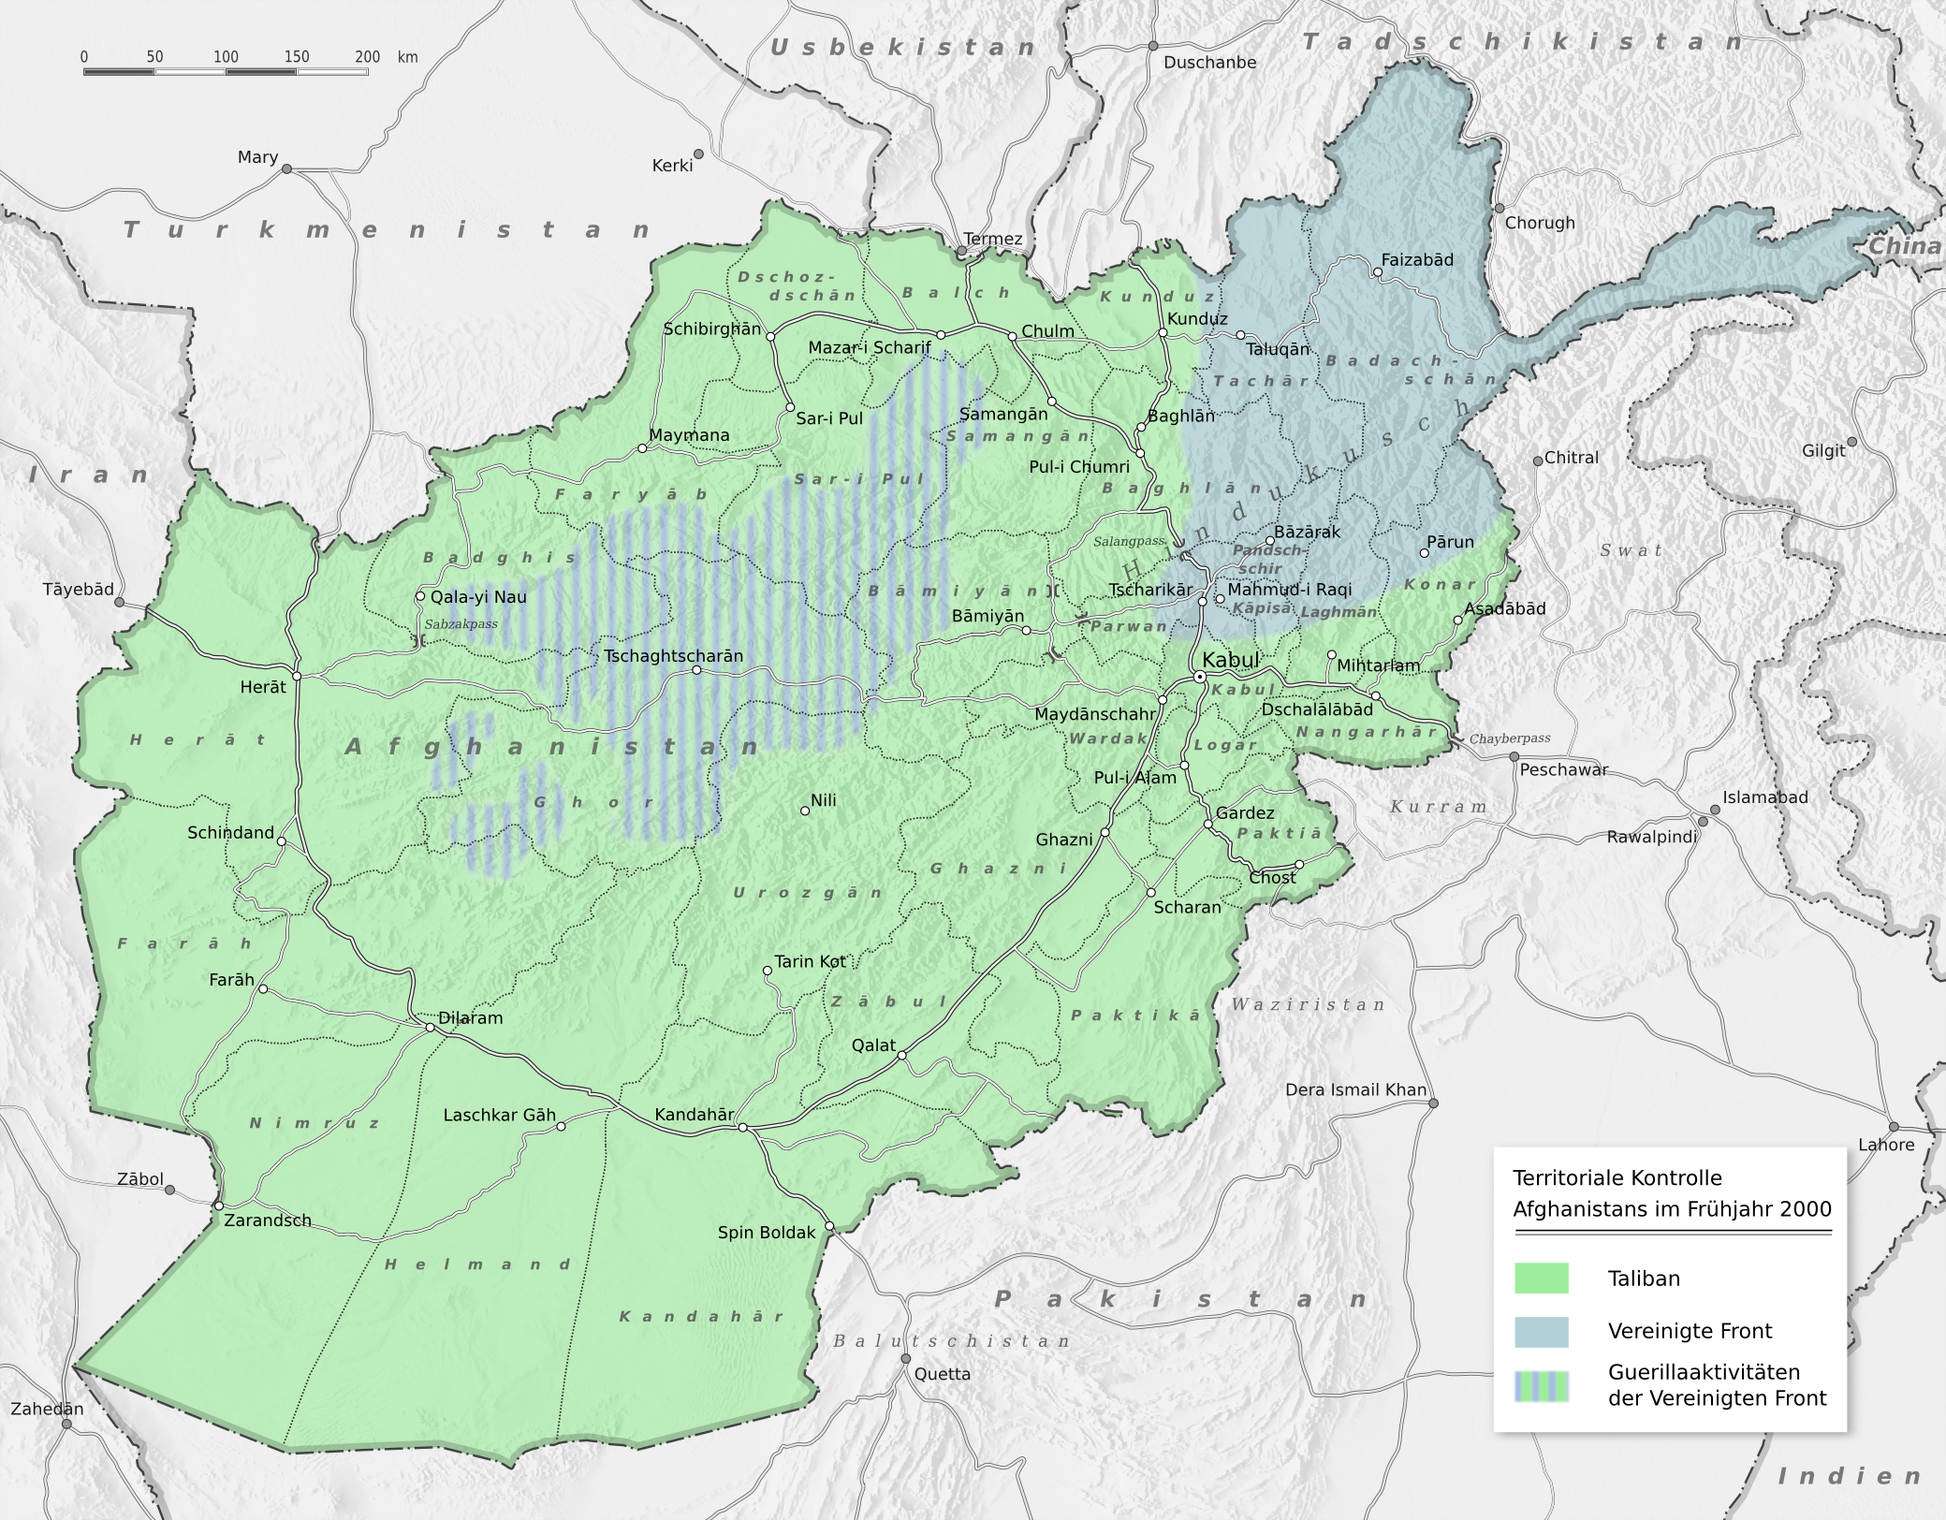
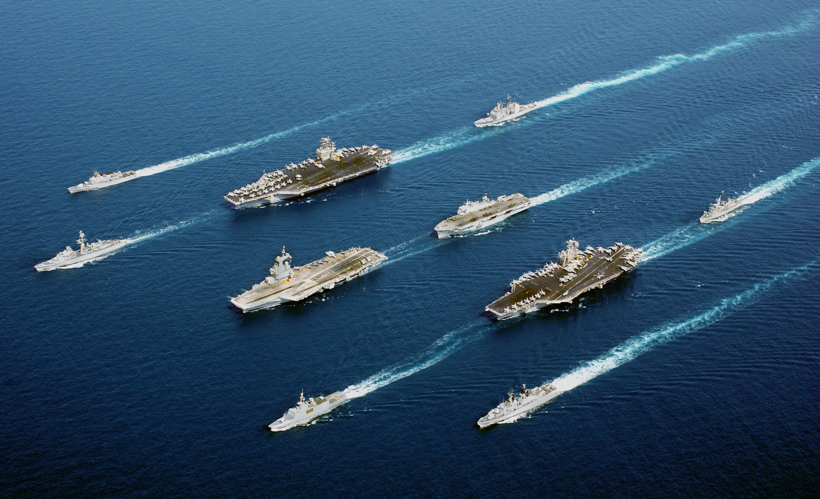
VII. THE AFGHAN WAR, 2001-2014
Afghanistan is the demographic centre of the world. It is notoriously unconquerable: Alexander, the British and the Soviets all failed. This I partly due to the terrain, and partly to the notorious (and self-conscious) audacity of its people. See Buzkashi Boys (2012).
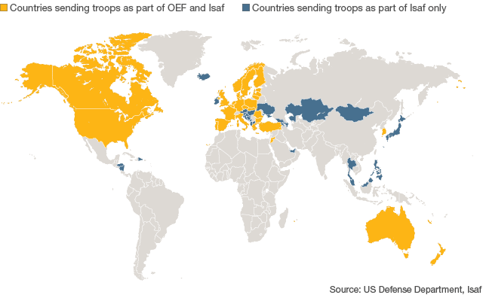
The withdrawal of the Soviets from Afghanistan had led (1989) led to the fall of President Najibullah (1992: hideously killed, 4’58’’), a civil war between warlords, Pashtuns or Pathans in the south, Daris in the north; and finally the triumph of the Saudi-funded, Pakistani-aided, Arab-based Taliban (1996), which established the Islamic Emirate of Afghanistan, with extremely strict sharia law. They also gave shelter to the Arab al-Qaeda, which had a larger, global strategy, and was prepared to gamble the future of the Islamic Emirate. Local resistance to the Taliban was led by the Northern Alliance but by 2001 government forces (perhaps 40% Pakistani!) held 90% of the country (see map).
The success of 9/11 pulled down the wrath of the world on the Taliban’s head. For the moment mankind, remembering the lessons of 1991, was united: the photo shows American, French, Italian, Dutch and British ships hurrying into the region.
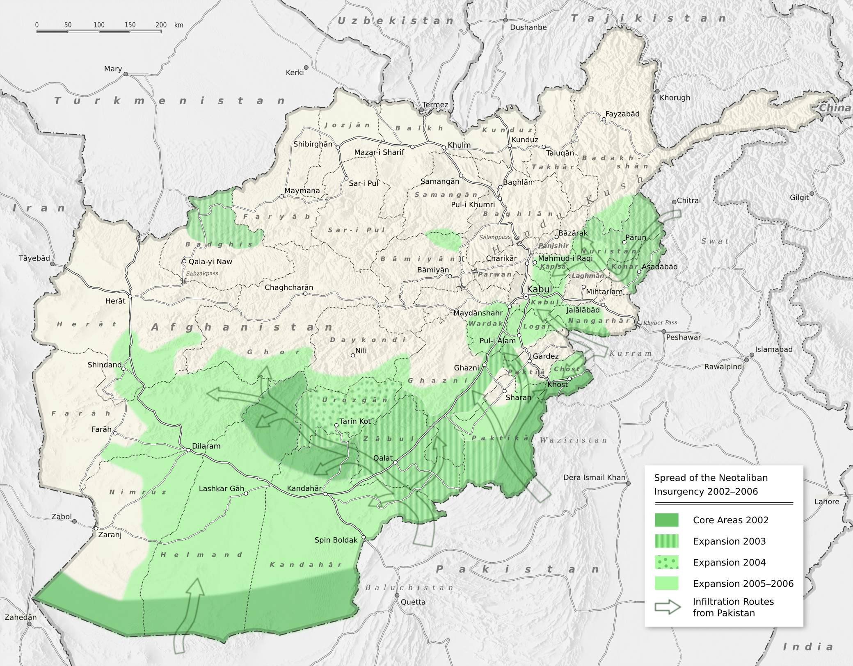
America, NATO and other allies (yellow on the map) launched Operation Enduring Freedom (no one seemed to notice the unfortunate double meaning). On October 7 bombing began; on 14 November Kabul fell to the Northern Alliance; consequently the U.N. created the International Security Assistance Force, ISAF, to hold the country together, and assist the transitional government under Hamad Karzai (left, with Bush). Osama bin Laden retired to a safe-house in Pakistan, where U.S. special forces killed him in 2011.
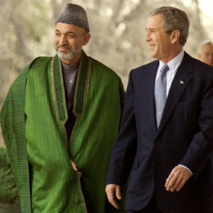
However, by September 2002 the Taliban had recovered its confidence and launched an insurgency, which continues in the Pashtun south to this day.
Obama was elected promising to escalate and win the war; he partly succeeded; the ISAF is scheduled to be gone by the end of this year.
Some 2,313 U.S. soldiers have died in the longest war in American history.

VII. THE SECOND GULF WAR, 2003-2011
Saddam Hussein had survived the First Gulf War, and continued to defy the West and the U.N. over disarmament: by the cease-fire agreement of 1991, he was forbidden weapons of mass destruction (WMD) – biological, chemical and nuclear weapons – but he refused to cooperate with arms inspectors.
From 1998 (Iraq Liberation Act) ‘regime change’ him became U.S. official policy. In December 1998, a bombing campaign, Operation Desert Fox destroyed much of Saddam’s military infrastructure. In January 2001 Bush fils became president; he was committed, in theory, to completing what his father had not completed in February 1991.
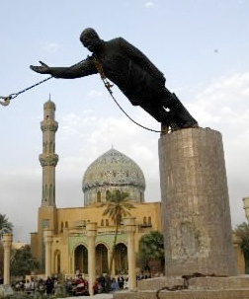
Saddam had nothing to with the 9/11 attacks. His regime was secular (nationalist-socialist); it was exactly the sort of government al-Qaeda existed to destroy. Nonetheless, America’s change if mood was useful to Bush: in September 2002 he proposed invasion to the U.N. Russia and China, but also NATO allies like France and Germany, demurred, and a compromise, UN Security Council Resolution 1441 (passed 15-0), merely restored weapons inspections. But Congress voted for war in October, and there was a massive public relations campaign; by February 2003 63% of the public favoured invasion. A worldwide demonstration on 15 February against the war (between six and ten million protestors) did not sway Bush or his staunch ally, Tony Blair of Britain, and on 20 March 2003, with Afghanistan quiet, the Coalition – overwhelmingly Americans, but with thousands of British, Australian, Danish, Polish, Spanish and Portuguese troops – invaded.
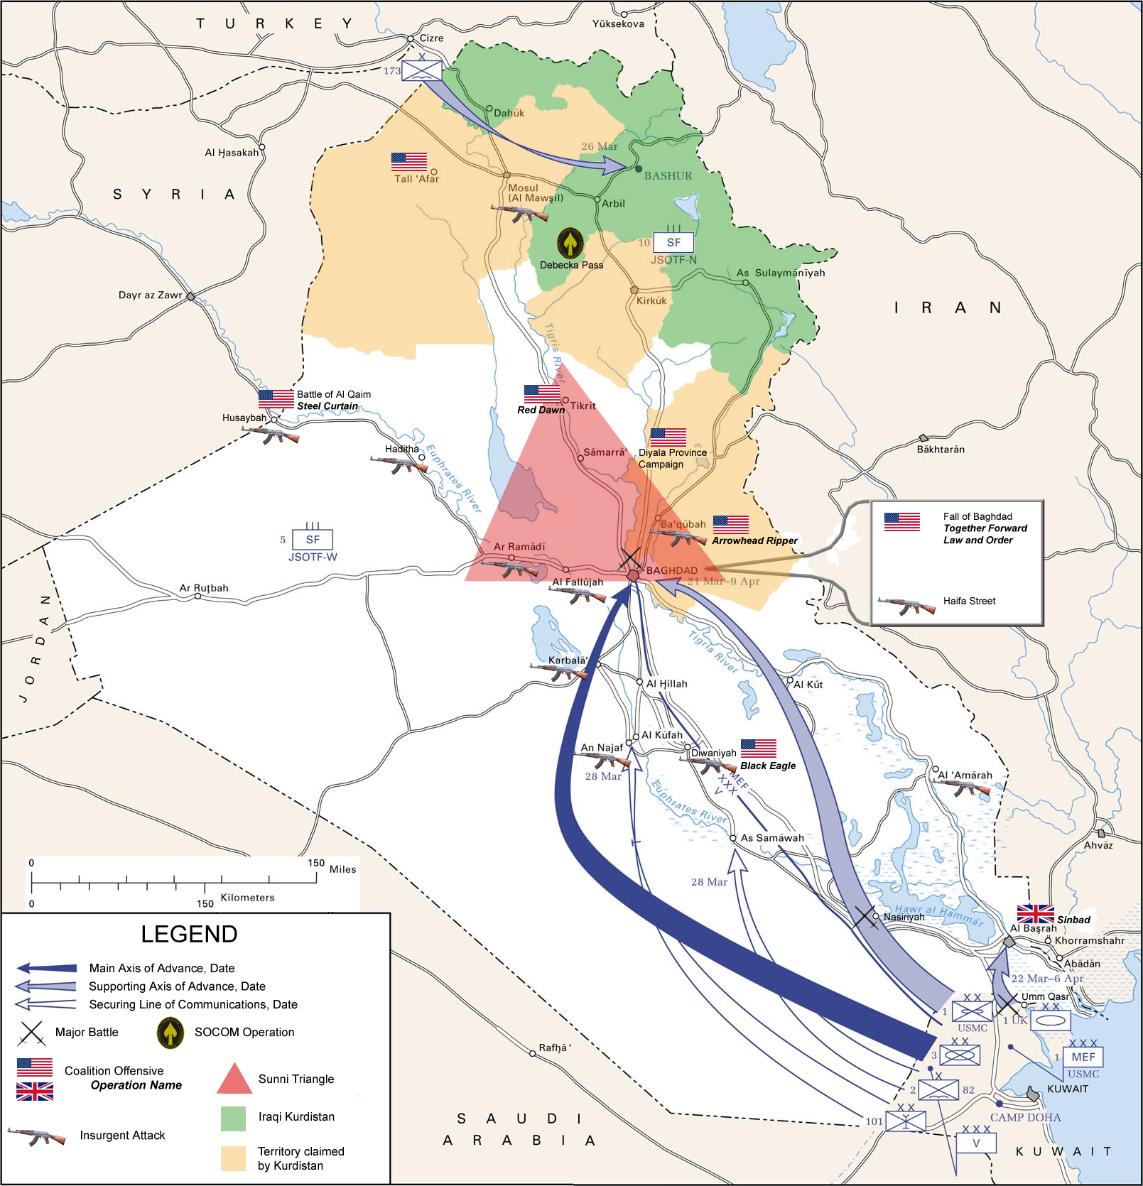
As in 1991, Operation Iraqi Freedom was a lopsided victory: in three weeks the government was toppled and all major cities captured, with perhaps 30,000 Iraqis killed versus fewer than 200 in the Coalition. No WMD were found. Bush gave an ill-timed well-known “Mission Accomplished” speech (to 1’14’’).
But Iraq is not a natural country. It was put together by the British in the 1920s under a foreign Sunni dynasty. After the 1958 revolution, the Ba’athist dictatorship kept a Sunni clique in power (just as Syrian Ba’athism kept a Shi’ite minority in power). The destruction of the regime, and the dissolution of the army by the occupier, unleashed communal violence, and a complicated war broke out: the Coalition versus Ba’athist loyalists; then the Coalition versus insurgents, nationalist or Islamicist (often from abroad); conflict between Arabs and the Kurds of the north, virtually independent since 1991; and woeful sectarian violence between the Sunnis, dominant only in ‘the Triangle’ but used to ruling the country, and the Shi’ite majority. This reached the pitch of full-scale civil war. The Iraqi adventure became deeply unpopular in America.
In December 2003 Saddam was captured, and hanged by the Iraqi government in December 2006. Al-Zarqawi, the al-Qaeda leader, was killed in June 2006; in January 2007 Bush announced a Surge of troops, which degraded the insurgency enough for withdrawal to begin. By 2011 Coalition soldiers had left Iraq; the Shia-dominated government of Nouri al-Maliki has trotted along since then, although there is certainly some potential for renewed civil war, as well as Iranian domination.
Casualties: 4,487 American soldiers; anything from 110,000 to a million violent deaths in all. By 2008 (ABC/Washington Post) 64% felt the War not worth fighting
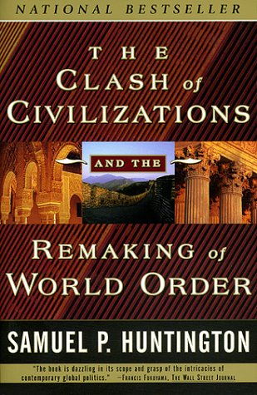
VIII. THE FUTURE OF WORLD HISTORY
Samuel P. Huntington is a right-wing political scientist at Harvard and Columbia, a former teacher of Francis Fukuyama, who in 1992 had suggested that the destruction of Communism had brought about the ‘end of history’.
In 1993 Huntington riposted with an article, “The Clash of Civilizations?” (note the ?!), expanded in 1996 to a book, The Clash of Civilizations and the Remaking of World Order. Huntingdon argues that with the end of the age of ideology (1789-1989), history did not end, but reverted to its normal state of affairs: cultural conflict. “This is not to advocate the desirability of conflicts between civilizations. It is to set forth descriptive hypothesis as to what the future may be like.” The future will see tension, not between ideological blocs, as in the Cold War, nor between sovereign nation states, but between the world’s major civilizations: Western, Latin American, Islamic, Chinese, Hindu, Orthodox, Japanese, and, perhaps, African.
One of those rivalries is far more intense than the others:

In Eurasia the great historic fault lines between civilizations are once more aflame. This is particularly true along the boundaries of the crescent-shaped Islamic bloc of nations, from the bulge of Africa to central Asia. Violence also occurs between Muslims, on the one hand, and Orthodox Serbs in the Balkans, Jews in Israel, Hindus in India, Buddhists in Burma and Catholics in the Philippines. Islam has bloody borders.

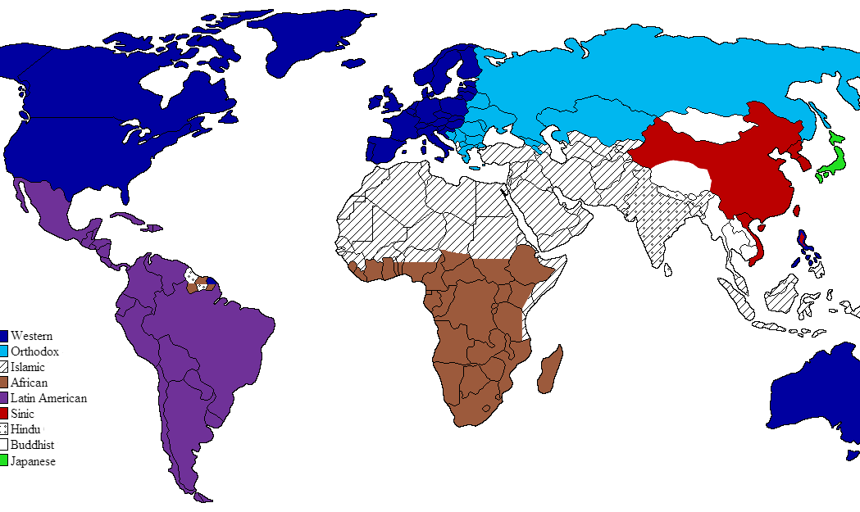
Huntingdon became extremely influential, and even more controversial, after 9/11. From the very start of the “War on Terror”, Bush went out of his way to insist the enemy was not Islam but “a fringe form of Islamic extremism that has been rejected by Muslim scholars and the vast majority of Muslim clerics; a fringe movement that perverts the peaceful teachings of Islam.” But after all, terrorism is merely a political technique: anyone can use it, anyone desist. Would Islam and the West be at ease if suicide bombing stopped?
No, says Huntington: differences among civilisations are too basic, and these differences – especially in religion – will not soon disappear. Rather, they become more intense: especially as economic modernisation separates people from longstanding local identities (religion fills the gap, providing identity and commitment transcending national boundaries), confronting then with very different cultures. The West is at the height of its power, but that very dominance exacerbates resentment, and enthusiasm for non-Western civilisations.
Huntingdon has been much condemned by academics and politicians. Edward Said, the Anglo-Palestinian thinker: the very idea of fixed “civilizations” is false, and that the Huntingdon theory is “the purest invidious racism, a sort of parody of Hitlerian science directed today against Arabs and Muslims” (wrote “The Clash of Ignorance”). Mohammad Khatami, Iranian ex-president, got the U.N. to name 2001 as the Year of Dialogue among Civilizations. The Spanish Prime Minister, Zapatero, and the semi-Islamicist Turkish Prime Minister, Erdoğan, proposed an Alliance of Civilizations initiative to the U.N. in 2005.
But whether the theme of C21 history is the clash or the reconciliation of civilisations, what becomes of American Exceptionalism?
IX. FUTURE HISTORY AND AMERICA
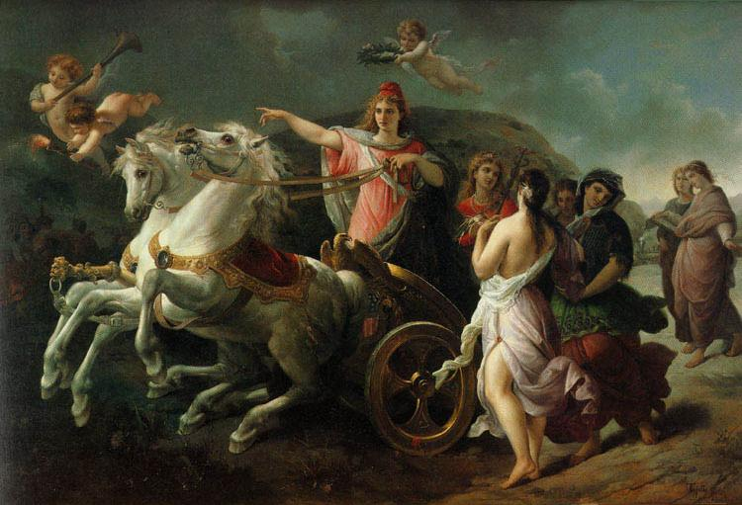
Exceptionalism is the idea of the U.S. as qualitatively different from other nation states: whether the old immigrant-producing realms of Europe, or the ancient empires of Asia, or the unfortunate banana republics of Latin America. The United States is “the first new nation”, different in kind from the others. The usual rules of history do not apply; she is indifferent to the old hatred, immune from the old quarrels. She embodies – so well that other nations ought merely to imitate her – liberty, egalitarianism, individualism, republicanism, populism and laissez-faire.
Here is Domenico Tojetti’s Progress of America: a cherub offers the laurels of victory to America; she, in her Phrygian cap of liberty, careers forward, pausing to point out to the other continents, without quite looking at them, the proper direction (which is natural for her, but must be laboriously learned by them). In the background ancient Greece and Rome look on enviously: “If only we ….”
“Our detached and distant situation invites and enables us to pursue a different course,” said Washington in his farewell address. The outside world “has a set of primary interests, which to us have none, or a very remote relation”, and “must be engaged in frequent controversies, the causes of which are essentially foreign to our concerns…. Why forego the advantages of so peculiar a situation?”
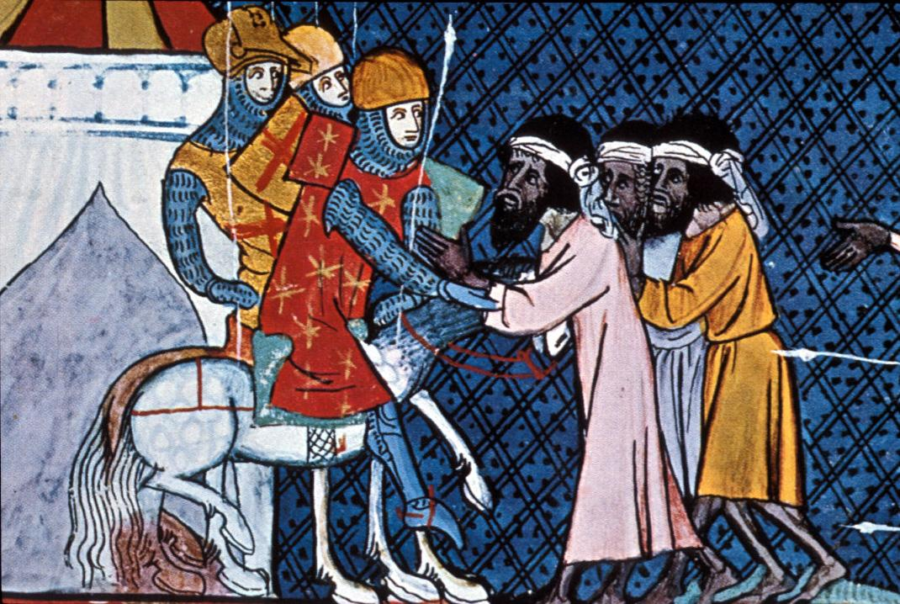
Such Exceptionalism seemed plausible to Americans during the century of isolationism.
It was a useful feeling during the Cold War, not least because Russia really is an exceptional nation – or rather, Muscovy is an exceptional empire, the extension in time of the Mongol hordes, immune from the usual European concerns about constitutionalism, the rule of the law, and harmony between nations; uniquely constructed on principles of conquest and deportation. Confronted with Mr Hyde, Dr Jekyll naturally feels himself to be a special case.
Exceptionalism made sense during the idyll of 1989-2001: America was simply on a luckier plane than anywhere else.
But if history is taking us back behind 1789 and 1776, back behind 1492 – behind nationalism, Enlightenment and political revolution, behind the inviolability of Western Europe – will young America be able to set the terms in such an old debate? If the theme of the C21 is to be the hoary controversy between mosque and church, will America be able to say “the causes … are essentially foreign to our concerns”? If the C20 was the American Century, the century of the New World, might not the C21 prove that – whatever the U.S.’ military and economic power, whatever its continuing domination of popular culture – the centre of the world, and the engine of history, lies in the Old?
RJCM 06iv14

