AMERICAN HISTORY SINCE 1945:
a series of lectures offered at Corvinus University, Budapest,
Monday evenings, February-April 2014,
by Richard Major

Class webpage: http://www.richardmajor.com/teaching/Corvinus/USsince1945.html
Dr Richard Major: richard@richardmajor.com

CLASS NOTES II (10 February): The sudden American Empire, 1945-1949

1. Points from last week
(a) Geography causes wealth
The incomparable bonanza of North America (9100 million hectares of arable land in the U.S., cf. 137 in the E.U!), with a light population of natives easily eliminated by European disease and arms, guaranteed that, once discovered, these regions would come in time to dominate the world’s economy.

After 1763, Britain eliminated the French and Spanish and became the sole Power in North America; in 1775 her ungrateful Thirteen Colonies revolted against the motherland, and (with the help of the French) formed a loose confederation, the United States. The future of world history therefore lay with this English-speaking republic.
Alexis de Tocqueville, an extremely prescient young nobleman from France, toured America in 1835. The United States population was only 15 million, but Tocqueville was sure it could reach ten times that (which it did in about 1950; it has since doubled again to more than 300 million).
All the United States needed was immigration, and it got it. Until 1924 there were virtually no restrictions on European immigration. There were 1.7 million immigrants in the 1840s; by the early 1880s, the U.S. was receiving a million Germans every year. (It remains, racially, a German country.)

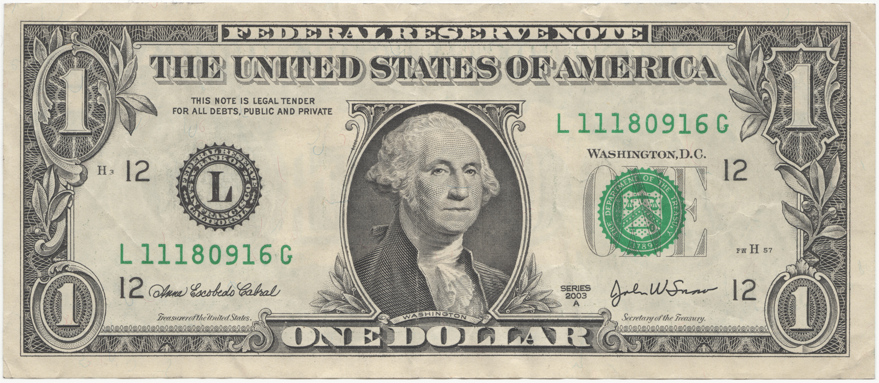
(b) Wealth creates power
The French alliance collapsed in 1794; after that the republic was committed to isolationism, as laid out in George Washington’s farewell address to the people (1796):

The great rule of conduct for us, in regard to foreign nations, is, in extending our commercial relations, to have with them as little political connexion as possible. … Europe has a set of primary interests, which to us have none, or a very remote relation. Hence she must be engaged in frequent controversies, the causes of which are essentially foreign to our concerns.… Our detached and distant situation invites and enables us to pursue a different course. … we may defy material injury from external annoyance …. Why forego the advantages of so peculiar a situation? Why quit our own to stand upon foreign ground? Why, by interweaving our destiny with that of any part of Europe, entangle our peace and prosperity in the toils of European ambition, rivalship, interest, humour, or caprice?

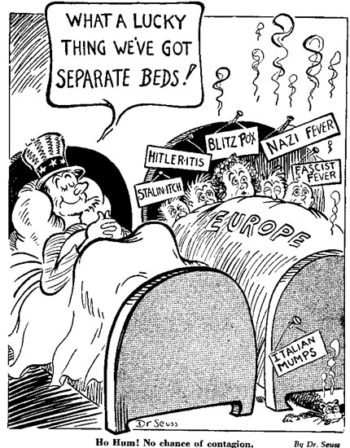
Washington’s words were immensely influential, and splendid isolation became the fixed policy of the United States. Apart from commercial wars with France (1798-1800) and Britain (1812-1815), America avoided European conflict – even when during her own Civil War (1861-1865) the French and British nearly intervened. Even after the larceny of her war with Spain (1898), when she seized the Spanish Empire, she refused all European alliances.
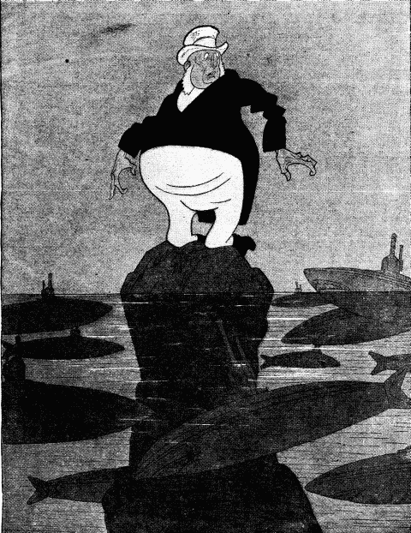
Nonetheless America, as the world’s great mercantile power, was inevitably drawn into the two world wars, because Britain could only survive by trade (see German cartoon at left) – or in other words, Germany could only prevail by starving Britain, which implied sinking American ships. Despite what Washington said, America’s commercial relations did in the end imply external annoyance and frequent controversies. The oceans are not quite that wide! (Study the American cartoon on the right.)
America’s wealth allowed her to afford enormous armaments; she ended both world wars with a huge army in Europe.
In 1919 she abandoned Europe as quickly as she could, and retreated back into isolationism.
In 1945-1947 she nearly did so again. Nearly – but not quite. And that ‘not quite’ is the hinge of modern history.
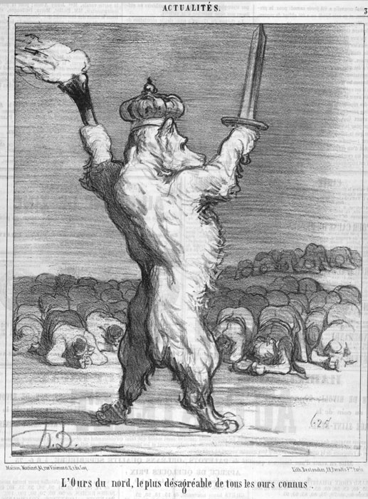
(c) Power stabilises as empire
Wealth creates power; incomparable wealth creates world power; and world power grows to world empire unless it is deliberately abdicated. This logic trumps American’s sincere impulse to isolationism.
After 1945 America decided not to abdicate her preeminent role – for a very interesting reason.
Back in 1835 Alexis de Tocqueville had made this prediction:
Today there are two great peoples on earth who, starting from different points, seem to advance toward the same goal: these are the Russians and the Anglo-Americans. All other peoples seem to have almost reached the limits drawn by nature…. Their point of departure is different, their paths are varied; nonetheless, each one of them seems called by a secret design of Providence to hold in its hands one day the destinies of half the world.
Tocqueville stresses that there is an ideological difference: Anglo-America is naturally democratic, Russia naturally autocratic – power there is normally wielded by one tyrant, the Tsar (and latterly Lenin, Stalin, Khrushchev, Brezhnev and Putin).
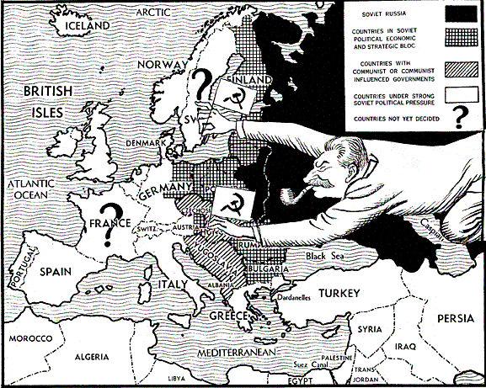
Nonetheless, there is a facet of mere geopolitical rivalry between these two nations on the periphery of European sphere, growing westward and eastward over almost infinite space until they become imperial. Whether reactionary and monarchist (to 1917), revolutionary and socialist (1917-1991), or reactionary and nationalist (since 1999), Russia is Anglo-America’s natural enemy.
Franklin Roosevelt, almost a great man, didn’t see this, and was recklessly compliant with Stalin’s demands. He died (April 1945) in the knick of time, and his successor, Harry S. [for nothing] Truman, a trivial man, a failed haberdasher, happened to be right. where FDR was wrong Under Truman, the American victory was not abdicated, and stabilised as a military and political empire, the great obstacle to Russian domination of the world.

Honoré Daumier, The Northern Bear, the most disagreeable of all the known bears, from ‘Chargeons les Russes’ (Let’s Make Caricatures of the Russians), Le Charivari, April 1854. Leslie Gilbert Illingworth, cartoon in Punch, June 1947
3. The empire conceived

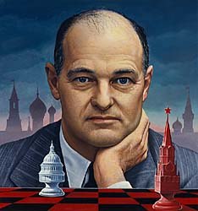
(a) Kennan’s ‘Long Telegram’
On 22 February 1946, George Kennan, Deputy at the U.S. embassy in Moscow, sent his famous (and very well-timed) ‘Long Telegram’ to Washington, laying out “undoubtedly the greatest task our diplomacy has ever faced and probably the greatest it will ever have to face”: confronting the victorious Soviet Union.
The ‘Long Telegram’ lays down the theory of the Cold War:
the Soviet Union perceived itself at perpetual war with capitalism;
it did not acknowledge the possibility of long-term peaceful coexistence with the capitalist world
it would use Marxists in the capitalist world as its allies,
but viewed left-wing but non-communist groups in other countries as a worse enemy than the capitalist ones.
The Soviet government’s structure made it impossible to form pictures of internal and external reality.
Nonetheless, the specific patterns of Soviet aggression arose, not from economic reality, nor even from Marxism, but from historic Russian nationalism and neurosis:

Russian rulers have invariably sensed that their rule was relatively archaic in form fragile and artificial in its psychological foundation, unable to stand comparison or contact with political systems of Western countries. For this reason they have always feared foreign penetration, feared direct contact between Western world and their own, feared what would happen if Russians learned truth about world without or if foreigners learned truth about world within.
It was no coincidence that Marxism, which had smoldered ineffectively for half a century in Western Europe, caught hold and blazed for first time in Russia. Only in this land which had never known a friendly neighbor or indeed any tolerant equilibrium of separate powers, either internal or international, could a doctrine thrive which viewed economic conflicts of society as insoluble by peaceful means. After establishment of Bolshevist regime, Marxist dogma, rendered even more truculent and intolerant by Lenin’s interpretation, became a perfect vehicle for sense of insecurity with which Bolsheviks, even more than previous Russian rulers, were afflicted.

(b) Churchill’s ‘Iron Curtain’ speech
Churchill had lost the election of July 1945 to the socialists, but he still had tremendous moral prestige in America, and at a speech at Westminster College in Fulton, Missouri, on 5 March 1946, with Truman sitting behind him:
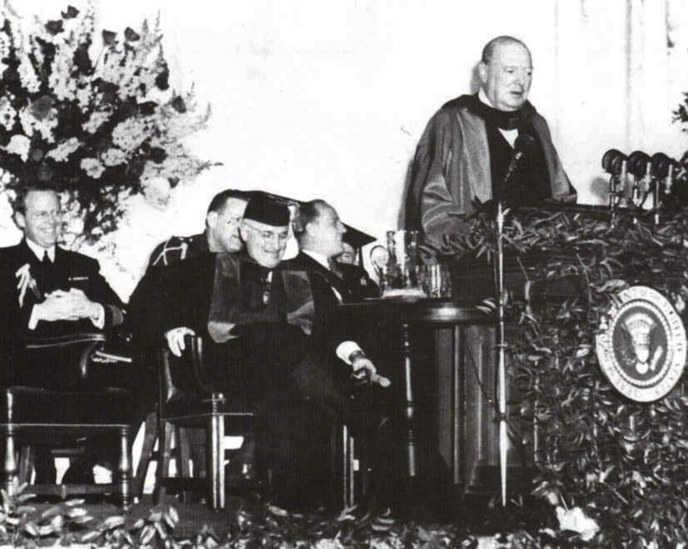
A shadow has fallen upon the scenes so lately light by the Allied victory. Nobody knows what Soviet Russia and its Communist international organization intends to do in the immediate future, or what are the limits, if any, to their expansive and proselytizing tendencies. …
It is my duty to place before you certain facts about the present position in Europe.
From Stettin in the Baltic to Trieste in the Adriatic an iron curtain has descended across the Continent. Behind that line lie all the capitals of the ancient states of Central and Eastern Europe. Warsaw, Berlin, Prague, Vienna, Budapest, Belgrade, Bucharest and Sofia, all these famous cities and the populations around them lie in what I must call the Soviet sphere, and all are subject in one form or another, not only to Soviet influence but to a very high and, in some cases, increasing measure of control from Moscow. Athens alone – Greece with its immortal glories – is free to decide its future at an election under British, American and French observation. The Russian-dominated Polish Government has been encouraged to make enormous and wrongful inroads upon Germany, and mass expulsions of millions of Germans on a scale grievous and undreamed-of are now taking place. The Communist parties, which were very small in all these Eastern States of Europe, have been raised to pre-eminence and power far beyond their numbers and are seeking everywhere to obtain totalitarian control. Police governments are prevailing in nearly every case, and so far, except in Czechoslovakia, there is no true democracy…..
Up till the year 1933 or even 1935, Germany might have been saved from the awful fate which has overtaken here and we might all have been spared the miseries Hitler let loose upon mankind. there never was a war in history easier to prevent by timely action than the one which has just desolated such great areas of the globe. It could have been prevented in my belief without the firing of a single shot, and Germany might be powerful, prosperous and honored today; but no one would listen and one by one we were all sucked into the awful whirlpool. We surely, ladies and gentlemen, I put it to you, surely, we must not let it happen again.

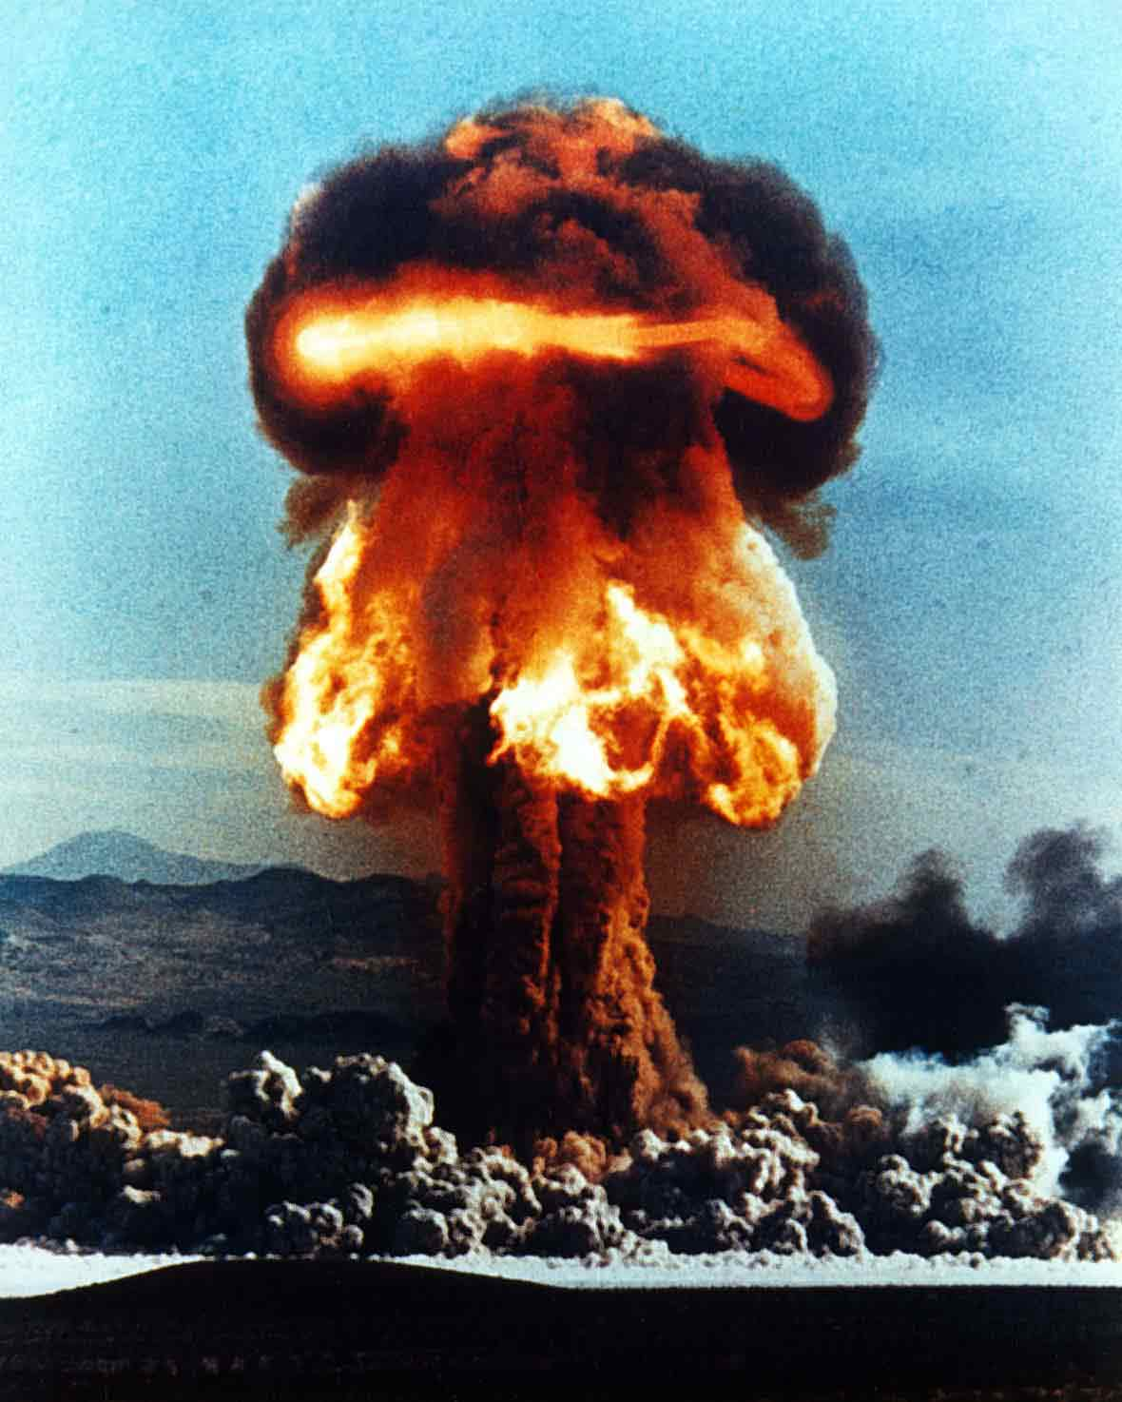
(c) Kennan’s ‘X Article’
In anonymous article in Foreign Affairs (July 1947) Kennan laid down a strategy for fighting a long Cold War with the Soviets (which went on 35 years long than he expected!):

the Soviets, even once they acquired atomic weapons, would never desire outright world war
they would rather wait for opportunities to take advantage of “diseased tissue” anywhere in the world.
It followed that the West must undertake a long-term policy of positive containment, defying the Soviets wherever they sought to advance: for if the Soviet Union is impervious to the logic of reason, it is highly sensitive to the logic of force.

Kennan cast the confrontation in theological terms:
The issue of Soviet-American relations is in essence a test of the overall worth of the United States as a nation among nations. To avoid destruction the United States need only measure up to its own best traditions and prove itself worthy of preservation as a great nation.
Surely, there was never a fairer test of national quality than this. In the light of these circumstances, the thoughtful observer of Russian-American relations will find no cause for complaint in the Kremlin's challenge to American society. He will rather experience a certain gratitude to a Providence which, by providing the American people with this implacable challenge, has made their entire security as a nation dependent on their pulling themselves together and accepting the responsibilities of moral and political leadership that history plainly intended them to bear.

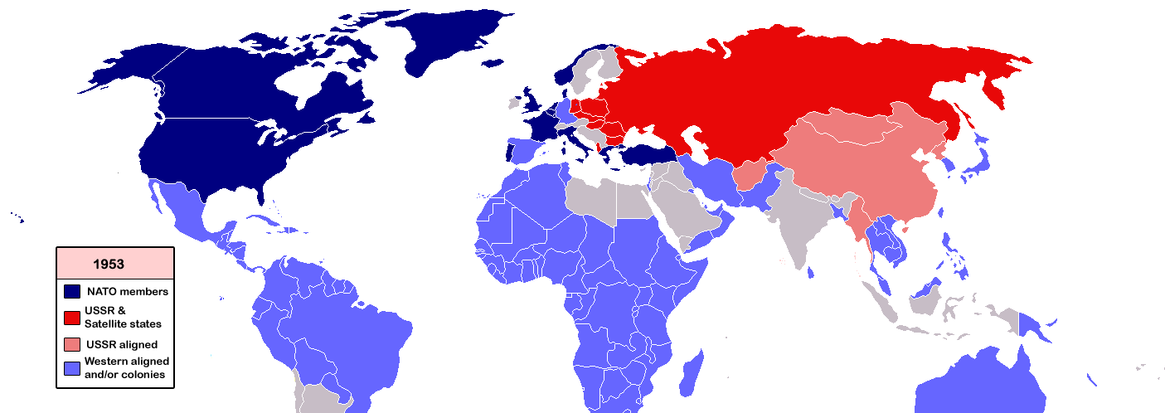
(d) NSC-68
The National Security Council’s plan, adopted in April 1950, fixed the lines of American policy for a generation.

NSC-68 renounced and reversed a century and a half of American isolationism, arguing that withdrawal from Europe, and consequent Soviet conquest of Europe, would not be the safe course, but rather, would be apocalyptic:
At some point in the course of isolation, many Americans would come to favor a surprise attack on the Soviet Union and the area under its control, in a desperate attempt to alter decisively the balance of power by an overwhelming blow with modem weapons of mass destruction. It appears unlikely that the Soviet Union would wait for such an attack before launching one of its own.

America, as the greatest constitutional power, had a moral, political and ideological obligation to preserve free institutions everywhere, and therefore to rearm at once:
Time is short, however, and the risks of war attendant upon a decision to build up strength will steadily increase the longer we defer it.

With the end of American’s nuclear monopoly, that obligation implied military presence all over the globe, and permanent militarisation of the American economy – defence spending (then only 6%) should go as high as 20%:
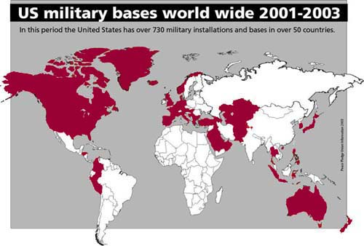
A more rapid build-up of political, economic, and military strength and thereby of confidence in the free world than is now contemplated is the only course which is consistent with progress toward achieving our fundamental purpose. The frustration of the Kremlin design requires the free world to develop a successfully functioning political and economic system and a vigorous political offensive against the Soviet Union. These, in turn, require an adequate military shield under which they can develop. It is necessary to have the military power to deter….

The new policy produced 675 overseas bases;
a million troops stationed abroa;
military commitments by the United States to 47 countries (see map);

And that is world empire. RJCM 01ii14

