AMERICAN HISTORY SINCE 1945:
a series of lectures offered at Corvinus University, Budapest,
Monday evenings, February-April 2014,
by Richard Major

Class webpage: http://www.richardmajor.com/teaching/Corvinus/USsince1945.html
Dr Richard Major: richard@richardmajor.com

CLASS NOTES VI (10 March):
The turmoil of the ’Sixties, the malaise of the ’Seventies

1. Cinema of the Cold War
Two weeks ago we look at how Hollywood pictured the golden age of capitalism.
But film also reflected the other side of post-war American history:
global rivalry with Communism and the atomic peril.
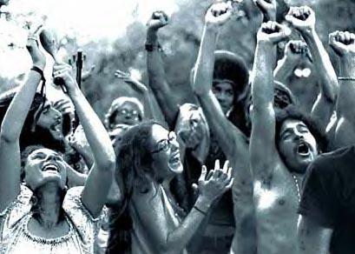
Here are some of those films.

2. America’s “suicide attempt”?
Paul Johnson: ‘a decade of illusions’?
Bizarre optimism, too brittle to survive:
on the Right (Vietnam) and on the Left (impossible welfarism),
amongst the young (the Age of Aquarius)
and the old (drug paranoia),
for whites (flight, flagellation) and blacks (riots, separatism)

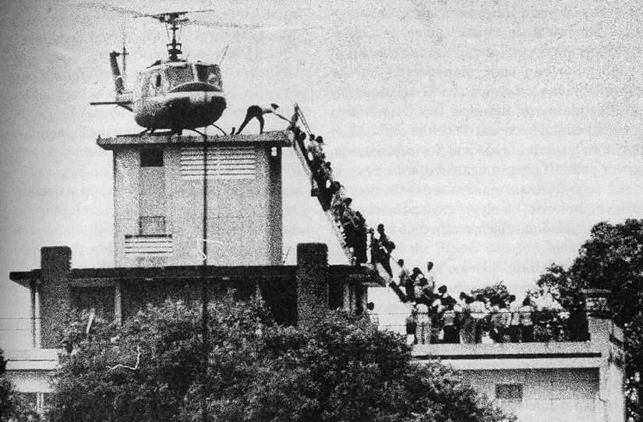
3. Malaise
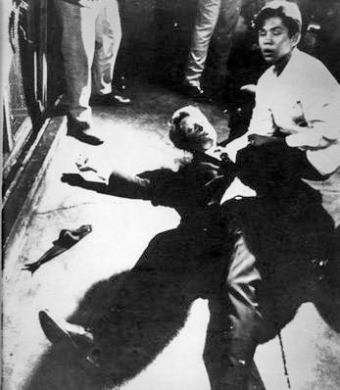
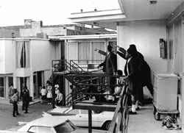
Much of the horror of these years was about feeling: the melancholy brought on by
assassinations (here are photos of the deaths of Robert Kennedy and Martin Luther King); Vietnam (here is the fall of Saigon); riots, scandals (the ‘smoking gun’ is at 5’10’’), the Nixon’s resignation (see 2’50”), the Iran hostage crisis (this is the trailer for the scandalously inaccurate 2012 film Argo), and the general silliness (trailer for the film version of Hair).
But there was a larger story: the apparent defeat of capitalism by socialism in the Cold War. Here is the world in 1980:

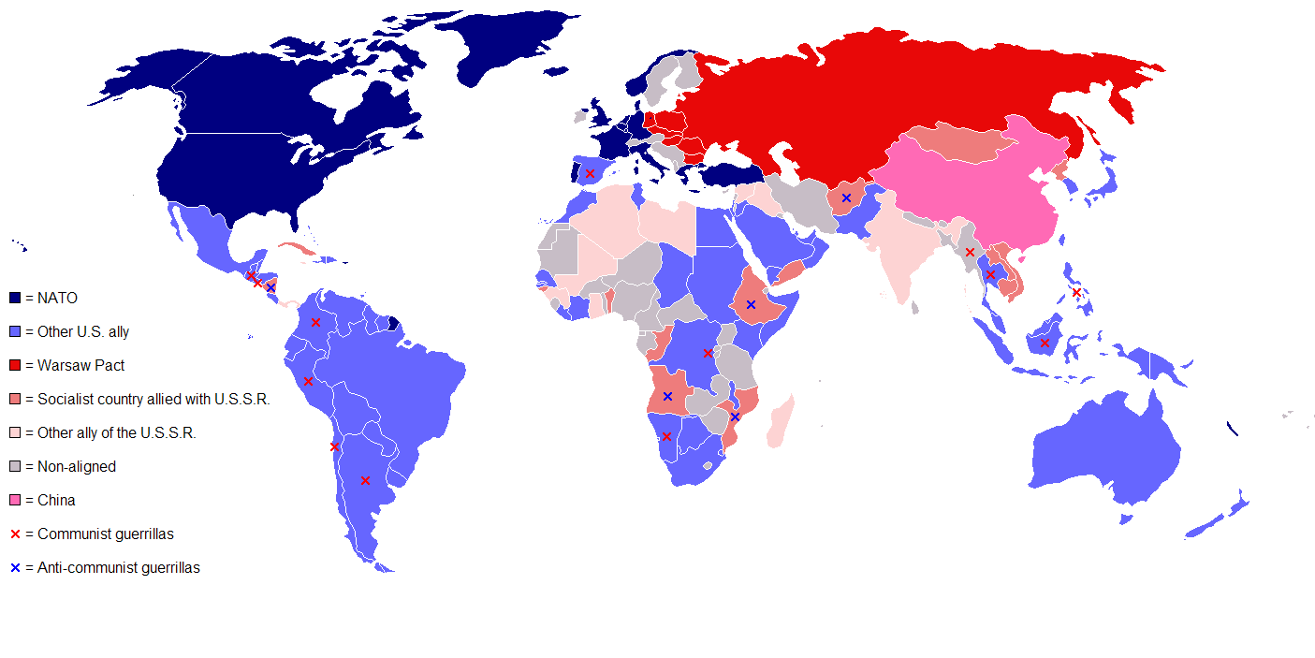
4. The American Presidency, 1945-1980

XXXII  Franklin Delano Roosevelt | 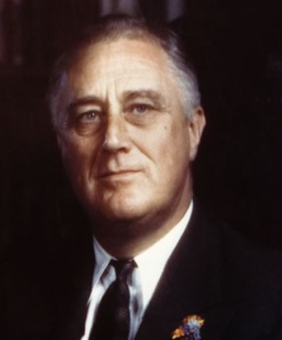 | Democrat  of New York  1933-1945  (died in office) | ¶ frivolous New York aristocrat  ¶ elected in depths of the Great Depression  ¶ introduced the New Deal, a programme of Federal activism which possibly prolonged the Depression, but remained immensely popular until the ’80s  ¶ personally very popular: elected four times (uniquely in American history)  ¶ enormously expanded the power of the Presidency  ¶ aided the Allies when war began in 1939  ¶ pushed his Isolationist country toward war with Germany and Japan  ¶ which led a Japanese attack and German declaration of war (December 1941)  ¶ increasingly pushed Churchill aside as war leader, deferred to Stalin  ¶ died suddenly, and deeply disillusioned with the Soviets,  just before the end of the European war.
XXXIII  Harry S. Truman | 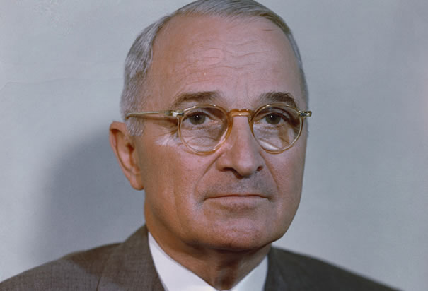 | Democrat  of Missouri  1945-1953 | ¶ an obscure Southerner, a bankrupt haberdasher; ‘S’ for nothing  ¶ went into politics and achieved some fame in the Senate  ¶ chosen as Vice-President instead of the left-wing Wallace  ¶ succeeded after 82 days  ¶ at once authorised the use of the atom bomb (of which he had not heard!)  ¶ broke with Soviets in March 1946:  the Truman Doctrine, Berlin Airlift, the Marshall Plan, NATO  ¶ narrowly reelected in 1948  ¶ oversaw the loss of China to the Communist (October 1949)  ¶ failed to win or end the Korean War (June 1950); sacked General MacArthur
XXXIV  Dwight Eisenhower | 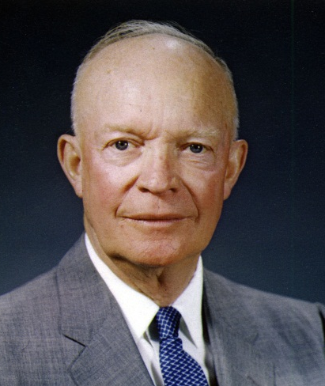 | Republican  of Kansas  1953-1961 | ¶ an elderly general (born 1890) who had conquered Europe in 1944-1945  and then served as Supreme Allied Commander Europe  ¶ drafted by Republicans to thwart isolationists within the party; landslide win  ¶ a moderate; continued and expanded the New Deal,  wary of military, helped destroy Senator McCarthy  ¶ ended Korean War  ¶ publicised ‘domino theory’ of Communist expansion  ¶ organised coups in Persia and Guatemala  ¶ introduced the first Civil Rights legislation
XXXV  John F. Kennedy | 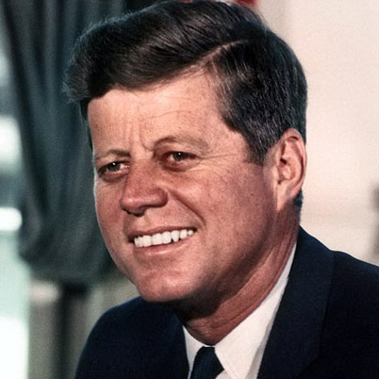 | Democrat  of Massachusetts  1961-1963  (assassinated) | ¶ born to a newly-rich family of Boston ‘machine’ politicians  ¶ nominated because young (born 1917) and telegenic,  despite Addison’s Disease, inexperience and promiscuity  ¶ narrowly defeated Eisenhower’s Vice-President, Richard Nixon  ¶ approved abortive Bay of Pigs invasion of Cuba  ¶ committed America to the Vietnam War  ¶ avoided world war during the Cuban Missile Crisis  ¶ initiated Project Apollo (leading to the moon landing in 1969)  ¶ the Berlin Wall  ¶ supported, not very successfully, the Civil Rights movement  ¶ assassinated in Dallas, Texas
XXXVI  Lyndon Johnson | 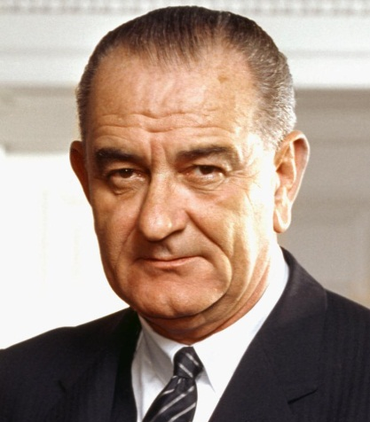 | Democrat  of Texas  1963-1969 | ¶ a cunning and tyrannical Senate leader; personally monstrous  ¶ nominated as Vice-President to ‘balance the ticket’  ¶ initiated the ‘Great Society’ programmes: the ‘War on Poverty’  ¶ responsible for broad Civil Rights Acts legislation  ¶ escalated American involvement in Indochina: the Gulf of Tonkin Resolution gave him power to wage war there, and eventually he had an American army of over half a million fighting and not winning the war there  ¶ 1968 saw the ‘student rebellion’, the assassination of Martin Luther King (April) and Robert Kennedy (June); Johnson, having done badly in primary elections, withdrew (March); the Democratic Convention (August) was chaotic and violent, and led to the nomination of Johnson’s Vice-President, Hubert H. Humphrey, who lost to Nixon in November
XXXVII  Richard M. Nixon | 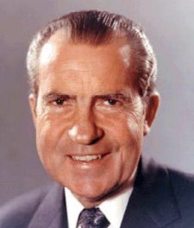 | Republican  of California  1969-1974  (resigned) | ¶ a strange paranoid little man, a working-class Quaker from California  ¶ escalated and then ended American involvement in Indochina;  the anti-Communist governments were then allowed to fall  ¶ ‘opened China’ in 1972  ¶ détente with the Soviets; SALT  ¶ a moderate: enforced desegregation, expanded social welfare, drug reform  ¶ reelected by a landslide in 1972, in which, quite unnecessarily,  his campaign committed various illegalities, leading to ‘Watergate’  ¶ ‘Nixon Shock’  ¶ Yom Kippur War (October 1973) and first oil crisis  ¶ complicated Watergate scandal; support collapses; forced resignation
XXXVIII  Gerald Ford | 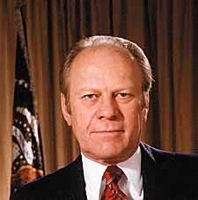 | Republican  of Michigan  1974-1977  (voted out of office) | ¶ rather effective as Minority Leader in the House (Democrat1 1955-95)  ¶ chosen as Vice-President after Nixon’s VP, Spiro Agnew,  forced to resign for personal corruption  ¶ Nixon, too, resigned; Ford became the only unelected President. Hapless.  ¶ signed shameful Helsinki Accords  ¶ presidency weakened; Congressional authority grows  ¶ presided, helplessly, over the Communist conquest of Indochina  ¶ worst economy Great Depression: inflation and recession  ¶ narrowly defeated Reagan for nomination; narrowly lost general election
XXXIX  James Carter | 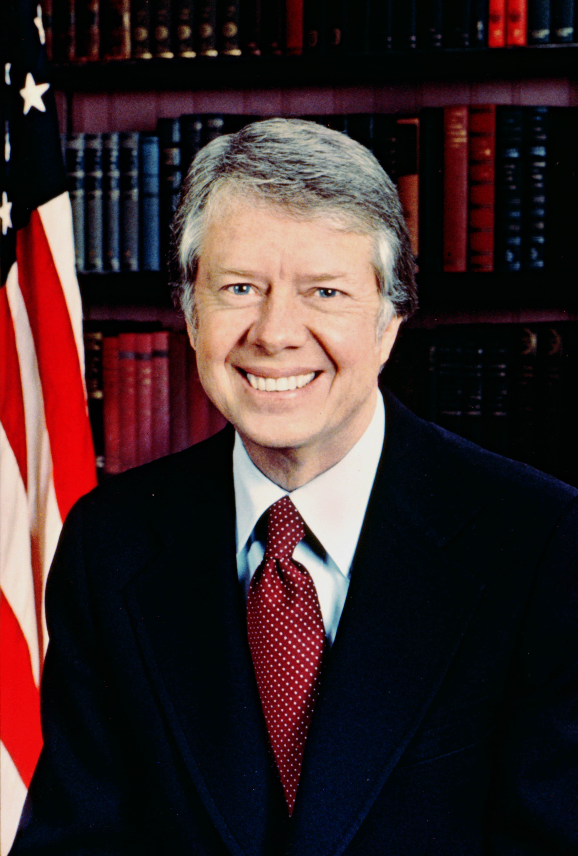 | Democrat  of Georgia  1977-1981  (voted out of office) | ¶ a naval officer and landowner from the Deep South  ¶ perceived as ‘well-meaning’; even more hapless than Ford in office  ¶ pessimistic and penitent: the malaise speech (“The threat is nearly invisible in ordinary ways. It is a crisis of confidence. It is a crisis that strikes at the very heart and soul and spirit of our national will.”)  ¶ inflation, stagnation and the energy crisis ticked on, unabated  ¶ the Camp David Accords: Egypt makes peace with Israel  ¶ Panama Canal Treaties, SALT II  ¶ Iranian Revolution in January 1979 causes the second oil shock and  ¶ the 1979–1981 Iran hostage crisis  ¶ the Soviet invasion of Afghanistan (December 1979) ended détente  ¶ authority of America, and of the American presidency, at its nadir  ¶ narrowly wins renomination over Ted Kennedy; lost in a landslide to Reagan and the Republicans (who take Senate for first time since 1952)

