AMERICAN HISTORY SINCE 1945:
a series of lectures offered at Corvinus University, Budapest,
Monday evenings, February-April 2014,
by Richard Major

Class webpage: http://www.richardmajor.com/teaching/Corvinus/USsince1945.html
Dr Richard Major: richard@richardmajor.com


CLASS NOTES VII (17 March):
The reversal of the ’Eighties: a social counter-revolution

As the Seventies waned, the intellectual energy passed from Left to Right as well.
Neo-conservatives were intellectuals who made the journey from Communism (usually of the Trotskyite variety) to advocacy of “assertive” promotion of democracy and “American national interest” by means of military force.
Supply-side economics: government should lower barriers (tax and regulations) to the supply of goods and services; supply will create demand – a contradiction of the Keynesian idea that supply is caused by demand creates, which can be manipulated.
These tendencies found their champion in Ronald Reagan, a Hollywood actor ‘run’ by right-wing Republicans in California. He was Governor (1967-1975); nearly took the presidential nomination from Ford in 1976; was nominated in 1980, despite his age (born 1911), and won a landslide, taking 44 states, taking back the Senate after quarter of a century. In 1984 he was reelected, carrying 49 states.
Before we discuss the political counter-revolution that triumphed in the ’Eighties, we have to understand the social forces that, even before the ’Seventies ended, reversed the social direction of America. For in countries too prosperous and stable for political revolution or civil war, a lot of history turns on social factors: wages, marriage, housing and religion.
For instance, the sexual and feminist revolution of the Sixties was being undone. In 1972 Congress overwhelmingly passed the Equal Rights Amendment (Equality of rights under the law shall not be denied or abridged by the United States or by any State on account of sex); it was immediately endorsed by Nixon; but it ran into trouble from the nascent New Right. Congress extended the deadline for ratification in 1978, but the Republican Party rejected E.R.A. in 1980, and it died in 1982.
Households were becoming more solitary; unionism was in drastic decline.
More generally, there was a reaction in culture, even among the young: here’s what 1980s bands looked like (Spandau Ballet).
Other social issues that caused the American counter-revolution are evolution, abortion, race and penal measures.
Evolution
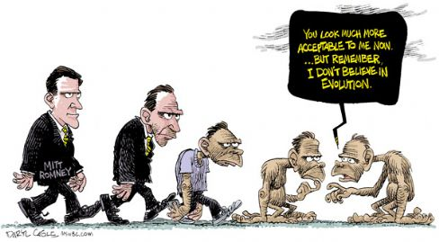
The United States has a curious, and strongly politicised, debate over biological evolution.
A Pew Research Center poll of 2013 shows that 60% of Americans, including 68% of white Catholics, believe humans and other living things have evolved over time.
But the contrary view, that humans have existed in their present form since the beginning of time, is extremely strong in certain groups: it is held by 64% of white evangelical Protestants, 50% of black Protestants – and by the Republican Party. Since 2009, Democrats have moved slightly toward evolution (64% to 67%), Republicans strongly the other way (54% to 43%). There’s now a 24% gap between the two parties, and it is necessary for ex-moderates like Romney (see cartoon).

Abortion
The United States inherited a broad common law prohibition from the English (“human life, from its commencement to its close, is protected by the common law,” insisted James Wilson, who helped write the Constitution. “In the contemplation of law, life begins when the infant is first able to stir in the womb”. )

In 1973, in Roe vs. Wade, the Supreme Court read a right to abortion on demand into the Constitution. About 50 million legal abortions have been performed in America since then. The rate peaked in 1990, and is in decline, at least among whites: the rate is 11 per 1,000 white women, 28 among Hispanics, and perhaps 60 among blacks.
The Democrats were traditionally more anti-abortion (being the party of Catholics), but by 2012 the two parties’ platforms were in binary opposition. The Democratic Party strongly and unequivocally supports Roe v. Wade. We oppose any and all efforts to weaken or undermine that right. The Republicans: We support a human life amendment to the Constitution and endorse legislation to make clear that the Fourteenth Amendment’s protections apply to unborn children.
It is a long-term vote-loser for the Left.
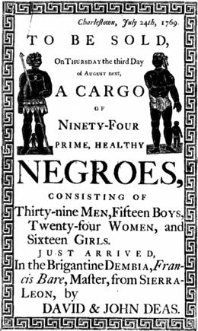
Race
The United states is an ex-slave country. More generally, it has historically relied, not on free labour as in Western Europe, but on cheap unfree or semi-free labour (enslaved Natives, then indentured immigrants, then blacks, then indentured Chinese, and now ‘illegals’).
The most important pool of labour were the slaves, exported by warrior kingdoms in West Africa and imported to British America and the United States (until the trade was banned in 1808); and their descendants. By 1860 there were four million of them in the Slave States of the South.
After the Civil War, which ended slavery, the blacks remained in the South until the Great Migration of the C20, reaching its climax in the 1960s. Black Americans, although still concentrated in the South, have become urban, and dominate many American cities.
Despite the Civil War, the South remained a strict racial hierarchy from 1877 until the 1960s: blacks were disenfranchised by various semi-legal or illegal means. The Democratic Party machine made sure there was no outside interference.

The Civil Rights movement was both a popular protest, and a sequence of legislation by Congress: Civil Rights Acts of 1957 (establishing the Civil Rights Commission), 1960 (Federal inspection of local voter registration polls) and 1964 (prohibiting racial discrimination by Federal and State governments); Voting Rights Act of 1965 (Federal oversight of elections in the South; largely struck down by Supreme Court in 2013); Fair Housing Act of 1968 (prohibiting racial discrimination in housing sale and rental); Civil Rights Restoration Act of 1987 (recipients of Federal funds selected by racial policy; overrode a veto by Reagan); Civil Rights Act of 1991 (trial by jury on discrimination, emotional distress damages).
Political results of Civil Rights: blacks enfranchised in South, and become solid Democratic voters; Southern whites turn to the Republicans, and the South, hitherto a one-party Democratic area, becomes almost one-party Republican (here is the 2008 electoral map) – there are now one white Democratic Congressman from the Deep South! More generally, race is an implicit issue in most political debates, and works, broadly speaking, for the Right.
Demographics. America remains a country that is predominantly ‘white’, that is, inhabited by people of European descent. Race is a tense part of politics because since the end of the baby boom reproduction levels have been low; blacks have more babies than white, three-quarters born to single mothers; young people are much more racially diverse than old; ‘Hispanics’ – Spanish-speaking emigrants from south of the frontier, overwhelmingly of pre-Columban descent – are slowly retaking the Southwest (right: vodka ad, 2008); and the long-term future in the United States is a white minority.
Meanwhile black income remains stubbornly below white; various factors, especially black illegitimacy, indicate it will stay like that.
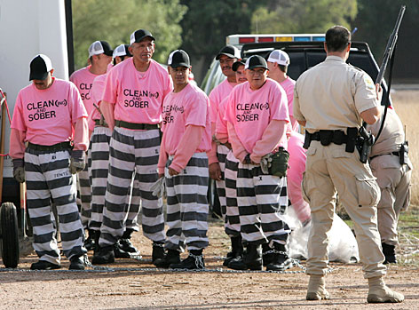
Penal
America is a Western democracy with a legal system that is unusual in three ways:

(a) judges are elected in many states, and their rulings and sentences are therefore liable to direct popular pressure.

(b) The Second Amendment of the Constitution guarantees the right to bear arms as a way of protecting the right of insurrection. Revolts have been out of favour since 1865, but the Second Amendment makes gun-control difficult, especially over the last thirty years. America has highly unusual patterns of gun ownership and homicide.

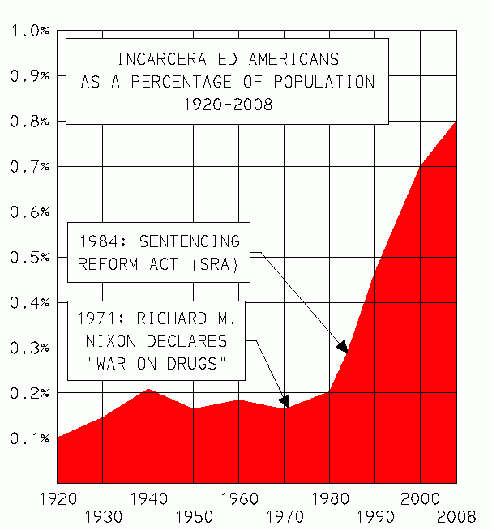
(c) A combination of (a) and (b) means that there is unusual political in America in favour of judicial severity: capital punishment and mass imprisonment, often under very harsh conditions: here is a contemporary chain gang.
This has especially been the case since ‘law and order’ was discovered, in the 1970s, to be sound electoral strategy (appealing as it does to poor whites, classic swing voters).
The Comprehensive Crime Control Act of 1984, for instance, established a United States Sentencing Commission, which tends to drive up severity, expanded the Secret Service’s jurisdiction, and re-instituted the Federal death penalty. This remains popular legislation, even though the rate of incarceration in America is bizarrely high by international standards: seven million adults are ‘under correctional supervision’ (probation, parole, jail, or prison), almost 3% of the population.
As with most political issues in America, race is significant: rates of imprisonment falls heavily on non-whites: (http://www.richardmajor.com/teaching/Corvinus/graphs/penal/byrace.jpg)
However in general the police are much more aggressive than elsewhere in the West: by the time he reaches 23, an American male has a 38% of having been arrested even if white (44% if Hispanic, 49% if black).


The Reagan Revolution: domestic
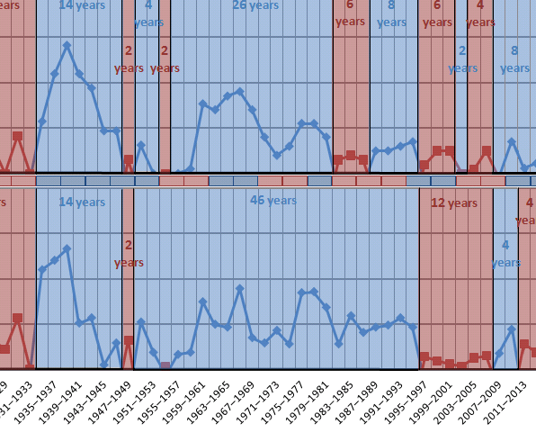
The end of the postwar consensus. Throughout the Western world, mainstream parties accepted collectivism, a mixed economy, a welfare state, Keynesian economic policy, a commitment to full, and (after the 1960s) a desire for permanent détente with the Soviet Union. That consensus ended with the election of Margaret Thatcher in Britain (May 1979) and Reagan in America (November 1980). There was a permanent ideological shift.
Tax-cuts and a permanent deficit. Reagan, especially after surviving an assassination attempt in March 1981, had remarkable sway over Congress and the public. He pushed through the Tax Reduction Act (July 1981: see photo): the top marginal tax bracket dropped from 70% to 50%; the Tax Reform Act of 1986 reduced it to 28%. This also represented a permanent counter-revolution: America is now hostile to redistributive taxation, and has settled into permanent deficit, partly because of the Reagan’s rearmament (a 40% real increase in defense spending from 1981 to 1985).
Reaganomics: supply-side theory: a laissez-faire philosophy, free-market fiscal policy, stimulation through large, across-the-board tax cuts, enough, it was hoped, to expand the tax base, offsetting the loss of revenue.
Right or wrong, he had the advantage of a very sunny economy, the Reagan boom. During his administration inflation dropped from 12.5% (average in 1980) to 4.4% (1988); unemployment fell from 7.5% to 5.4%; GDP grew 7.9% on average, and reached a tremendous 12.2% in 1982.
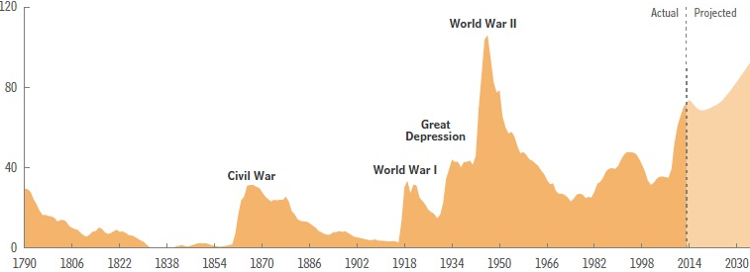
The return of aristocracy. The Gini coefficient (after Corrado Gini, 1912) measures the income inequality among values of a frequency distribution, with 1 perfect inequality in a society – one man earns everything – and 0 perfect quality. Since World War II there had been, broadly speaking, increased income equality; pre-tax income grew less amongst the rich. From the end of the ’70s that was reversed, and now America is unusual globally in the scale of its hereditary wealth. CEOs, for instance, have earned more and more, and a larger and larger percentage of wealth lies with the richest families. This changes the nature of Western society.

