AMERICAN HISTORY SINCE 1945:
a series of lectures offered at Corvinus University, Budapest,
Monday evenings, February-April 2014,
by Richard Major

Class webpage: http://www.richardmajor.com/teaching/Corvinus/USsince1945.html
Dr Richard Major: richard@richardmajor.com

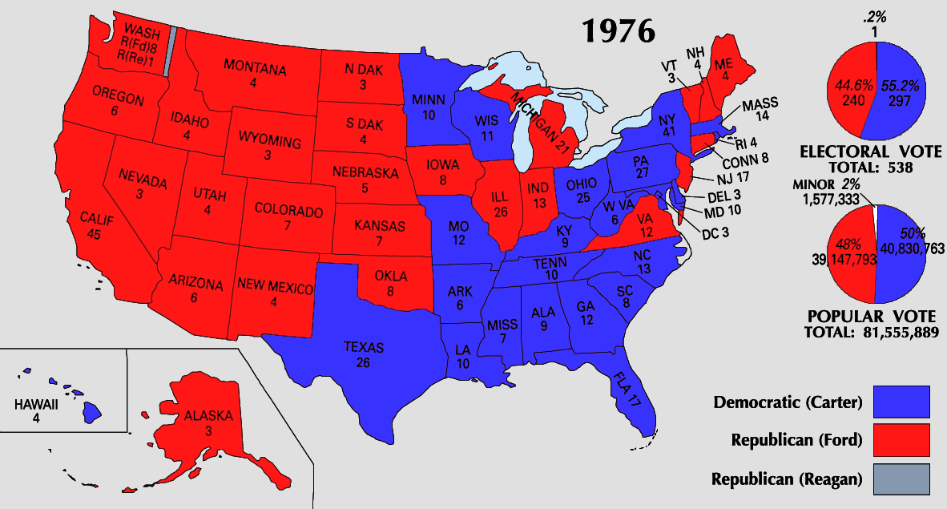
CLASS NOTES VIII (24 March):

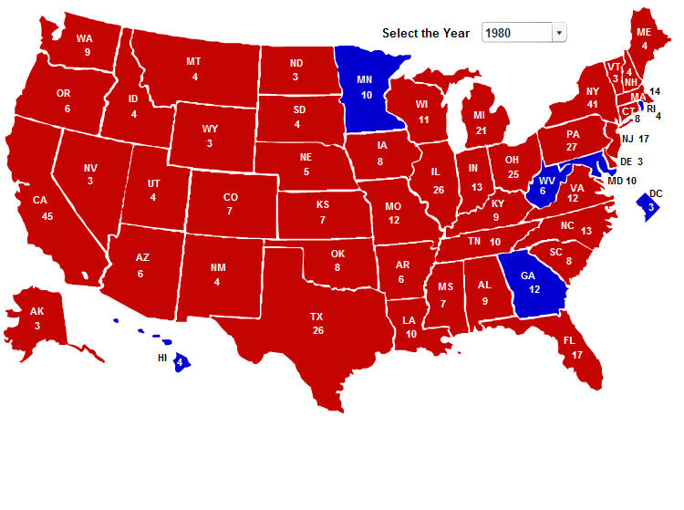
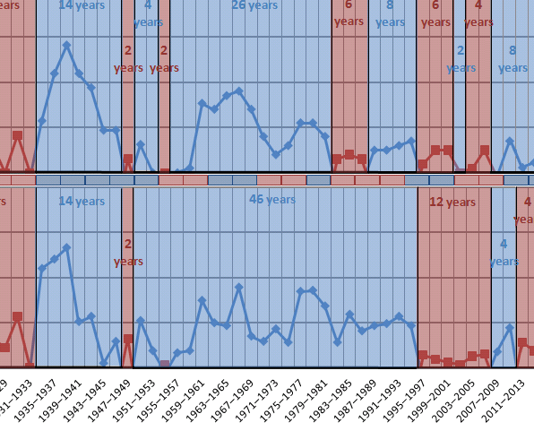
The domination of the Right
The Reagan Revolution: domestic
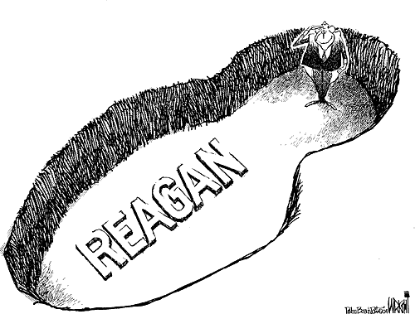
The end of the postwar consensus. Throughout the Western world, mainstream parties accepted collectivism, a mixed economy, a welfare state, Keynesian economic policy, a commitment to full, and (after the 1960s) a desire for permanent détente with the Soviet Union. That consensus ended with the election of Margaret Thatcher in Britain (May 1979) and Reagan in America (November 1980). There was a permanent ideological shift, which has yet to be reversed.
Tax-cuts and a permanent deficit. Reagan, especially after surviving an assassination attempt in March 1981, had remarkable sway over Congress and the public. He pushed through the Tax Reduction Act (July 1981: see photo): the top marginal tax bracket dropped from 70% to 50%; the Tax Reform Act of 1986 reduced it to 28%. This also represented a permanent counter-revolution: America is now hostile to redistributive taxation, and has settled into permanent deficit, partly because of the Reagan’s rearmament (a 40% real increase in defense spending from 1981 to 1985).
End of unionsm: 1981 Air traffic controllers’ strike: sacks 12,000 of them
Reaganomics: supply-side theory: a laissez-faire philosophy, free-market fiscal policy, stimulation through large, across-the-board tax cuts, enough, it was hoped, to expand the tax base, offsetting the loss of revenue.
Right or wrong, he had the advantage of a very sunny economy, the Reagan boom. During his administration inflation dropped from 12.5% (average in 1980) to 4.4% (1988); unemployment fell from 7.5% to 5.4%; GDP grew 7.9% on average, and reached a tremendous 12.2% in 1982.
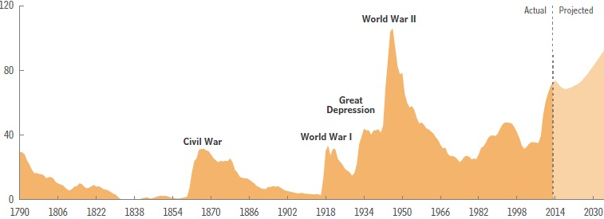
The return of aristocracy. The Gini coefficient (after Corrado Gini, 1912) measures the income inequality among values of a frequency distribution, with 1 perfect inequality in a society – one man earns everything – and 0 perfect quality. Since World War II there had been, broadly speaking, increased income equality; pre-tax income grew less amongst the rich. From the end of the ‘70s that was reversed, and now America is unusual globally in the scale of its hereditary wealth. CEOs, for instance, have earned more and more, and a larger and larger percentage of wealth lies with the richest families. This changes the nature of Western society.

The Reagan Revolution: ideology
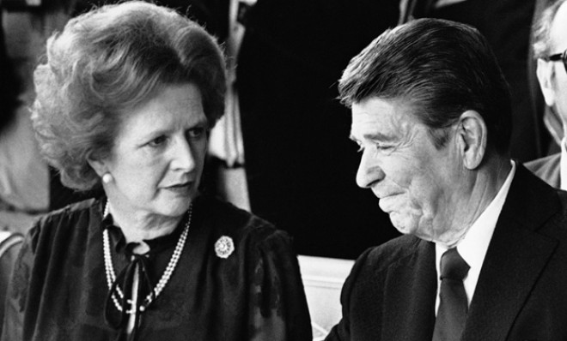
-- October 1978: Karol Wojtyła elected pope as John Paul II
-- May 1979: Margaret Thatcher becomes the British Prime Minister
-- December 1979: the Soviet Union invades Afghanistan. Carter withdraws from SALT II, boycotts the Moscow Olympics, and introduces grain embargoes. Covert aid to mujahideen.
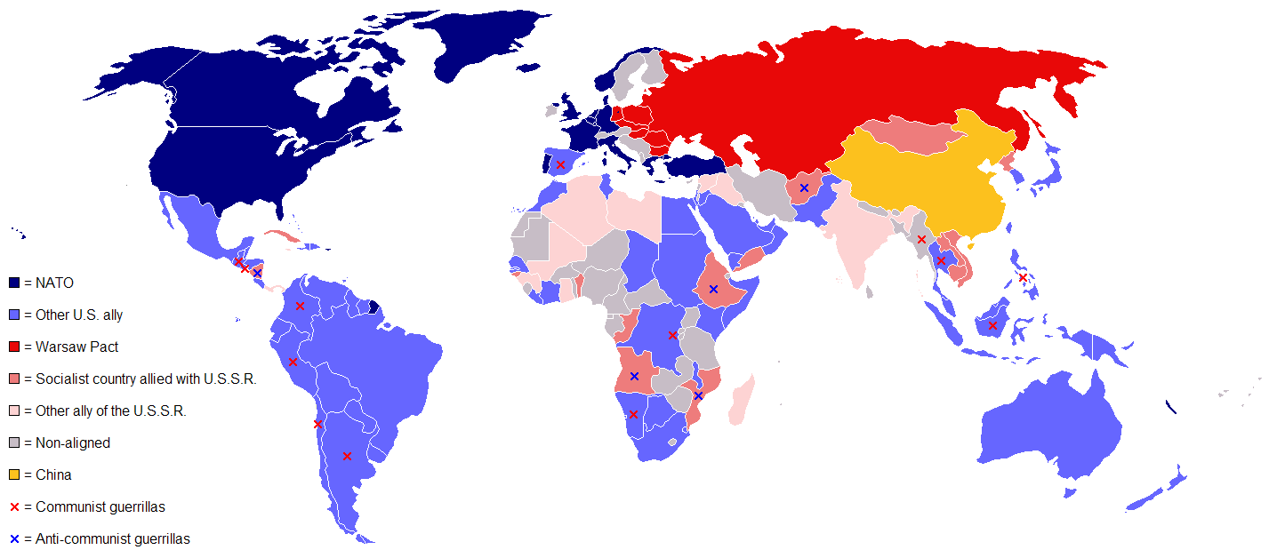
-- November 1980: landslide victory for Reagan, who promises increased military spending and confrontation with the Soviets everywhere, and who rejects detente in principle:

“American policy toward the Soviet Union is simple, and some would say simplistic. It is this: We win and they lose. What do you think of that?”

The Soviet Union is an “e vil empire” (1983)

June 1982, in an address to the British Parliament in the Palace of Westminster: “the forward march of freedom and democracy will leave Marxism–Leninism on the ash-heap of history”.

March 1983: the Soviet Union is “an evil empire”; “Communism is another sad, bizarre chapter in human history whose last pages even now are being written”.

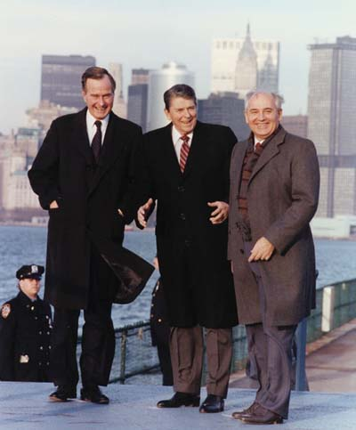
The Second Cold War

-- 1980–1981 Polish crisis
-- 1983 Reagan introduced the Strategic Defense Initiative (SDI or ‘Star Wars’); cruise missiles in Europe, opposimg Soviet SS20s
-- 1983 invasion of Grenada; Lebanese Civil War
-- 1985 Reagan Doctrine: besides mere incontain ment, an additional right to subvert existing Communist governments.
-- 1985: Mikhail Gorbachev takes over in Soviet Union: glasnost (openness) and perestroika (restructurng)
-- 1986 bombing of Libya
-- 1986: military spending at nealry 7% if GDP, highest ever in peace time
-- 1986: Iran-Contra scandal
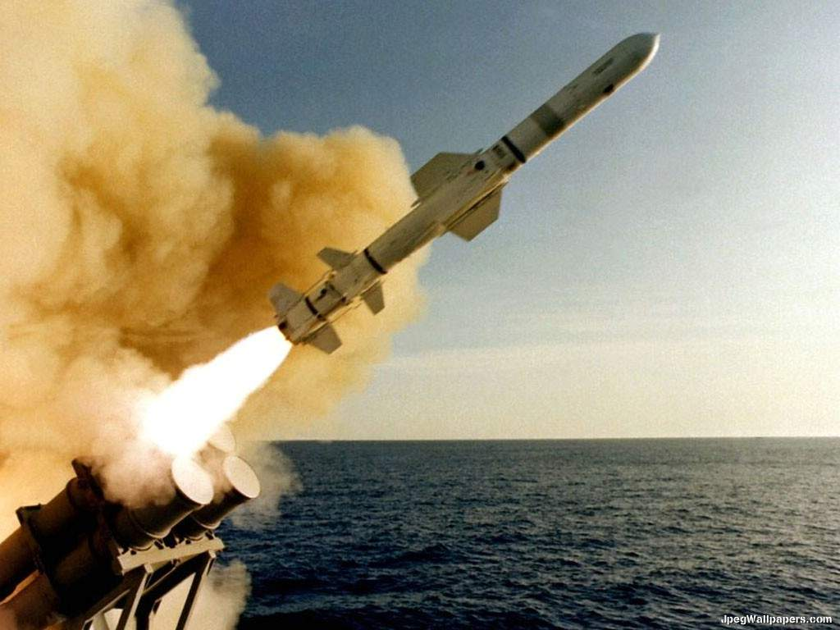
-- 1986: Reykjavik Summit: nuclear weapoms nearly abolished
-- 1987: “Mr. Gorbachev, tear down this wall!”
-- 1987: INF treaty
-- 1988: Soviet withdrawl from Afghanistan
-- 1988: George Bush, Reagan’s rather colourless Vice-President, easily elected as his successor
-- 1989: beginning with Latvia in January, anti-Communist revolutions throughout Europe; in November, fall of the Berlin Wall
-- Decembr 1989: Malta Summit and
-- 1991: beginning with Latvia in January, anti-Communist revolutions; August: failed Communist coup in Moscow; December Soviet Union dissolved

It was an economic matter always: the Americans spent $8 trillion on the Cold War, and the Soviet Union went bankrupt keeping up

Cinema of the Cold War

