AMERICAN HISTORY SINCE 1945:
a series of lectures offered at Corvinus University, Budapest,
Monday evenings, February-April 2014,
by Richard Major

Class webpage: http://www.richardmajor.com/teaching/Corvinus/USsince1945.html
Dr Richard Major: richard@richardmajor.com

CLASS NOTES IX (31 March):
The New World Order, 1989-2001

The object of human existence, according to the American Constitution, is life, liberty and the pursuit of happiness.
So far in this course, we have seen the United States since 1945 committed to the following role in history:

life
‘active containment’ and then (from 1980) ‘roll-back’ of Communism; permanent militarisation; nuclear strategy of MAD; NATO
liberty
ideological commitment to constitutional and liberal government in the post-colonial world
the pursuit of happiness
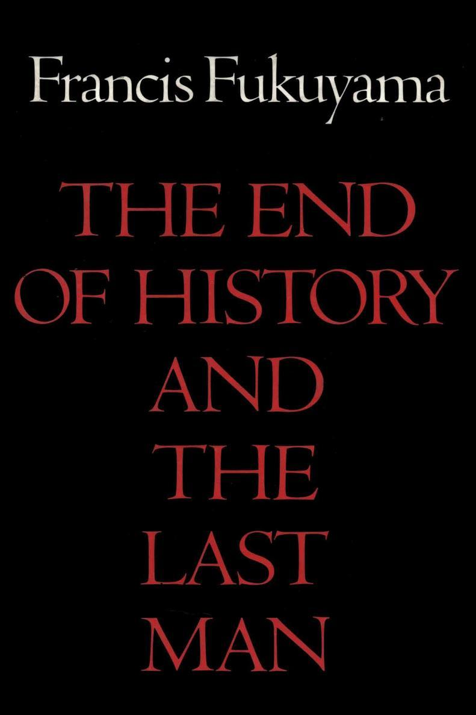
mixed and (after 1980) almost pure capitalist expansion at home

Until 1989 these goals were not always achieved;
but after 1989 a brief golden age opened, when victory was easy;
hence Francis Fukuyama’s 1989 essay The End of History?
Since 2001, history has resumed!

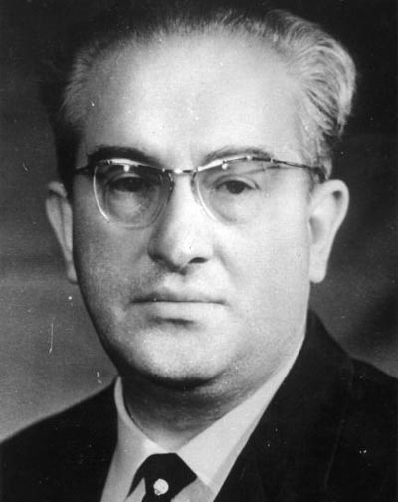
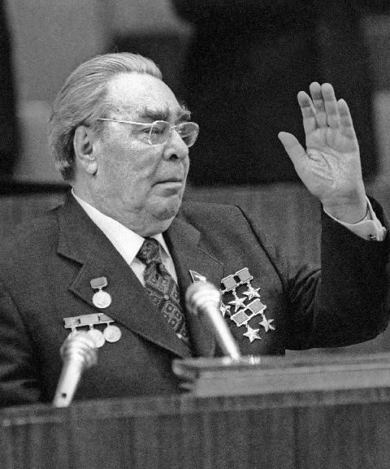
Life: America’s Soviet enemy implodes
In ‘the kitchen debate’ of 1959, Khrushchev had promised to ‘bury’ the West by overcoming it economically;. By 1982 Soviet economic stagnation was apparent, especially in industry (although agriculture was ruined too: the regime survived by importing grain from its American foe). Yet Communism seemed too entrenched to change – not least because it was becoming hereditary.
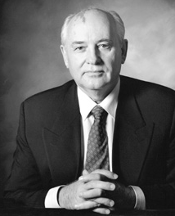
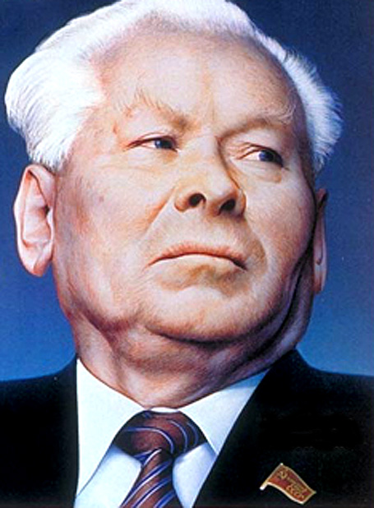
Brezhnev (left) died in November 1982. His successor, after a struggle, was the appalling Andropov (right), a sterile reactionary afflicted with a ‘Hungary syndrome’ – an obsession with crushing dissent by military force – who raged against Reagan’s “bellicose, lunatic anti-Communism” but died after 14 months without doing much harm. The aged Konstantin Chernenko (left) lasted just over a year; then power passed to young (born 1931) Mikhail Gorbachev.
who introduced (1986) perestroika, or restructuring of the system; and (1988) glasnost, or openness, including some civil liberties, culminating in a new constitution, with Gorbachev as President, and semi-free elections in 1989.
But Communism couldn’t be reformed. Economically, Gorbachev hastened its collapse: by the end of the 1980s, there were severe shortages of meat and sugar, despite rationing; a massive deficit; a big internal debt; and Afghanistan.
Nationalist turmoil reached the point of full-scale racial war in the Caucasus; the Baltic republics tried to break away; Boris Yeltsin (bottom left) became president of Russia, and set himself up as Gorbachev’s rival.
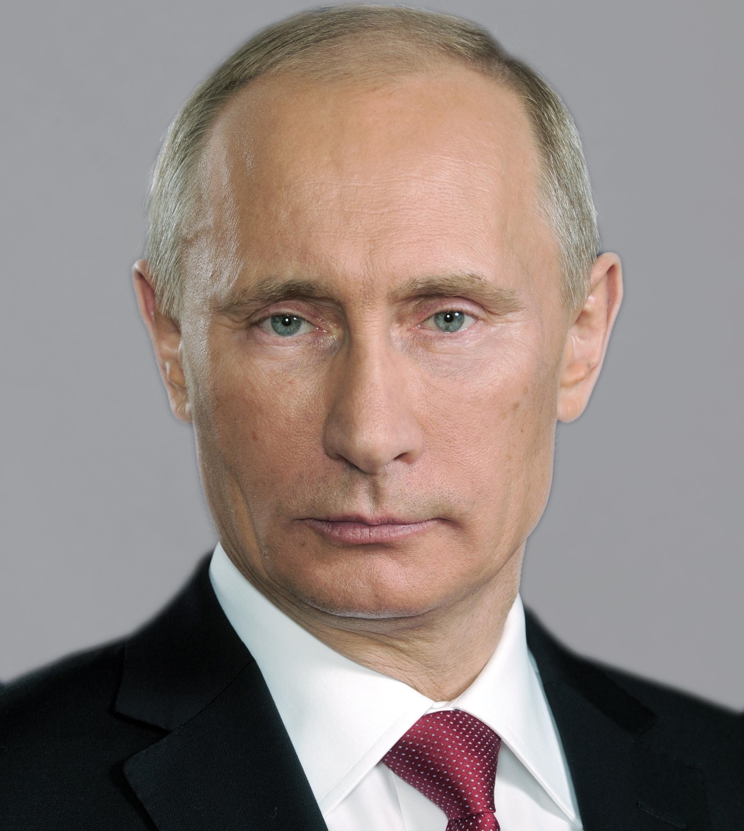
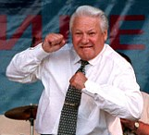
An attempt by hardliners to prevent a loosening of the USSR into a ‘Union of Sovereign States’ – the August coup of 1991 – overthrew Gorbachev; but the coup was run by fools and drunks – note the shaking hands of Gennady Yanayev, the Acting President, in this infamous press conference (10’) – and it collapsed after a few days. But Gorbachev was finished; power passed to Yeltsin (also a drunk; on a 1995 visit to Washington he was found on Pennsylvania Avenue in his underwear, trying to hail a cab to find pizza); the Soviet Union was dissolved.
Yeltsin presided over decline and chaos in the new Russia; on 31 December 1999 he suddenly despaired, asked forgiveness, and resigned. Vladimir Putin (right), a KGB general with steely eyes and an obsession with recovering the glories of Tsarist Russia, took over, and has been dictator ever since.

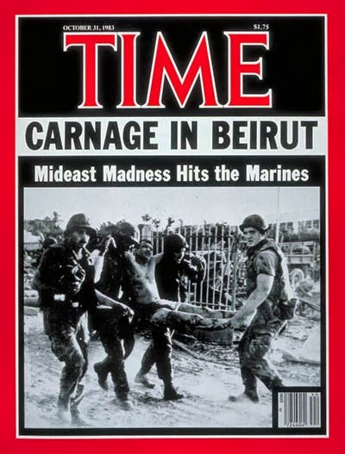
Liberty: Becoming the sole super-power
Once the Vietnam War turned into a disaster in the mid-’Sixties,
Americans lost their taste for foreign adventures;
after the fall of Indochina in April 1975, America became entirely quiescent.
Carter’s Secretary of State, Cyrus Vance, advanced Vance’s Rule of Two and a Half:
“Any military project will take twice as long as planned, cost twice as much,
and produce only half of what is wanted.”
Only under Reagan did foreign wars resume: it was at first a mixed bag.

August 1982-February 1984: unsuccessful intervention in endless civil wars in Lebanon
October 1983: invasion of Grenada, after one Communist faction overthrown by another
April 1986: bombing of Libya in revenge for terrorist attacks
April 1988: Operation Praying Mantis: one-day naval war with Iran
December 1989: invasion of Panama to get rid of the dictator Noriega
January-February 1991: Operation Desert Storm, THE FIRST GULF WAR against Iraq
December 1992-May 1993: unsuccessful intervention in endless civil wars in Somalia:
Black Hawk Down (2001)
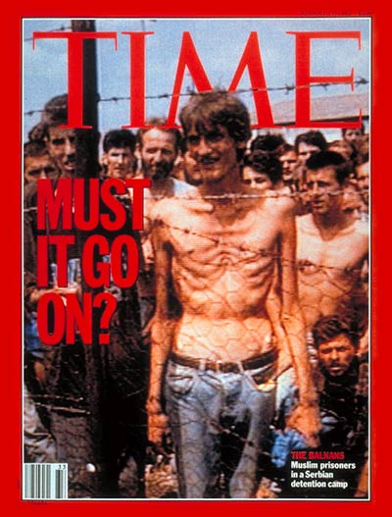
September 1994: Operation Uphold Democracy: invasion of Haïti
to restore President Aristide (whom the U.S. then helped overthrow in 2004)
August-September 1995: Operation Deliberate Force: NATO air force intervention in the Bosnian War (100,000 killed, perhaps 50,000 raped, 2.2 million homeless: much the worst war in Europe since 1945).
Dayton Agreement in December ends the war.
March-June 1999: NATO air force intervention in Kosovo War: Serbia, after bombing,
caves in and withdraws. Here’s some maudlin Serb propaganda.

Only some had U.N. approval; not all were victorious.
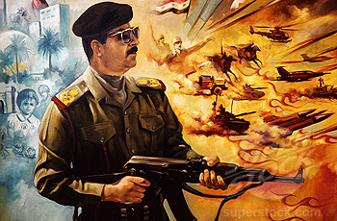
But t he one that matters was the First Gulf War, which reversed the whole tendency of the twentieth century: nationalist socialism, military aggression, the failure of collective security, Western appeasement. After 1991 America possessed, and was prepared to exorcise, hegemonic jurisdiction over the planet: this was the New World Order proposed by Bush in 1990.
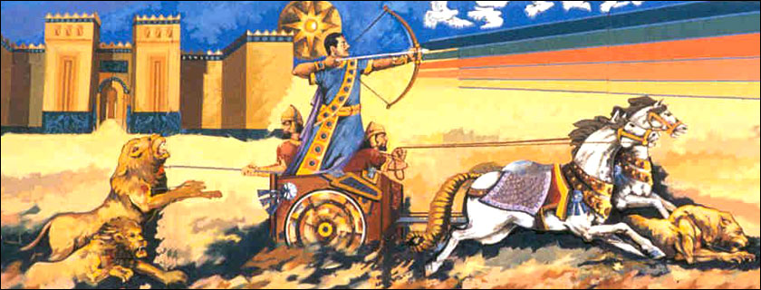
THE FIRST GULF WAR

1914-1918 British (who have held Kuwait since 1890) conquer Mesopotamia from the Turks and
1920-1922 establish the Kingdom of Iraq.
1958 Monarchy overthrown by nationalist-socialist dictatorship; from 1968, a Ba’athist state
led (after purges) by the amazingly bloody Saddam Hussein. Alliance with the Soviets.
1979 February: Iranian Revolution: Shah overthrown; Shi’ite priestly dictatorship under the Ayatollah Khomeini. Army purged.
1979 November – 1981 January: hostage crisis: American diplomats seized by mob and held by regime
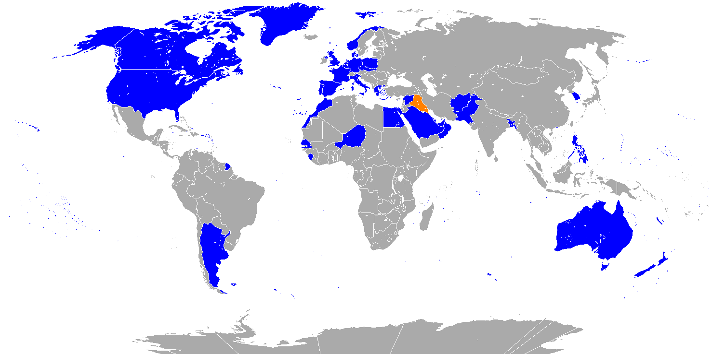
1980 September: Iraq invades Iran. The Iran-Iraq War (confusingly known as also known as the First Persian Gulf War) settled down to a reenactment of World War One: large-scale trench warfare, barbed wire, gas (especially by the Iraqis, against Kurdish villages), manned machine-gun posts, bayonet charges, human wave attacks across no-man’s land: a million dead. Iraqis funded by the Sunni world and armed by the West. The war ends in a draw in 1988.
1990 August 2: Saddam, who now has the fourth biggest army in the world, overruns Kuwait and annexes it.
August 7: Bush orders “wholly defensive” Operation Desert Shield to prevent Iraq from invading Saudi Arabia
November 29: UN Security Council passed Resolution 678, authorising members “to use all necessary means” to evict Iraq from Kuwait.
The U.S. (despite a close Senate vote for the war 52-47) assembles a large Coalition (blue on map).
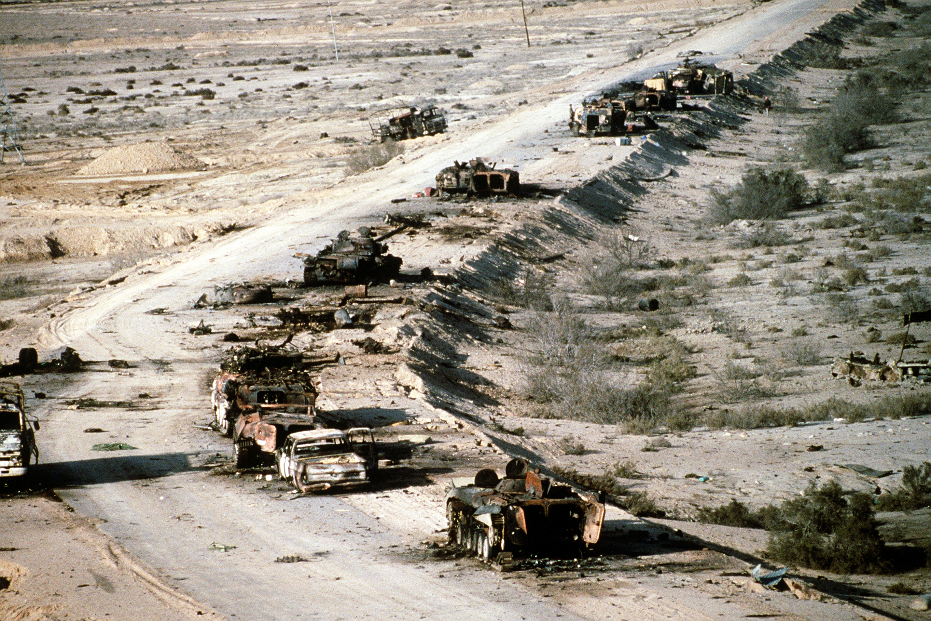
1991 January 17: Operation Desert Storm: air war begins. Here’s the luckiest man in Iraq;
February 24: massive Coalition invasion of Iraq and Kuwait. Rapid and total victory. BBC documentary
February 26: about 10,000 retreating Iraqi troops killed on the highway of death (left).
February 28: unilateral ceasefire.
March-April: Saddam crushes risings in the south (Three Kings (1999)); in the north, Coalition intervention effectively saves the Kurds.
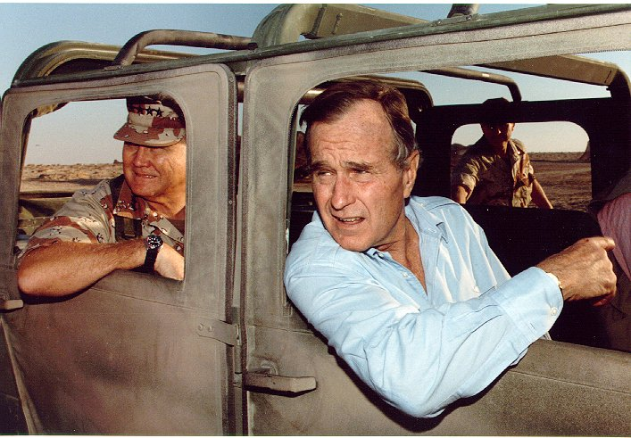
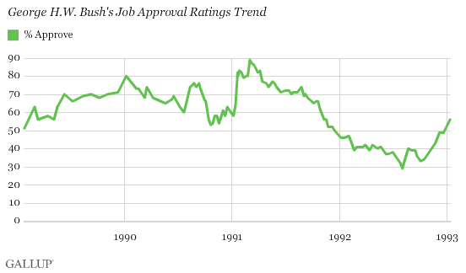
the pursuit of Happiness: the Clintonian idyll
George Bush was fantastically popular after the Gu lf War (here he is in the desert for Thanksgiving 1990), and no prominent Democrat dared challenge him for reelection.
But his own curious detachment, lingering doubts about whether the Coalition should have gone on to Baghdad, and a sharp recession, undermined him.
Bush faced a young, curiously irresistable Democrat from Arkansas, Clinton, and a bizarre Texan billionaire gnome, Ross Perot. Here is one of their debates (beginning and from 9’30”). In November 1992 the election (Clinton 43%, Bush 38%, Perot 19%)

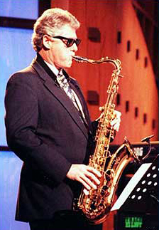
William Jefferson Clinton (left) is a remarkable politician. The mood in America remained very right-wing; in the midterm elections of 1994 the ‘Republican Revolution’ brought the Republicans, especially the populist Right led by Newt Gingrich, control of the Senate and (for the first time in 46 years) the House; it was a landslide comparable to 1980, a permanent shift.
Nonetheless, Clinton had no difficulty in winning reelection in 1996 against the charmless Robert Dole, and left office in January 2001 still very popular.
These were peaceful days, comparatively uneventful, so ‘events’ were often frivolous.
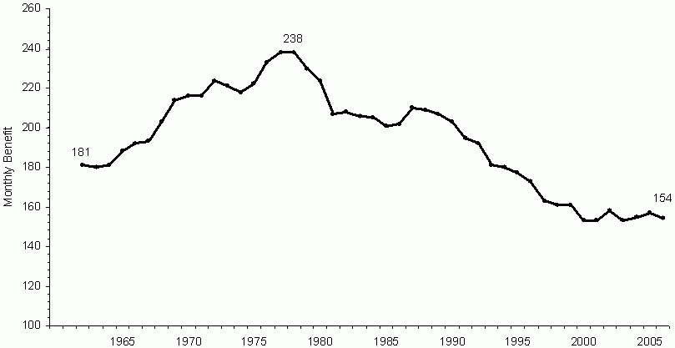
Clinton was resposible for one great demstic reform. The Right’s ‘Contract with America’ echoed his own 1992 promise to “end welfare as we have come to know it”, and the result was ‘welfare reform’: the Personal Responsibility and Work Opportunity Reconciliation Act (1996). This graph shows what the average welfare recepient received in 2006 dollars; obviously the welfare state was dwindling before Clinton; but he was responsible for formally ending the experiement in social planning begun by Roosevelt and Johnson.
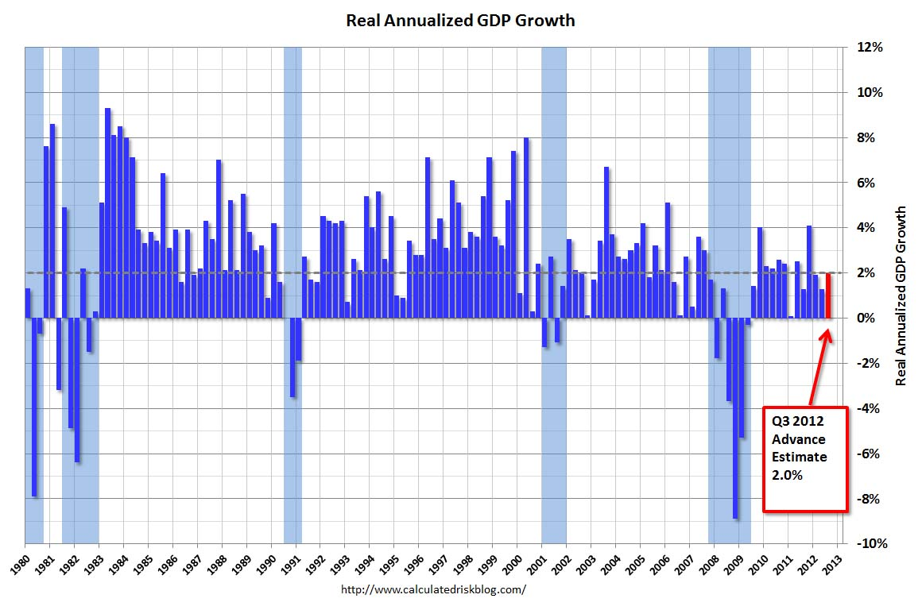
America historically tends to get richer at about 2% a year: ponder this logarithmic table.
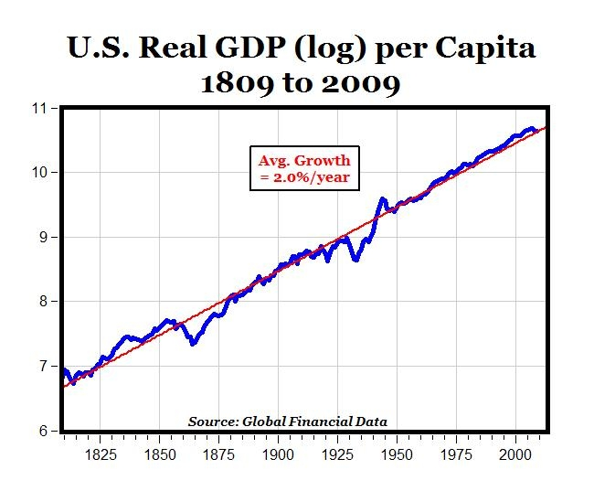
The brief recessions of 1980-83, 1991-2, 2000-2 and 2008-9 all caused a change of ruling party.
Of the three great long booms in-between – the ’Eighties, the ’Nineties and the ’Naughties – it was the Clinton boom which lasted longest’ so the Clinton presidency was sunniest. Even that appalling long-term crisis, the Federal debt, eased:

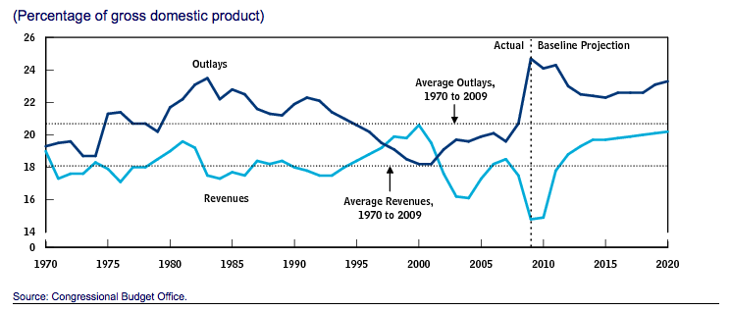
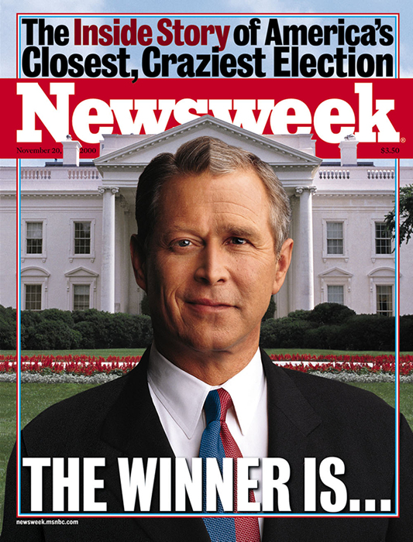
Instead of serious politics, there was a comic attempted coup d'état by the Republican Congress, a convoluted affair beginning with Whitewater (a property deal in Arkansas way back, in which the Clintons lost money), and then moving on via the Starr Report to Zippergate, involving an intern named Monica Lewinksy. Popular condemnation of the Republicans at the polls (midterm election 1988) did not deter them; Clinton was impeached, tried before the Senate, acquitted on a party-line vote. Gingrich fell (he was having an affair); so did his successor, Bob Livingston (ditto); so did the House manager, Bob Barr (ditto). Good dirty fun all round: I did not have sex with that woman (6’17’’); confessing to the Grand Jury (from 11’20”) that he had; his televised address (to 1’05); her testimony (39’50); his remarks afterward.

In 2000 the Democratic nomination went to the wooden Vice-President, Al Gore; the Republicans nominated the elder Bush’s curious smirking Texanised son; the issue-free 2000 election was a farce and produced a disputed result, resolved by the Supreme Court (voting on party lines). The twentieth century ended without dignity, but in a haze of prosperity and comfort, with a $237 billion Federal surplus. George W. Bush was sworn in as XLIIIrd President in January; he disposed of the surplus with a tax cut in June; on the morning of 11 September, the twelfth year of post-history, he was in Florida, listening to children read about a pet goat (1’00”).

